MINISTRY OF EDUCATION AND TRAINING

CAN THO UNIVERSITY

COLLEGE OF INFORMATION AND COMMUNICATION TECHNOLOGY

**🙞 🕮 🙜**



GRADUATION THESIS

BACHELOR OF ENGINEERING IN

INFORMATION TECHNOLOGY

(HIGH-QUALITY PROGRAM)

GRADE 10 ADMISSION MANAGEMENT SYSTEM FOR CAN THO CITY

Student: Kim Duy Thanh

Student ID: B2105686

Class: 2021-2025 (K47)

Advisor: Dr. Thai Minh Tuan

Can Tho, 12/2025

MINISTRY OF EDUCATION AND TRAINING

CAN THO UNIVERSITY

COLLEGE OF INFORMATION AND COMMUNICATION TECHNOLOGY

DEPARTMENT OF INFORMATION TECHNOLOGY

**🙞 🕮 🙜**



GRADUATION THESIS

BACHELOR OF ENGINEERING IN

INFORMATION TECHNOLOGY

(HIGH-QUALITY PROGRAM)

GRADE 10 ADMISSION MANAGEMENT SYSTEM FOR CAN THO CITY

Student: Kim Duy Thanh

Student ID: 123453454

Class: 2021-2025 (Cohort K47)

Advisor: Dr. Thai Minh Tuan

Can Tho, 12/2025

|  |  |
| --- | --- |
| ĐẠI HỌC CẦN THƠ  **TRƯỜNG CÔNG NGHỆ THÔNG TIN**  **VÀ TRUYỀN THÔNG** | **CỘNG HÒA XÃ HỘI CHỦ NGHĨA VIỆT NAM**  **Độc lập – Tự do – Hạnh phúc** |

**XÁC NHẬN CHỈNH SỬA LUẬN VĂN**

**THEO YÊU CẦU CỦA HỘI ĐỒNG**

Tên luận văn (tiếng Việt và tiếng Anh):

- Tiếng Việt: Hệ thống hỗ trợ tuyển sinh lớp 10 Thành phố Cần Thơ

- Tiếng Anh: Grade 10 Admission Management System for Can Tho City

Họ tên sinh viên: Kim Duy Thành MSSV: B2105686

Mã lớp: DI21V7F2

Đã báo cáo tại hội đồng ngành: Công nghệ Thông tin – Chất lượng cao

Ngày báo cáo: 21/12/2025

Luận văn đã được chỉnh sửa theo góp ý của Hội đồng.

*Cần Thơ, ngày 26 tháng 12 năm 2025*

**Giáo viên hướng dẫn**

*(Ký và ghi họ tên)*

**Thái Minh Tuấn**

ACKNOWLEDGMENTS

Firstly, I would like to express my deepest appreciation to my instructor, Dr. Thai Minh Tuan, who has enthusiastically guided me throughout the writing of my thesis and provided sincere, highly constructive comments to help me complete this report. I would not have been able to complete this graduation thesis without the extensive and useful knowledge and experience that he has imparted to me, as well as the comments and criticisms of all teachers in the thesis defense council.

Secondly, I would like to extend my sincere thanks to all teachers who have taught me over the past 4 years at the College of Information and Communication Technology, Can Tho University. It is from the important and useful knowledge that the teachers have imparted to me during the course of my studies that I have acquired the necessary knowledge and skills to continue researching, learning, and developing professional skills, thereby completing my graduation thesis.

Also, I could not have undertaken this journey without the companionship and support of my family. My family has provided timely financial support to me throughout my university studies, at the same time given me useful advice and reminders throughout my university studies and opened my mind to issues related to my graduation thesis so that I could complete it in the best way.

Lastly, I’d like to acknowledge my friends, classmates, and teammates who have studied with me over the past 4 years of university studies. They have given me useful advice and consultation throughout the writing of my thesis, as well as shared their experiences, so that I can learn and complete this thesis well.

ABSTRACT

This thesis focuses on designing an online grade 10 admission system applicable to multiple platforms (web, mobile) to synchronize the admission system of provinces and cities in Vietnam after the merger on July 1, 2025. This thesis aims to address the drawbacks of the current admission systems in three old provinces and cities (Can Tho City, Hau Giang Province, Soc Trang Province) and to develop an integrated system adaptable to the new Can Tho City. The thesis content includes four main subsystems: a subsystem for managing admission records; a subsystem for managing candidate exam information; a subsystem for managing scores and announcing admission results; and a subsystem for managing and controlling exam status. The thesis has used MySQL and Java Spring Boot for creating the backend; HTML, CSS, JavaScript, and React framework for web interface; Dart and Flutter for mobile interface, and some APIs from Google (reCAPTCHA API and Google Maps API) to connect between the frontend and backend. The thesis has completed all the basic and mandatory functions of an online admission system, and has many extended features to support user groups in the process of searching and processing information related to the admission period. This thesis has been advised, evaluated, and commented on by some officials working in secondary schools, high schools in Can Tho City, and in the Department of Education and Training, so it will suit the needs of the majority of users of the system.

# TABLE OF CONTENTS

TABLE OF CONTENTS i

LIST OF TABLES iii

LIST OF FIGURES v

CHAPTER 1: INTRODUCTION 1

1.1. Overview of research situation 1

1.2. The reason for choosing the topic 1

1.3. The purposes of the thesis 2

1.4. Research methods 2

1.5. The subjects of the thesis 2

1.6. The scopes of the thesis 2

CHAPTER 2: BACKGROUND 3

2.1. Client–Server model 3

2.2. Model – View – Controller (MVC) 3

2.3. MySQL 3

2.4. Java and Spring Framework 3

2.5. React 4

2.6. Dart and Flutter 4

CHAPTER 3: REQUIREMENTS ANALYSIS 5

3.1. The general system flow 5

3.2. User groups 6

3.3. List of functions 9

3.4. Operating platforms 10

3.5. Detailed description of functions 11

CHAPTER 4: SYSTEM DESIGN 30

4.1. Architecture model of the system 30

4.2. Data model of the system 31

CHAPTER 5: SYSTEM IMPLEMENTATION 37

5.1. Web application 37

5.1.1. Functions for Guest users 37

5.1.2. Functions for Administrators 42

5.1.3. Functions for Admissions Council Officials 45

5.1.4. Functions for Secondary School Officials 49

5.1.5. Functions for High School Officials 54

5.1.6. Functions for Students 59

5.2. Mobile application 63

5.2.1. Functions for Guest users 63

5.2.2. Functions for Administrators 69

5.2.3. Functions for Admissions Council Officials 72

5.2.4. Functions for Secondary School Officials 76

5.2.5. Functions for High School Officials 78

5.2.6. Functions for Students 81

CHAPTER 6: CONCLUSION 83

6.1. Conclusion 83

6.2. Future work 83

REFERENCES 84

# LIST OF TABLES

Table 3.1. The list of functions 9

Table 3.2. Description of use case GUEST-01 11

Table 3.3. Description of use case GUEST-02 11

Table 3.4. Description of use case GUEST-03 11

Table 3.5. Description of use case ALL-01 12

Table 3.6. Description of use case ALL-02 13

Table 3.7. Description of use case ALL-03 13

Table 3.8. Description of use case ADMIN-01 13

Table 3.9. Description of use case ADMIN-02 14

Table 3.10. Description of use case ADMIN-03 14

Table 3.11. Description of use case ADMIN-04 14

Table 3.12. Description of use case ADMIN-05 15

Table 3.13. Description of use case ADMIN-06 15

Table 3.14. Description of use case ADMIN-07 15

Table 3.15. Description of use case ADMIN-08 16

Table 3.16. Description of use case SGDDT-01 16

Table 3.17. Description of use case SGDDT-02 17

Table 3.18. Description of use case SGDDT-03 17

Table 3.19. Description of use case SGDDT-04 17

Table 3.20. Description of use case SGDDT-05 18

Table 3.21. Description of use case SGDDT-06 18

Table 3.22. Description of use case SGDDT-07 18

Table 3.23. Description of use case SGDDT-08 19

Table 3.24. Description of use case SGDDT-09 19

Table 3.25. Description of use case SGDDT-10 19

Table 3.26. Description of use case THCS-01 20

Table 3.27. Description of use case THCS-02 20

Table 3.28. Description of use case THCS-03 20

Table 3.29. Description of use case THCS-04 21

Table 3.30. Description of use case THCS-05 21

Table 3.31. Description of use case THCS-06 21

Table 3.32. Description of use case THCS-07 22

Table 3.33. Description of use case THCS-08 22

Table 3.34. Description of use case THCS-09 22

Table 3.35. Description of use case THCS-10 23

Table 3.36. Description of use case THCS-11 23

Table 3.37. Description of use case THCS-12 23

Table 3.38. Description of use case THPT-01 24

Table 3.39. Description of use case THPT-02 24

Table 3.40. Description of use case THPT-03 24

Table 3.41. Description of use case THPT-04 25

Table 3.42. Description of use case THPT-05 25

Table 3.43. Description of use case THPT-06 25

Table 3.44. Description of use case THPT-07 26

Table 3.45. Description of use case THPT-08 26

Table 3.46. Description of use case THPT-09 26

Table 3.47. Description of use case THPT-10 27

Table 3.48. Description of use case THPT-11 27

Table 3.49. Description of use case THPT-12 27

Table 3.50. Description of use case THPT-13 28

Table 3.51. Description of use case THPT-14 28

Table 3.52. Description of use case HS-01 28

Table 3.53. Description of use case HS-02 29

Table 3.54. Description of use case HS-03 29

Table 3.55. Description of use case HS-04 29

Table 4.1. The overview information of entities/tables in the system 31

Table 4.2. Table DAN_TOC 32

Table 4.3. Table DTKK 32

Table 4.4. Table DTKK_CHUYEN 32

Table 4.5. Table DTUT 32

Table 4.6. Table HOC_SINH 32

Table 4.7. Table KET_QUA_THI 33

Table 4.8. Table KQ_HOC_TAP 33

Table 4.9. Table LOAI_TK 34

Table 4.10. Table LOP_CHUYEN 34

Table 4.11. Table LOP_CHUYEN_THPT 34

Table 4.12. Table NGUYEN_VONG 34

Table 4.13. Table PHUONG_XA 35

Table 4.14. Table TAI_KHOAN 35

Table 4.15. Table THI_SINH 35

Table 4.16. Table TRANG_THAI_CSDL 35

Table 4.17. Table TRUONG_THCS 36

Table 4.18. Table TRUONG_THPT 36

# LIST OF FIGURES

Figure 3.1. Use Case Diagram for Guest users 6

Figure 3.2. Use Case Diagram for general functions of logged-in users 6

Figure 3.3. Use Case Diagram for Administrators 7

Figure 3.4. Use Case Diagram for Admissions Council Officials 7

Figure 3.5. Use Case Diagram for Secondary School Officials 8

Figure 3.6. Use Case Diagram for High School Officials 8

Figure 3.7. Use Case Diagram for Students 9

Figure 4.1. Architecture model of the system 30

Figure 4.2. Entity Relationship Diagram of the system (simplified version) 31

Figure 5.1. The homepage web interface 37

Figure 5.2. The footer of the web interface 38

Figure 5.3. Search Admission Result interface 38

Figure 5.4. The Search Result interface with only one student 39

Figure 5.5. The Search Result page with more than one student 39

Figure 5.6. Admission Numbers interface 40

Figure 5.7. Admission Information of High School for the Gifted 40

Figure 5.8. Admission Documents interface 41

Figure 5.9. Login interface 41

Figure 5.10. Administrator’s homepage 42

Figure 5.11. Account Management homepage 42

Figure 5.12. Confirmation dialog for deleting an account 43

Figure 5.13. Add Account page 43

Figure 5.14. Dialog for importing accounts 44

Figure 5.15. Reset password dialog 45

Figure 5.16. Change Password page 45

Figure 5.17. Admissions Council Official’s homepage 46

Figure 5.18. Student Management homepage 46

Figure 5.19. Update Student’s Score page 47

Figure 5.20. Import Student’s Score 47

Figure 5.21. State Management homepage 48

Figure 5.22. Update State dialogs (for Boolean and Timestamp states) 48

Figure 5.23. Secondary School Official’s homepage 49

Figure 5.24. Student Management homepage 49

Figure 5.25. Detailed Information page 50

Figure 5.26. Update Students page 50

Figure 5.27. Confirmation dialog to delete a student 51

Figure 5.28. Initiate Student Profile page 51

Figure 5.29. Add Student Profile page 52

Figure 5.30. Import Initial Student Profile dialog 52

Figure 5.31. Import Student Profile dialog 53

Figure 5.32. Delete All Students dialog 53

Figure 5.33. High School Official’s homepage 54

Figure 5.34. Profile Management homepage 55

Figure 5.35. Detailed Information page 55

Figure 5.36. Update Student page 56

Figure 5.37. Confirmation dialog to delete a student 56

Figure 5.38. Add Student Profile page 57

Figure 5.39. Import Student Profile dialog 57

Figure 5.40. Confirmation dialog for deleting all students 58

Figure 5.41. Candidate Management page 59

Figure 5.42. Student’s homepage 59

Figure 5.43. Student Information homepage 60

Figure 5.44. Update Information page 60

Figure 5.45. The Admission Form after exporting 61

Figure 5.46. Admission Result page (with successful message) 61

Figure 5.47. Admission Result page (with failure message) 62

Figure 5.48. Welcome page and homepage of the mobile application 63

Figure 5.49. Search Admission Result interface of the mobile application 64

Figure 5.50. The result interface after typing information 65

Figure 5.51. Admission Numbers interface of the mobile application 66

Figure 5.52. Admission Documents interface of the mobile application 67

Figure 5.53. Login interface of the mobile application 68

Figure 5.54. Administrator Homepage 69

Figure 5.55. Account Management page 70

Figure 5.56. Change Password page 71

Figure 5.57. Admissions Council Official’s homepage 72

Figure 5.58. Candidate Management and Update Score page 73

Figure 5.59. State Management page 74

Figure 5.60. Update State dialog 75

Figure 5.61. Timestamp modifying (date and time) 75

Figure 5.62. Secondary School Official’s homepage 76

Figure 5.63. Student Management and Student Detailed Information page 77

Figure 5.64. High School Official’s homepage 78

Figure 5.65. Student Management and Detailed Information page 79

Figure 5.66. Candidate Management page 80

Figure 5.67. Student’s homepage 81

Figure 5.68. Student Information page 82

# INTRODUCTION

## Overview of research situation

Since 2018, to create more favorable conditions for secondary schools, high schools, parents, and students in Can Tho City (before the merger), Can Tho Department of Education and Training has deployed a common online enrollment system for all schools in the area on the web platform [1]. Through actual use, the system has shown its effectiveness in supporting online enrollment registration, as well as helping parents and students have an overview of the number of candidates registering for high schools in the city, and it is still being used until this year's enrollment period (school year 2025-2026). However, the application still has some limitations, such as: The application design is still quite sketchy, there are no distinctive signs to identify the enrollment system of Can Tho City when compared with other admission systems of other provinces and cities; The application interface has not been fully built; Difficult to locate and track content, because all information is contained on a single page.

In addition, since July 1, 2025, Vietnam has started operating a 2-level local government and implementing the merger of provinces and cities. In detail, the new Can Tho City includes old Can Tho City, Hau Giang Province, and Soc Trang Province [2]. Before the merger, each locality had a separate grade 10 enrollment support system that served the specific requirements of that province/city. However, after the merger, enrollment needs to be implemented uniformly on a common system and ensure good integration of elements of the systems corresponding to the old provinces, cities, and in accordance with the enrollment regulations of the new Can Tho City.

## The reason for choosing the topic

From the problem mentioned in 1.1, building an application to help administrators, officials, teachers, and students in the new Can Tho City (after the merger) synchronize enrollment data between old provinces and cities and make it more convenient to manipulate and manage information related to the grade 10 high school entrance exam is extremely urgent.

This topic was established as a valuable suggestion to contribute to improving and developing the enrollment system with a typical image of the locality, not only meeting the requirements for storing enrollment records on the online platform of the Department of Education and Training of Can Tho City, but also creating an intuitive, easy-to-follow interface for user groups, parents and students, and helping to synchronize data of the enrollment system of the old provinces/cities before merging into a unified, synchronized system.

## The purposes of the thesis

The purposes of the thesis are to design an application to support high school admissions for grade 10 students in Can Tho City on cross-platform (web platform and mobile application), helping to manage the list of registered students, manage candidates, exam scores, and announce exam scores conveniently and effectively, helping to improve the experience and efficiency of teachers, parents, students and other user groups.

## Research methods

The main approach of the topic is Theoretical research - Application development - Practical operation, with detailed content as follows:

- Search and collect information on the grade 10 admission regulations of provinces and cities before the merger, and discover the current web application of the grade 10 admission system of Can Tho City before the merger.

- Build detailed specifications of the requirements to be met with the software and functions of the system, and build the design framework of the system.

- Build interface and program web applications, mobile applications.

- Test and fix errors, evaluate the system.

- Operate the system in practice, adjust, and perfect the system.

## The subjects of the thesis

The research object of the thesis is the Grade 10 Admission Management System, with 6 main user groups: guests, administrators, officials of the Department of Education and Training, officials in charge at secondary schools, officials in charge at high schools, and students. This application has the following main subsystems: a subsystem for managing admission records; a subsystem for managing candidate exam information; a subsystem for managing scores and announcing admission results; and a subsystem for managing and controlling exam status.

## The scopes of the thesis

The topic focuses on building interfaces and operations to track and register student records (including personal information, academic results, admission wishes), operations to support high schools (assigning registration numbers, arranging exam rooms), and interfaces to view results for students on the web interface, including determining exam results according to the number of registered quotas. The application only supports admission to grade 10 at public high schools in Can Tho City (admission by a common examination) and does not support admission to private schools and other special schools in the area.

# BACKGROUND

## Client–Server model

The Client–Server model is an architectural pattern in which a client sends service requests and a server processes them and returns responses. The client typically handles the user interface and lightweight logic, while the server provides resources, executes business operations, or manages centralized data. Communication occurs through standard network protocols such as HTTP or TCP, enabling loosely coupled but well-coordinated systems. This model supports scalability, maintainability, and clear separation of responsibilities. However, the server may become a performance bottleneck or a single point of failure if not designed with load balancing or redundancy. The client–server model remains the foundation of most web applications, cloud services, and modern distributed systems [3] [4].

## Model – View – Controller (MVC)

The Model – View – Controller (MVC) architecture separates an application into three independent components. The Model manages data and business logic, the View presents data to the user, and the Controller handles incoming requests and coordinates interactions between the Model and the View. This separation enhances maintainability, scalability, and testability. MVC also allows multiple Views to present the same Model and supports applications with complex interactions. It serves as the basis for many web and desktop frameworks, such as ASP.NET MVC, Spring MVC, and Ruby on Rails. Nonetheless, in large-scale applications, Controllers may grow overly complex if not structured carefully [5] [6].

## MySQL

MySQL is an open-source relational database management system (RDBMS) based on the Structured Query Language (SQL). It follows a client–server architecture, where the MySQL Server manages data storage and processing, while client tools issue SQL commands. MySQL supports core relational features such as tables, indexes, foreign keys, and ACID transactions, making it suitable for enterprise-grade applications. Its performance, reliability, and ease of deployment have contributed to widespread adoption across web development, data-driven applications, and cloud platforms. MySQL also provides replication, partitioning, and high-availability configurations for large-scale systems. It is commonly used together with languages and frameworks such as Java, PHP, and Node.js, and is a standard component of the LAMP stack [7] [8].

## Java and Spring Framework

Java is a general-purpose, object-oriented programming language designed for portability, reliability, and security through its “write once, run anywhere” philosophy. It provides a rich standard library and a robust runtime environment, making it widely used in enterprise systems, web applications, mobile development, and distributed architectures. The Spring Framework builds on Java to offer a comprehensive ecosystem for developing modular and maintainable applications. Its core features include Inversion of Control (IoC), Dependency Injection (DI), and aspect-oriented programming, which improve code organization and testability. Spring also provides specialized modules such as Spring MVC for web development, Spring Data for database integration, and Spring Boot for rapid application setup and deployment. Together, Java and Spring constitute one of the most widely adopted stacks in enterprise and cloud-native development [9] [10].

## React

React is an open-source JavaScript library designed for building dynamic and component-based user interfaces. It adopts a declarative programming style and manages UI rendering through a virtual DOM, which improves performance by minimizing direct DOM manipulation. In React, applications are composed of reusable components that encapsulate structure, behavior, and state, enhancing maintainability and scalability. State management can be handled internally or through external libraries such as Redux or Zustand for more complex applications. React also provides hooks - functional APIs for handling state, lifecycle logic, and side effects - to simplify component development. Its ecosystem includes companion tools such as React Router for navigation and Next.js for server-side rendering. React has become one of the most widely adopted front-end technologies in modern web development [11] [12].

## Dart and Flutter

Dart is a modern, object-oriented programming language developed by Google, optimized for building user interfaces with strong support for asynchronous programming. Flutter, also developed by Google, is a cross-platform UI framework that uses Dart to build native-compiled applications for mobile, web, and desktop from a single codebase. Flutter’s architecture centers on widgets - immutable UI components that describe visual structure and behavior. It uses a high-performance rendering engine (Skia) to draw every pixel on screen, enabling consistent design across platforms without relying on platform-specific UI components. The framework supports fast development through features like hot reload and provides a rich ecosystem of customizable widgets. Flutter is widely used for mobile app development due to its performance, flexibility, and fast time-to-market [13] [14].

# REQUIREMENTS ANALYSIS

## The general system flow

When accessing the application, guest users will be able to observe preliminary information about the number of days remaining until the exam, the schedule, and time of important events, and the expected exam schedule on the homepage interface. At the Admission Number interface, users can view the list of public high schools in the area along with the number of quotas and the number of registered applications. At the Document interface, users can view documents related to the exam issued by the Department of Education and Training and the City People's Committee. Users can go to the Login interface to use functions specific to each user group. After logging in, depending on the account type, users will be redirected to the appropriate interface and will only be allowed to perform the tasks that the user group is allowed to perform, specifically:

+ Administrators can manage created accounts, add and delete accounts. Administrators can also export the list of accounts and export the default password to give to the staff in charge of secondary and high schools, and can also re-issue passwords to users when they forget their passwords.

+ Admissions Council Officials can monitor the list of candidates, update scores for candidates, perform the admission process (by virtual filtering method) to give official admission results. In addition, staff can also lock or unlock exam statuses, such as the status allowing application registration, the status allowing updating registration numbers and exam rooms, the status allowing updating exam results, and the status announcing admission results to match reality.

+ Secondary School Officials can view the list of registered students, create new profiles for students (can create initial profiles with some basic information or create detailed profiles), and assign default accounts to students (by manually entering on the interface or importing Excel files to create multiple new student profiles and accounts at the same time), update, and delete profiles. In addition, the staff in charge can also export the list of student profiles and export the list of default accounts and passwords for students to access the system.

+ High School Officials can manage the list of profiles of students from other provinces taking exams at the corresponding secondary school (such as adding or importing profiles from Excel, updating, deleting profiles), and export the list of student profiles from other provinces and export the default accounts and passwords of students. In addition, the officer in charge can also view the list of candidates taking the exam at the school (those who register for the highest choice at the corresponding high school) and export the list of candidates taking the exam with information about the registration number and exam room of the candidates. Also, they can export the admission results of candidates participating in their high school.

+ Students can view their personal profile information and update the appropriate content, and can also view their own exam results when the Department of Education and Training announces the results.

## User groups

This application has six main user groups, including Guest users, Administrators, Admissions Council Officials (in the Department of Education and Training), Secondary School Officials, High School Officials, and Students.

The relationship between users and functions is displayed from Figure 3.1 to Figure 3.7 below.



Figure 3.1. Use Case Diagram for Guest users



Figure 3.2. Use Case Diagram for general functions of logged-in users



Figure 3.3. Use Case Diagram for Administrators



Figure 3.4. Use Case Diagram for Admissions Council Officials



Figure 3.5. Use Case Diagram for Secondary School Officials



Figure 3.6. Use Case Diagram for High School Officials



Figure 3.7. Use Case Diagram for Students

## List of functions

The list of functions of the system is shown in Table 3.1 below. There are 54 functions, which are 54 use cases and they will be mentioned in part 3.5 below.

Table 3.1. The list of functions

|  |  |  |
| --- | --- | --- |
| **#** | **Function ID** | **Function name** |
| 1 | GUEST-01 | Get the admission numbers of high schools |
| 2 | GUEST-02 | Get the admission documents |
| 3 | GUEST-03 | Search the admission result |
| 4 | ALL-01 | Login |
| 5 | ALL-02 | Change password |
| 6 | ALL-03 | Logout |
| 7 | ADMIN-01 | Get account list |
| 8 | ADMIN-02 | Search accounts |
| 9 | ADMIN-03 | Add a new account |
| 10 | ADMIN-04 | Import new accounts |
| 11 | ADMIN-05 | Delete an account |
| 12 | ADMIN-06 | Export account list |
| 13 | ADMIN-07 | Export account and password for officials |
| 14 | ADMIN-08 | Reset password |
| 15 | SGDDT-01 | Get the candidate list |
| 16 | SGDDT-02 | Search candidates |
| 17 | SGDDT-03 | Update candidate ID and exam room |
| 18 | SGDDT-04 | Update score |
| 19 | SGDDT-05 | Import scores |
| 20 | SGDDT-06 | Export scores |
| 21 | SGDDT-07 | Run the admission system |
| 22 | SGDDT-08 | Export the admission result |
| 23 | SGDDT-09 | Get the list of states |
| 24 | SGDDT-10 | Update a state |
| 25 | THCS-01 | Get the student list |
| 26 | THCS-02 | Search students |
| 27 | THCS-03 | Initiate a student |
| 28 | THCS-04 | Import the initial information of students |
| 29 | THCS-05 | Add a new student |
| 30 | THCS-06 | Import new students |
| 31 | THCS-07 | Get the student’s detailed information |
| 32 | THCS-08 | Update a student |
| 33 | THCS-09 | Export the student’s information |
| 34 | THCS-10 | Export the student’s accounts |
| 35 | THCS-11 | Delete a student |
| 36 | THCS-12 | Delete all students |
| 37 | THPT-01 | Get the student list |
| 38 | THPT-02 | Search students |
| 39 | THPT-03 | Add a new student |
| 40 | THPT-04 | Import new students |
| 41 | THPT-05 | Get the student’s detailed information |
| 42 | THPT-06 | Update a student |
| 43 | THPT-07 | Export the student’s information |
| 44 | THPT-08 | Export the student’s accounts |
| 45 | THPT-09 | Delete a student |
| 46 | THPT-10 | Delete all students |
| 47 | THPT-11 | Get the candidate list |
| 48 | THPT-12 | Search candidates |
| 49 | THPT-13 | Export candidate list |
| 50 | THPT-14 | Export the admission result of high school |
| 51 | HS-01 | Get detailed information |
| 52 | HS-02 | Update student information |
| 53 | HS-03 | Export student information to Word |
| 54 | HS-04 | Get the admission result |

## Operating platforms

With the web application, the system is compatible with current versions of Google Chrome, Firefox, and Microsoft Edge browsers.

With the mobile application, after deployment, the system is compatible with current versions of Android operating systems.

## Detailed description of functions

The detailed description of each function is provided in each table from Table 3.2 to Table 3.55 below.

Each table from Table 3.2 to Table 3.4 represents the detailed information of each use case for guest users, with 3 use cases, including getting the admission numbers of high schools in Can Tho City, getting the admission documents, and searching the admission result.

Table 3.2. Description of use case GUEST-01

|  |  |
| --- | --- |
| **GUEST-01** | **Get the admission numbers of high schools** |
| **Description** | Guests see the list of high schools with the admission number of each high school provided. |
| **Actors** | Guests |
| **Pre-condition** | None |
| **Result** | Guests see the list of high schools and the admission numbers. |
| **Main flow** | 1. Guests click on the “Admission number” button.  2. The system retrieves the high school list and their admission number and provides it to the guests. |
| **Alternative flow** | None |
| **Exception flow** | None |

Table 3.3. Description of use case GUEST-02

|  |  |
| --- | --- |
| **GUEST-02** | **Get the admission documents** |
| **Description** | Guests see the list of documents related to the admission process. |
| **Actors** | Guests |
| **Pre-condition** | None |
| **Result** | Guests see the detailed documents. |
| **Main flow** | 1. Guests click on the “Admission Documents” button.  2. The system retrieves the document list, then provides it to the guests.  3. Guests choose one of those documents to see the details.  4. The system shows the document details.  5. Users can see the document details or open it in a new tab. |
| **Alternative flow** | None. |
| **Exception flow** | None |

Table 3.4. Description of use case GUEST-03

|  |  |
| --- | --- |
| **GUEST-03** | **Search the admission result** |
| **Description** | Guests search for admission results. |
| **Actors** | Guests |
| **Pre-condition** | None |
| **Result** | Guests see the admission result of a student. |
| **Main flow** | 1. Guests click on the “Search result” button, the system redirects to the search page, and retrieves the high school list.  2. Guests choose the high school, search type, keyword, and click on the reCAPTCHA button, then click “Search”.  3. The system shows the search result (see Alternative flow and Exception flow). |
| **Alternative flow** | 3.1. If there is only 1 student in the result list, it will show the full result of this student for guests.  3.2. If there is more than 1 student in the result list, it will show the student list. Users need to choose one of them to see the detailed result, like Alternative flow 3.1. |
| **Exception flow** | 3.1. If there are no students in the result list, it will show a message for guests to notify them that no student matches their search requirements.  3.2. If guests have not clicked on the reCAPTCHA button, it will show a warning message to notify guests that they must verify before searching. |

Each table from Table 3.5 to Table 3.7 represents the detailed information of each use case for all users who have accounts, with 3 use cases, including logging in to the system, changing password, and logging out.

Table 3.5. Description of use case ALL-01

|  |  |
| --- | --- |
| **ALL-01** | **Login** |
| **Description** | Guests log in to the system using the username and password provided by the officials/administrators. |
| **Actors** | Guests |
| **Pre-condition** | None |
| **Result** | Guests log in successfully and go to the homepage of their role. |
| **Main flow** | 1. Guests click on the “Login” button, and the system redirects to the login page.  2. Guests type their username, password, click on the reCAPTCHA button to verify, and click the “Login” button.  3. The system checks the user’s account and shows a successful message, then redirects users to the suitable page with their role. |
| **Alternative flow** | None |
| **Exception flow** | 3.1. If the username and password do not match, it will show an error message.  3.2. If guests have not clicked on the reCAPTCHA button, it will show a warning message to notify guests that they must verify before searching. |

Table 3.6. Description of use case ALL-02

|  |  |
| --- | --- |
| **ALL-02** | **Change password** |
| **Description** | Users change their current password. |
| **Actors** | Users (Admins, Admissions Council Officials, Secondary School Officials, High School Officials, Students) |
| **Pre-condition** | Users have logged in (complete use case ALL-01). |
| **Result** | Users change their passwords successfully. |
| **Main flow** | 1. Users click on the “Change password” button. The system redirects to the Change Password page.  2. Users type their current password, their new password, and confirm their new password before clicking on “Save”.  3. The system shows a successful message for users. |
| **Alternative flow** | None |
| **Exception flow** | 3.1. If the current password does not match with the actual current password, or the new password is the same as the current password, or the confirmed new password is not match the new password, it will show an error message for users. |

Table 3.7. Description of use case ALL-03

|  |  |
| --- | --- |
| **ALL-03** | **Logout** |
| **Description** | Users log out of the system. |
| **Actors** | Users (Admins, Admissions Council Officials, Secondary School Officials, High School Officials, Students) |
| **Pre-condition** | Users have logged in (complete use case ALL-01). |
| **Result** | Users log out successfully. |
| **Main flow** | 1. Users click on the “Logout” button, then the system shows a dialog for users to confirm.  2. Users click on the confirm button, then the system redirects users to the homepage. |
| **Alternative flow** | None |
| **Exception flow** | 2.1. If users click on the “Undo” button, it will close the dialog. |

Each table from Table 3.8 to Table 3.15 represents the detailed information of each use case for administrators, with 8 use cases. Administrators will work on the Account Management subsystem with all use cases related to retrieving and managing accounts for all users in the admission system.

Table 3.8. Description of use case ADMIN-01

|  |  |
| --- | --- |
| **ADMIN-01** | **Get account list** |
| **Description** | Admins see the full account list in the system. |
| **Actors** | Admins |
| **Pre-condition** | Admins have logged in. |
| **Result** | Admins see the list of accounts with overview information. |
| **Main flow** | 1. Admins click on the “Account management” button.  2. The system retrieves the account list and shows it in the interface for admins. |
| **Alternative flow** | None |
| **Exception flow** | None |

Table 3.9. Description of use case ADMIN-02

|  |  |
| --- | --- |
| **ADMIN-02** | **Search accounts** |
| **Description** | Admins search accounts by keyword. |
| **Actors** | Admins |
| **Pre-condition** | Admins have logged in, complete use case ADMIN-01. |
| **Result** | Admins get an account list suitable for their keyword. |
| **Main flow** | 1. Admins type their keyword in the search box.  2. The system will search and filter accounts and show them in the interface for admins. |
| **Alternative flow** | None |
| **Exception flow** | 2.1. If no account exists, the system will show an error message for admins. |

Table 3.10. Description of use case ADMIN-03

|  |  |
| --- | --- |
| **ADMIN-03** | **Add a new account** |
| **Description** | Admins add a new account for officials. |
| **Actors** | Admins |
| **Pre-condition** | Admins have logged in, complete use case ADMIN-01. |
| **Result** | Admins add a new account successfully. |
| **Main flow** | 1. Admins click on the “Add account” button. The system will redirect to the Add Account page.  2. Admins type information in all boxes and choose “Submit”.  3. The system checks the account and shows a successful message for admins. |
| **Alternative flow** | None |
| **Exception flow** | 3.1. If admins submit an account with the same username, it will show an error message. |

Table 3.11. Description of use case ADMIN-04

|  |  |
| --- | --- |
| **ADMIN-04** | **Import new accounts** |
| **Description** | Admins import a list of accounts for officials. |
| **Actors** | Admins |
| **Pre-condition** | Admins have logged in, complete use case ADMIN-01. |
| **Result** | Admins import the list of accounts successfully. |
| **Main flow** | 1. Admins click on the “Import accounts” button, then a dialog will be shown.  2. Admins choose an Excel file containing the account list and import it, then click on the “Import” button.  3. The system will check all accounts in the list and show the import result, including the number of successful accounts and errors (if they exist). |
| **Alternative flow** | None |
| **Exception flow** | None |

Table 3.12. Description of use case ADMIN-05

|  |  |
| --- | --- |
| **ADMIN-05** | **Delete an account** |
| **Description** | Admins delete an official account. |
| **Actors** | Admins |
| **Pre-condition** | Admins have logged in, complete use case ADMIN-01. |
| **Result** | Admins delete an account successfully. |
| **Main flow** | 1. Admins click on the “Delete account” button on an account. The system will show a confirmation dialog.  2. Admins choose the confirm button, the system will delete this account, the dialog will be closed, and the list will be refreshed. |
| **Alternative flow** | None |
| **Exception flow** | None |

Table 3.13. Description of use case ADMIN-06

|  |  |
| --- | --- |
| **ADMIN-06** | **Export account list** |
| **Description** | Admins export the list of all accounts to Excel. |
| **Actors** | Admins |
| **Pre-condition** | Admins have logged in, complete use case ADMIN-01. |
| **Result** | Admins export the list of accounts successfully. |
| **Main flow** | 1. Admins click on the “Export account list” button.  2. The system will export the list of accounts in an Excel file. Admins can install it on their computer. |
| **Alternative flow** | None |
| **Exception flow** | None |

Table 3.14. Description of use case ADMIN-07

|  |  |
| --- | --- |
| **ADMIN-07** | **Export account and password for officials** |
| **Description** | Admins export the username and password list for officials. |
| **Actors** | Admins |
| **Pre-condition** | Admins have logged in, complete use case ADMIN-01. |
| **Result** | Admins export the list of usernames and passwords of users. |
| **Main flow** | 1. Admins click on the “Export account for officials” button.  2. The system will export the list of accounts (username, password) for officials in an Excel file. Admins can install it on their computer. |
| **Alternative flow** | None |
| **Exception flow** | None |

Table 3.15. Description of use case ADMIN-08

|  |  |
| --- | --- |
| **ADMIN-08** | **Reset password** |
| **Description** | Admins reset the password for users if they contact admins. |
| **Actors** | Admins |
| **Pre-condition** | Admins have logged in, complete use case ADMIN-01. |
| **Result** | Admins reset passwords for users successfully. |
| **Main flow** | 1. Admins click on the “Reset password” button. A dialog will be opened.  2. Admins type the username of users who want to reset their password.  3. The system shows the successful message and shows the new default password for admins to transfer to users. |
| **Alternative flow** | None |
| **Exception flow** | None |

Each table from Table 3.16 to Table 3.25 represents the detailed information of each use case for Admission Council Officials from the Department of Education and Training of Can Tho City, with 10 use cases. Officials will work on the Candidate Management subsystem with all use cases related to retrieving and managing admission result of all candidates participating in the admission exam of Can Tho City (from SGDDT-01 to SGDDT-08), and the State Management subsystem with all use cases related to managing important states of the system (from SGDDT-09 to SGDDT-10), such as admission permission or show the final result, which can affect other functions of other users in the admission system.

Table 3.16. Description of use case SGDDT-01

|  |  |
| --- | --- |
| **SGDDT-01** | **Get the candidate list** |
| **Description** | Officials see the full candidate list in the system. |
| **Actors** | Admissions Council Officials |
| **Pre-condition** | Officials have logged in. |
| **Result** | Officials see the list of candidates and their scores. |
| **Main flow** | 1. Officials click on the “Candidate management” button.  2. The system retrieves the candidate list and shows it in the interface for Officials. |
| **Alternative flow** | None |
| **Exception flow** | 2.1. If no candidates exist, an error message will be shown. |

Table 3.17. Description of use case SGDDT-02

|  |  |
| --- | --- |
| **SGDDT-02** | **Search candidates** |
| **Description** | Officials search candidates by keyword. |
| **Actors** | Admissions Council Officials |
| **Pre-condition** | Officials have logged in, completed use case SGDDT-01. |
| **Result** | Officials get the candidate list suitable for their keyword. |
| **Main flow** | 1. Officials type their keyword in the search box.  2. The system will search and filter candidates and show them in the interface for Officials. |
| **Alternative flow** | None |
| **Exception flow** | 2.1. If no candidates exist, an error message will be shown. |

Table 3.18. Description of use case SGDDT-03

|  |  |
| --- | --- |
| **SGDDT-03** | **Update candidate ID and exam room** |
| **Description** | Officials update the candidate ID, exam room for candidates. |
| **Actors** | Admissions Council Officials |
| **Pre-condition** | Officials have logged in, complete use case SGDDT-01. |
| **Result** | Officials update the candidate ID and exam room successfully. |
| **Main flow** | 1. Officials click on the “Update candidate ID and exam room” button.  2. The system will run to assign candidate ID and exam room for all candidates in the system, and show a successful message for officials. |
| **Alternative flow** | None |
| **Exception flow** | None |

Table 3.19. Description of use case SGDDT-04

|  |  |
| --- | --- |
| **SGDDT-04** | **Update score** |
| **Description** | Officials update scores for a candidate. |
| **Actors** | Admissions Council Officials |
| **Pre-condition** | Officials have logged in, completed use case SGDDT-01. |
| **Result** | Officials update scores successfully. |
| **Main flow** | 1. Officials click on the “Update score” button on a candidate in a list, and the Update score interface will be shown.  2. Officials modify the scores of this candidate and click on the Save button to confirm.  3. The system will check the score and show a successful message for officials. |
| **Alternative flow** | None |
| **Exception flow** | 3.1. If the score typing is not valid, it will show an error message for officials. |

Table 3.20. Description of use case SGDDT-05

|  |  |
| --- | --- |
| **SGDDT-05** | **Import scores** |
| **Description** | Officials import scores for candidates. |
| **Actors** | Admissions Council Officials |
| **Pre-condition** | Officials have logged in, completed use case SGDDT-01. |
| **Result** | Officials import scores successfully. |
| **Main flow** | 1. Officials click on the “Import scores” button. The system will show a dialog.  2. Officials choose the Excel file that contains the list of candidates with their scores and import it, then choose the Import button to score.  3. The system will check and show the import result with the number of successful candidates and errors, if any. |
| **Alternative flow** | None |
| **Exception flow** | None |

Table 3.21. Description of use case SGDDT-06

|  |  |
| --- | --- |
| **SGDDT-06** | **Export scores** |
| **Description** | Officials export the scoreboard of all candidates. |
| **Actors** | Admissions Council Officials |
| **Pre-condition** | Officials have logged in, complete use case SGDDT-01. |
| **Result** | Officials export the scoreboard successfully. |
| **Main flow** | 1. Officials click on the “Export scores” button.  2. The system will export the scoreboard in an Excel file. Officials can install it to their computer. |
| **Alternative flow** | None |
| **Exception flow** | None |

Table 3.22. Description of use case SGDDT-07

|  |  |
| --- | --- |
| **SGDDT-07** | **Run the admission system** |
| **Description** | Officials run the admission system. |
| **Actors** | Admissions Council Officials |
| **Pre-condition** | Officials have logged in, completed use case SGDDT-01. |
| **Result** | Officials run the system successfully, and the data is modified. |
| **Main flow** | 1. Officials click on the “Run the admission system” button.  2. The system will run a process to check whether candidates are admitted to any high school in their choices. After finishing, it will show a message to notify officials. |
| **Alternative flow** | None |
| **Exception flow** | None |

Table 3.23. Description of use case SGDDT-08

|  |  |
| --- | --- |
| **SGDDT-08** | **Export the admission result** |
| **Description** | Officials export the detailed admission result of all students. |
| **Actors** | Admissions Council Officials |
| **Pre-condition** | Officials have logged in, complete use case SGDDT-01. |
| **Result** | Officials export the result successfully. |
| **Main flow** | 1. Officials click on the “Export admission result” button.  2. The system will export the result in an Excel file. Officials can install it to their computer. |
| **Alternative flow** | None |
| **Exception flow** | None |

Table 3.24. Description of use case SGDDT-09

|  |  |
| --- | --- |
| **SGDDT-09** | **Get the list of states** |
| **Description** | Officials get the full list of states related to the admission. |
| **Actors** | Admissions Council Officials |
| **Pre-condition** | Officials have logged in. |
| **Result** | Officials get the state list successfully. |
| **Main flow** | 1. Officials click on the “State management” button.  2. The system will show the list of states existing in the system. |
| **Alternative flow** | None |
| **Exception flow** | 2.1. If no state exists, it will show an error message. |

Table 3.25. Description of use case SGDDT-10

|  |  |
| --- | --- |
| **SGDDT-10** | **Update a state** |
| **Description** | Officials update a state value. |
| **Actors** | Admissions Council Officials |
| **Pre-condition** | Officials have logged in, complete use case SGDDT-09. |
| **Result** | Officials update a state successfully. |
| **Main flow** | 1. Officials click on the “Update state” button on a state. A dialog will be opened.  2. Officials modify the state (see Alternative flow), then click on the Submit button to save.  3. The system checks and shows a successful message, then refreshes the list. |
| **Alternative flow** | 2.1. With the Boolean state, officials choose one value in the dropdown list.  2.2. With the timestamp state, officials modify the date and time using the text box or the browser’s interface to update. |
| **Exception flow** | None |

Each table from Table 3.26 to Table 3.37 represents the detailed information of each use case for Secondary School Officials, with 10 use cases. Officials will work on the Student Management subsystem with all use cases related to retrieving and managing admission information of all students studying in their secondary school.

Table 3.26. Description of use case THCS-01

|  |  |
| --- | --- |
| **THCS-01** | **Get the student list** |
| **Description** | Officials see the full student list of their secondary school. |
| **Actors** | Secondary School Officials |
| **Pre-condition** | Officials have logged in. |
| **Result** | Officials see the list of students and their information. |
| **Main flow** | 1. Officials click on the “Student management” button.  2. The system retrieves the student list and shows it in the interface for Officials. |
| **Alternative flow** | None |
| **Exception flow** | 2.1. If no students exist, an error message will be shown. |

Table 3.27. Description of use case THCS-02

|  |  |
| --- | --- |
| **THCS-02** | **Search students** |
| **Description** | Officials search students by keyword. |
| **Actors** | Secondary School Officials |
| **Pre-condition** | Officials have logged in, complete use case THCS-01. |
| **Result** | Officials get the student list suitable with their keyword. |
| **Main flow** | 1. Officials type their keyword in the search box.  2. The system will search, filter students and show them in the interface for Officials. |
| **Alternative flow** | None |
| **Exception flow** | 2.1. If no students exist, an error message will be shown. |

Table 3.28. Description of use case THCS-03

|  |  |
| --- | --- |
| **THCS-03** | **Initiate a student** |
| **Description** | Officials create initial information for a student. |
| **Actors** | Secondary School Officials |
| **Pre-condition** | Officials have logged in, complete use case THCS-01. |
| **Result** | Officials create student profile successfully. |
| **Main flow** | 1. Officials click on the “Initiate student” button. The system will redirect to the page for creating initial data for students.  2. Officials complete form fields and click on “Submit”.  3. The system will check and show a successful message. |
| **Alternative flow** | None |
| **Exception flow** | 3.1. If the student ID exists or officials have not typed in all fields, it will show an error message to officials. |

Table 3.29. Description of use case THCS-04

|  |  |
| --- | --- |
| **THCS-04** | **Import initial information of students** |
| **Description** | Officials import initial information for multiple students. |
| **Actors** | Secondary School Officials |
| **Pre-condition** | Officials have logged in, complete use case THCS-01. |
| **Result** | Officials import students successfully. |
| **Main flow** | 1. Officials click on the “Import initial information” button. A dialog will be shown.  2. Officials choose the file containing the initial student list, then import it and click on “Import”.  3. The system will check data and show the import result, including the number of students imported successfully and the number of errors, if any. |
| **Alternative flow** | None |
| **Exception flow** | None |

Table 3.30. Description of use case THCS-05

|  |  |
| --- | --- |
| **THCS-05** | **Add a new student** |
| **Description** | Officials add a new student profile. |
| **Actors** | Secondary School Officials |
| **Pre-condition** | Officials have logged in, complete use case THCS-01. |
| **Result** | Officials import students successfully. |
| **Main flow** | 1. Officials click on the “Add student” button. The system will redirect to the import page.  2. Officials complete form fields and click on “Submit” to confirm their information.  3. The system will check and show a successful message. |
| **Alternative flow** | None |
| **Exception flow** | 3.1. If officials have not provided information in mandatory fields, or the student ID exists, it will show an error message. |

Table 3.31. Description of use case THCS-06

|  |  |
| --- | --- |
| **THCS-06** | **Import new students** |
| **Description** | Officials import multiple students. |
| **Actors** | Secondary School Officials |
| **Pre-condition** | Officials have logged in, complete use case THCS-01. |
| **Result** | Officials import students successfully. |
| **Main flow** | 1. Officials click on the “Import students” button. A dialog will be shown.  2. Officials choose the file containing the student list, similar as the template provided in the dialog, and the ZIP file containing profile images of students, then import it and click on “Import”.  3. The system will check data and show the import result, including the number of students imported successfully and the number of errors, if any. |
| **Alternative flow** | None |
| **Exception flow** | None |

Table 3.32. Description of use case THCS-07

|  |  |
| --- | --- |
| **THCS-07** | **Get student’s detailed information** |
| **Description** | Officials see the detailed information of a student. |
| **Actors** | Secondary School Officials |
| **Pre-condition** | Officials have logged in, complete use case THCS-01. |
| **Result** | Officials see the student information. |
| **Main flow** | 1. Officials click “Detailed Information” button of a student.  2. The system will redirect to the Detail Information page. Officials can see the detailed information of a student. |
| **Alternative flow** | None |
| **Exception flow** | None |

Table 3.33. Description of use case THCS-08

|  |  |
| --- | --- |
| **THCS-08** | **Update a student** |
| **Description** | Officials update a student in their list. |
| **Actors** | Secondary School Officials |
| **Pre-condition** | Officials have logged in, completed use case THCS-01. |
| **Result** | Officials update the student successfully. |
| **Main flow** | 1. Officials click on the “Update” button on a student. The system will redirect to the Update page.  2. Officials modify form fields if needed and click on “Submit” to confirm their information.  3. The system will check and show a successful message. |
| **Alternative flow** | None |
| **Exception flow** | 3.1. If officials have not typed information in mandatory fields, or if the student ID have existed, it will show an error message. |

Table 3.34. Description of use case THCS-09

|  |  |
| --- | --- |
| **THCS-09** | **Export the student’s information** |
| **Description** | Officials export information of students in an Excel file. |
| **Actors** | Secondary School Officials |
| **Pre-condition** | Officials have logged in, complete use case THCS-01. |
| **Result** | Officials export file successfully. |
| **Main flow** | 1. Officials click on the “Export student information” button.  2. The system will export an Excel file containing detailed information of students, officials can install and save this file. |
| **Alternative flow** | None |
| **Exception flow** | None |

Table 3.35. Description of use case THCS-10

|  |  |
| --- | --- |
| **THCS-10** | **Export the student’s accounts** |
| **Description** | Officials export the list of student’s accounts. |
| **Actors** | Secondary School Officials |
| **Pre-condition** | Officials have logged in, complete use case THCS-01. |
| **Result** | Officials export file successfully. |
| **Main flow** | 1. Officials click on the “Export student account” button.  2. The system will export an Excel file containing students’ accounts, officials can install, save it to their computer and then transfer it to the students. |
| **Alternative flow** | None |
| **Exception flow** | None |

Table 3.36. Description of use case THCS-11

|  |  |
| --- | --- |
| **THCS-11** | **Delete a student** |
| **Description** | Officials delete a student. |
| **Actors** | Secondary School Officials |
| **Pre-condition** | Officials have logged in, completed use case THCS-01. |
| **Result** | Officials delete the student successfully. |
| **Main flow** | 1. Officials click on the “Delete” button on a student. A confirmation dialog will be shown.  2. Officials click on the Confirm button to delete, the system will delete this student, close the dialog and reload the list. |
| **Alternative flow** | None |
| **Exception flow** | None |

Table 3.37. Description of use case THCS-12

|  |  |
| --- | --- |
| **THCS-12** | **Delete all students** |
| **Description** | Officials delete all students in their secondary school. |
| **Actors** | Secondary School Officials |
| **Pre-condition** | Officials have logged in, completed use case THCS-01. |
| **Result** | Officials delete all students successfully. |
| **Main flow** | 1. Officials click on the “Delete all students” button, a confirmation dialog will be shown.  2. Officials click on the Confirm button to delete, the system will delete students, close the dialog and reload the student list. |
| **Alternative flow** | None |
| **Exception flow** | None |

Each table from Table 3.38 to Table 3.51 represents the detailed information of each use case for High School Officials, with 14 use cases. Officials will work on the Student Management subsystem with all use cases related to retrieving and managing admission information of all students studying outside Can Tho City and participating in the admission exam in their current high school (from THPT-01 to THPT-10). This subsystem is only available for high schools that accept students from both inside and outside of Can Tho City (such as High Schools for the Gifted or some other special schools). Officials can also work on the Candidate Management subsystem with all use cases related to retrieving and managing candidate information of all candidates who will participate in the exam in their high school (from THPT-11 to THPT-14).

Table 3.38. Description of use case THPT-01

|  |  |
| --- | --- |
| **THPT-01** | **Get the student list** |
| **Description** | Officials see the full student list registered in their high school. |
| **Actors** | High School Officials |
| **Pre-condition** | Officials have logged in. |
| **Result** | Officials see the list of students and their information. |
| **Main flow** | 1. Officials click on the “Student management” button.  2. The system retrieves the student list and shows it in the interface for Officials. |
| **Alternative flow** | None |
| **Exception flow** | 2.1. If no students exist, an error message will be shown. |

Table 3.39. Description of use case THPT-02

|  |  |
| --- | --- |
| **THPT-02** | **Search students** |
| **Description** | Officials search students by keyword. |
| **Actors** | High School Officials |
| **Pre-condition** | Officials have logged in, completed use case THPT-01. |
| **Result** | Officials get the student list suitable with their keyword. |
| **Main flow** | 1. Officials type their keyword in the search box.  2. The system will search and filter students and show them in the interface for Officials. |
| **Alternative flow** | None |
| **Exception flow** | 2.1. If no students exist, the system will show an error message for Officials. |

Table 3.40. Description of use case THPT-03

|  |  |
| --- | --- |
| **THPT-03** | **Add a new student** |
| **Description** | Officials add a new student profile. |
| **Actors** | High School Officials |
| **Pre-condition** | Officials have logged in, complete use case THPT-01. |
| **Result** | Officials import students successfully. |
| **Main flow** | 1. Officials click on the “Add a Student” button. The system will redirect to the Add Student page.  2. Officials complete form fields and click on “Submit” to confirm their information.  3. The system will check and show a successful message. |
| **Alternative flow** | None |
| **Exception flow** | 3.1. If officials have not provided information in mandatory fields, or if the student ID exists, it will show an error message. |

Table 3.41. Description of use case THPT-04

|  |  |
| --- | --- |
| **THPT-04** | **Import new students** |
| **Description** | Officials import multiple students. |
| **Actors** | High School Officials |
| **Pre-condition** | Officials have logged in, complete use case THPT-01. |
| **Result** | Officials import students successfully. |
| **Main flow** | 1. Officials click on the “Import students” button. A dialog will be shown.  2. Officials choose the file containing the student list, similar to the template provided in the dialog, and the ZIP file containing profile images of students, then import it and click on “Import”.  3. The system will check data and show the import result, including the number of students imported successfully and the number of errors, if any. |
| **Alternative flow** | None |
| **Exception flow** | None |

Table 3.42. Description of use case THPT-05

|  |  |
| --- | --- |
| **THPT-05** | **Get student’s detailed information** |
| **Description** | Officials see the detail information of a student. |
| **Actors** | High School Officials |
| **Pre-condition** | Officials have logged in, complete use case THPT-01. |
| **Result** | Officials see the student information. |
| **Main flow** | 1. Officials click the “Detail Information” button of a student.  2. The system will redirect to See detail page, officials can see the detailed profile and information of a student. |
| **Alternative flow** | None |
| **Exception flow** | None |

Table 3.43. Description of use case THPT-06

|  |  |
| --- | --- |
| **THPT-06** | **Update a student** |
| **Description** | Officials update a student in their list. |
| **Actors** | High School Officials |
| **Pre-condition** | Officials have logged in, completed use case THPT-01. |
| **Result** | Officials update the student successfully. |
| **Main flow** | 1. Officials click on the “Update” button of a student. The system will redirect to the Update page.  2. Officials modify form fields if needed and click on “Submit” to confirm their information.  3. The system will check and show a successful message. |
| **Alternative flow** | None |
| **Exception flow** | 3.1. If officials have not typed information in mandatory fields, or if the student ID exists, it will show an error message. |

Table 3.44. Description of use case THPT-07

|  |  |
| --- | --- |
| **THPT-07** | **Export the student’s information** |
| **Description** | Officials export information of students in an Excel file. |
| **Actors** | High School Officials |
| **Pre-condition** | Officials have logged in, completed use case THPT-01. |
| **Result** | Officials export file successfully. |
| **Main flow** | 1. Officials click on the “Export student information” button.  2. The system will export an Excel file containing full information of students, officials can install and save this file. |
| **Alternative flow** | None |
| **Exception flow** | None |

Table 3.45. Description of use case THPT-08

|  |  |
| --- | --- |
| **THPT-08** | **Export the student’s accounts** |
| **Description** | Officials export the list of students’ accounts. |
| **Actors** | High School Officials |
| **Pre-condition** | Officials have logged in, completed use case THPT-01. |
| **Result** | Officials export file successfully. |
| **Main flow** | 1. Officials click on the “Export student account” button.  2. The system will export an Excel file containing students’ accounts, officials can install and save it to their computer, and then transfer it to the students. |
| **Alternative flow** | None |
| **Exception flow** | None |

Table 3.46. Description of use case THPT-09

|  |  |
| --- | --- |
| **THPT-09** | **Delete a student** |
| **Description** | Officials delete a student. |
| **Actors** | High School Officials |
| **Pre-condition** | Officials have logged in, completed use case THPT-01. |
| **Result** | Officials delete the student successfully. |
| **Main flow** | 1. Officials click on the “Delete” button on a student, a confirmation dialog will be shown.  2. Officials click on the confirm button to delete, the system will delete this student, close the dialog and reload the list. |
| **Alternative flow** | None |
| **Exception flow** | None |

Table 3.47. Description of use case THPT-10

|  |  |
| --- | --- |
| **THPT-10** | **Delete all students** |
| **Description** | Officials delete all students registered in their high school. |
| **Actors** | High School Officials |
| **Pre-condition** | Officials have logged in, completed use case THPT-01. |
| **Result** | Officials delete all students successfully. |
| **Main flow** | 1. Officials click on the “Delete all students” button, a confirmation dialog will be shown.  2. Officials click on the confirm button to delete, the system will delete students, close the dialog and reload the student list. |
| **Alternative flow** | None |
| **Exception flow** | None |

Table 3.48. Description of use case THPT-11

|  |  |
| --- | --- |
| **THPT-11** | **Get the candidate list** |
| **Description** | Officials see the candidate list participating in the admission exam at their high school. |
| **Actors** | High School Officials |
| **Pre-condition** | Officials have logged in. |
| **Result** | Officials see the candidate list and their information. |
| **Main flow** | 1. Officials click on the “Candidate management” button.  2. The system retrieves the candidate list and shows it in the interface for Officials. |
| **Alternative flow** | None |
| **Exception flow** | None |

Table 3.49. Description of use case THPT-12

|  |  |
| --- | --- |
| **THPT-12** | **Search candidates** |
| **Description** | Officials search candidates by keyword. |
| **Actors** | High School Officials |
| **Pre-condition** | Officials have logged in, completed use case THPT-11. |
| **Result** | Officials get the candidate list suitable for their keyword. |
| **Main flow** | 1. Officials type their keyword in the search box.  2. The system will search and filter candidates and show them in the interface for Officials. |
| **Alternative flow** | None |
| **Exception flow** | 2.1. If no students exist, an error message will be shown. |

Table 3.50. Description of use case THPT-13

|  |  |
| --- | --- |
| **THPT-13** | **Export candidate list** |
| **Description** | Officials export the list of candidates in an Excel file. |
| **Actors** | High School Officials |
| **Pre-condition** | Officials have logged in, completed use case THPT-11. |
| **Result** | Officials exported the candidate list successfully. |
| **Main flow** | 1. Officials click on the “Export candidate list” button.  2. The system will export an Excel file containing candidate information. Officials can install and save it to their computer. |
| **Alternative flow** | None |
| **Exception flow** | None |

Table 3.51. Description of use case THPT-14

|  |  |
| --- | --- |
| **THPT-14** | **Export the admission result of high school** |
| **Description** | Officials export the detailed admission result of all students participating the exam in their high school. |
| **Actors** | High School Officials |
| **Pre-condition** | Officials have logged in, complete use case THPT-11. |
| **Result** | Officials export the result successfully. |
| **Main flow** | 1. Officials click on the “Export admission result” button.  2. The system will export the result in an Excel file. Officials can install it to their computer. |
| **Alternative flow** | None |
| **Exception flow** | None |

Each table from Table 3.52 to Table 3.55 represents the detailed information of each use case for Students, with 4 use cases. Students will work on the Student Management subsystem with all use cases related to retrieving and updating admission information of the student. Also, they can export the Word file as an admission form containing their admission information and get their admission result.

Table 3.52. Description of use case HS-01

|  |  |
| --- | --- |
| **HS-01** | **Get detailed information** |
| **Description** | Students see their detailed admission information. |
| **Actors** | Students |
| **Pre-condition** | Students have logged in. |
| **Result** | Students see their detailed information. |
| **Main flow** | 1. Students click on the “Student information” button.  2. The system retrieves the detailed information and shows it in the interface for Students. |
| **Alternative flow** | None |
| **Exception flow** | None |

Table 3.53. Description of use case HS-02

|  |  |
| --- | --- |
| **HS-02** | **Update student information** |
| **Description** | Students update their information. |
| **Actors** | Students |
| **Pre-condition** | Students have logged in, completed use case HS-01. |
| **Result** | Students update information successfully. |
| **Main flow** | 1. Students click on the “Update information” button, and the system will redirect to the Update information page.  2. Students modify their information if needed and click on the “Save” button to confirm.  2. The system will check and show the successful message. |
| **Alternative flow** | None |
| **Exception flow** | None |

Table 3.54. Description of use case HS-03

|  |  |
| --- | --- |
| **HS-03** | **Export student information to Word** |
| **Description** | Students export their information to a Word file. |
| **Actors** | Students |
| **Pre-condition** | Students have logged in, completed use case HS-01. |
| **Result** | Students export the file successfully. |
| **Main flow** | 1. Students click on the “Export information” button.  2. The system will export the information in a Word file. Students can install it on their computer. |
| **Alternative flow** | None |
| **Exception flow** | None |

Table 3.55. Description of use case HS-04

|  |  |
| --- | --- |
| **HS-04** | **Get the admission result** |
| **Description** | Students see their admission results. |
| **Actors** | Students |
| **Pre-condition** | Students have logged in. |
| **Result** | Students see their results successfully. |
| **Main flow** | 1. Students click on the “Admission result” button.  2. The system will retrieve the result and show it to students. |
| **Alternative flow** | None |
| **Exception flow** | 2.1. If the state in the system for showing the result is “Not permitted”, it will show an error message. |

# SYSTEM DESIGN

## Architecture model of the system

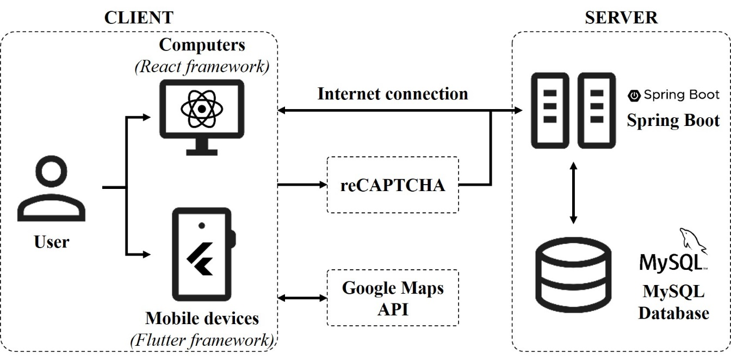

Figure 4.1. Architecture model of the system

The application is designed according to the Client–Server model, as shown in Figure 4.1 above. On the server side, there are 2 main components: The relational database, which is a MySQL database, and the Spring Boot framework to connect between clients and the MySQL database. On the client side, users can connect to the system by using web browsers, such as Google Chrome, Firefox, and Microsoft Edge, or using a mobile application from both Android and iOS operating systems to connect to the server side.

In detail, the MySQL database will store almost all important information about students’ profiles, choices, and exam results. This database also stores account information of all users and other common information related to the exam, such as the list of Secondary schools, High schools, priority groups, encouraged groups, and ethnic groups. From that information, users can use functions to create, update, or aggregate data according to their needs.

Spring Boot framework works as a bridge that connects the client side and the MySQL database. In this framework, a large number of REST APIs have been implemented to connect between the client-side and the database. Users can only use these APIs to connect without interacting directly with the database, which will make the data in the database safer.

Client-side and server-side need an internet connection to identify each other. Besides client-side and server-side, some other public APIs have been used in this application, such as Google Maps API, which is used to present the map of the office at the bottom of the web interface, and reCAPTCHA API to check the validation of some sensitive activities or DDoS, such as login or searching exam results.

## Data model of the system

The system includes 17 entities (tables), with the simplified version of Entity Relationship Diagram (ERD) represented in Figure 4.2 below.



Figure 4.2. Entity Relationship Diagram of the system (simplified version)

The overview information of each table is described in Table 4.1 below.

Table 4.1. The overview information of entities/tables in the system

|  |  |  |
| --- | --- | --- |
| **#** | **Table name** | **Main function** |
| **1** | DAN_TOC | Represents the ethnic group of students. |
| **2** | DTKK | Represents the encouraged group of students. |
| **3** | DTKK_CHUYEN | Represents the encouraged group of students if they are participating in High Schools for the Gifted. |
| **4** | DTUT | Represents the priority group of students. |
| **5** | HOC_SINH | Represents the detailed information of students. |
| **6** | KET_QUA_THI | Represents the admission result of students. |
| **7** | KQ_HOC_TAP | Represents the study results of students in the secondary school. |
| **8** | LOAI_TK | Represents the type of accounts. |
| **9** | LOP_CHUYEN | Represents the specialized class/subject that will appear in Can Tho City. |
| **10** | LOP_CHUYEN_THPT | Represents the specialized class/subject in a particular High School for the Gifted. |
| **11** | NGUYEN_VONG | Represents the admission selections/choices of students in Can Tho City. |
| **12** | PHUONG_XA | Represents the ward, commune, or special zone of a secondary school or a high school. |
| **13** | TAI_KHOAN | Represents the account of users. |
| **14** | THI_SINH | Represents the admission information of candidates participating in the exam. |
| **15** | TRANG_THAI_CSDL | Represents the database and admission state for Admission Council Officials. |
| **16** | TRUONG_THCS | Represents the list of Secondary Schools. |
| **17** | TRUONG_THPT | Represents the list of High Schools. |

The details of each entity (table) are shown from Table 4.2 to Table 4.18 below. (*In the following tables, PK means Primary Key constraint; NN means Not Null constraint; and UQ means Unique constraint.*)

Table 4.2. Table DAN_TOC

|  |  |  |  |  |  |
| --- | --- | --- | --- | --- | --- |
| **Column name** | **Data type** | **PK** | **NN** | **UQ** | **Default** |
| MA_DT | INT | x | x |  |  |
| TEN_DT | VARCHAR(255) |  | x |  |  |

Table 4.3. Table DTKK

|  |  |  |  |  |  |
| --- | --- | --- | --- | --- | --- |
| **Column name** | **Data type** | **PK** | **NN** | **UQ** | **Default** |
| MA_DTKK | INT | x | x |  |  |
| TEN_DTKK | VARCHAR(255) |  | x |  |  |
| DIEM_CONG | DECIMAL(5,2) |  | x |  | 0.00 |

Table 4.4. Table DTKK_CHUYEN

|  |  |  |  |  |  |
| --- | --- | --- | --- | --- | --- |
| **Column name** | **Data type** | **PK** | **NN** | **UQ** | **Default** |
| MA_DTKK_CHUYEN | INT | x | x |  |  |
| TEN_DTKK_CHUYEN | VARCHAR(255) |  | x |  |  |
| DIEM_CONG | DECIMAL(5,2) |  | x |  | 0.00 |

Table 4.5. Table DTUT

|  |  |  |  |  |  |
| --- | --- | --- | --- | --- | --- |
| **Column name** | **Data type** | **PK** | **NN** | **UQ** | **Default** |
| MA_DTUT | INT | x | x |  |  |
| TEN_DTUT | VARCHAR(255) |  | x |  |  |
| DIEM_CONG | DECIMAL(5,2) |  | x |  | 0.00 |

Table 4.6. Table HOC_SINH

|  |  |  |  |  |  |
| --- | --- | --- | --- | --- | --- |
| **Column name** | **Data type** | **PK** | **NN** | **UQ** | **Default** |
| MA_HS | INT | x | x |  |  |
| HO_VA_CHU_LOT_HS | VARCHAR(255) |  | x |  |  |
| TEN_HS | VARCHAR(255) |  | x |  | 0.00 |
| GIOI_TINH | TINYINT(1) |  |  |  | NULL |
| NGAY_SINH | DATE |  |  |  | NULL |
| NOI_SINH | VARCHAR(255) |  |  |  | NULL |
| MA_DT  *(FK from DAN_TOC (MA_DT))* | INT |  |  |  | 1 |
| DIA_CHI_THUONG_TRU | VARCHAR(2048) |  |  |  | NULL |
| CHO_O_HIEN_NAY | VARCHAR(2048) |  |  |  | NULL |
| MA_THCS  *(FK from TRUONG_THCS (MA_THCS))* | VARCHAR(20) |  | x |  |  |
| NAM_TOT_NGHIEP_THCS | INT |  |  |  | 2026 |
| MA_DTUT  *(FK from DTUT (MA_DTUT))* | INT |  |  |  | 0 |
| MA_DTKK  *(FK from DTKK (MA_DTKK))* | INT |  |  |  | 0 |
| MA_DTKK_CHUYEN  *(FK from DTKK_CHUYEN (MA_DTKK_CHUYEN))* | INT |  |  |  | 0 |
| NGOAI_NGU_DANG_HOC | VARCHAR(255) |  |  |  | NULL |
| NGOAI_NGU_DU_THI | VARCHAR(255) |  |  |  | NULL |
| SO_DIEN_THOAI | VARCHAR(255) |  |  |  | NULL |
| DIEM_TB_MON_CHUYEN | DECIMAL(5,2) |  |  |  | NULL |
| TONG_DIEM_TB_LOP_9 | DECIMAL(5,2) |  |  |  | NULL |
| ANH_DAI_DIEN | VARCHAR(255) |  |  |  | NULL |
| TEN_THCS_NGOAI_TPCT | VARCHAR(255) |  |  |  | NULL |
| TEN_XA_NGOAI_TPCT | VARCHAR(255) |  |  |  | NULL |
| TEN_TINH_NGOAI_TPCT | VARCHAR(255) |  |  |  | NULL |

Table 4.7. Table KET_QUA_THI

|  |  |  |  |  |  |
| --- | --- | --- | --- | --- | --- |
| **Column name** | **Data type** | **PK** | **NN** | **UQ** | **Default** |
| MA_HS  *(FK (1:1) from HOC_SINH (MA_HS))* | VARCHAR(20) | x | x |  |  |
| DIEM_TOAN | DECIMAL(5,2) |  |  |  | NULL |
| DIEM_VAN | DECIMAL(5,2) |  |  |  | NULL |
| DIEM_MON_THU_3 | DECIMAL(5,2) |  |  |  | NULL |
| DIEM_MON_CHUYEN | DECIMAL(5,2) |  |  |  | NULL |

Table 4.8. Table KQ_HOC_TAP

|  |  |  |  |  |  |
| --- | --- | --- | --- | --- | --- |
| **Column name** | **Data type** | **PK** | **NN** | **UQ** | **Default** |
| MA_HS  *(FK from HOC_SINH (MA_HS))* | VARCHAR(20) | x | x |  |  |
| LOP | INT | x | x |  |  |
| HOC_TAP | VARCHAR(50) |  | x |  |  |
| REN_LUYEN | VARCHAR(50) |  | x |  |  |

Table 4.9. Table LOAI_TK

|  |  |  |  |  |  |
| --- | --- | --- | --- | --- | --- |
| **Column name** | **Data type** | **PK** | **NN** | **UQ** | **Default** |
| MA_LOAI_TK | INT | x | x |  |  |
| TEN_LOAI_TK | VARCHAR(255) |  | x |  |  |

Table 4.10. Table LOP_CHUYEN

|  |  |  |  |  |  |
| --- | --- | --- | --- | --- | --- |
| **Column name** | **Data type** | **PK** | **NN** | **UQ** | **Default** |
| MA_LOP_CHUYEN | VARCHAR(5) | x | x |  |  |
| TEN_LOP_CHUYEN | VARCHAR(255) |  | x |  |  |
| MON_CHUYEN | VARCHAR(255) |  | x |  |  |

Table 4.11. Table LOP_CHUYEN_THPT

|  |  |  |  |  |  |
| --- | --- | --- | --- | --- | --- |
| **Column name** | **Data type** | **PK** | **NN** | **UQ** | **Default** |
| MA_THPT  *(FK from TRUONG_THPT (MA_THPT))* | VARCHAR(20) | x | x |  |  |
| MA_LOP_CHUYEN  *(FK from LOP_CHUYEN (MA_LOP_CHUYEN))* | VARCHAR(5) | x | x |  |  |
| CHI_TIEU | INT |  | x |  | 0 |

Table 4.12. Table NGUYEN_VONG

|  |  |  |  |  |  |
| --- | --- | --- | --- | --- | --- |
| **Column name** | **Data type** | **PK** | **NN** | **UQ** | **Default** |
| MA_HS  *(FK from HOC_SINH (MA_HS))* | VARCHAR(20) | x | x |  |  |
| MA_THPT  *(FK from TRUONG_THPT (MA_THPT))* | VARCHAR(20) |  | x |  |  |
| THU_TU | INT | x | x |  |  |
| NV_2B | TINYINT(1) |  |  |  | 0 |
| LOP_TIENG_PHAP | TINYINT(1) |  |  |  | 0 |
| MA_LOP_CHUYEN  *(FK from LOP_CHUYEN (MA_LOP_CHUYEN))* | VARCHAR(5) |  |  |  | NULL |
| KET_QUA | VARCHAR(255) |  |  |  | NULL |

Table 4.13. Table PHUONG_XA

|  |  |  |  |  |  |
| --- | --- | --- | --- | --- | --- |
| **Column name** | **Data type** | **PK** | **NN** | **UQ** | **Default** |
| MA_PHUONG_XA | INT | x | x |  |  |
| TEN_PHUONG_XA | VARCHAR(255) |  | x |  |  |

Table 4.14. Table TAI_KHOAN

|  |  |  |  |  |  |
| --- | --- | --- | --- | --- | --- |
| **Column name** | **Data type** | **PK** | **NN** | **UQ** | **Default** |
| TEN_TK | VARCHAR(50) | x | x |  |  |
| MAT_KHAU | VARCHAR(255) |  |  |  | NULL |
| MA_LOAI_TK  *(FK from LOAI_TK (MA_LOAI_TK))* | INT |  | x |  | 4 |
| SO_DINH_DANH | VARCHAR(20) |  |  |  | NULL |
| HASH_MAT_KHAU | VARCHAR(255) |  |  |  | NULL |
| DA_DOI_MAT_KHAU | TINYINT(1) |  |  |  | 0 |

Table 4.15. Table THI_SINH

|  |  |  |  |  |  |
| --- | --- | --- | --- | --- | --- |
| **Column name** | **Data type** | **PK** | **NN** | **UQ** | **Default** |
| MA_HS  *(FK (1:1) from HOC_SINH (MA_HS))* | VARCHAR(20) | x | x |  |  |
| MA_THPT  *(FK from TRUONG_THPT (MA_THPT))* | VARCHAR(20) |  |  |  | NULL |
| MA_LOP_CHUYEN  *(FK from LOP_CHUYEN (MA_LOP_CHUYEN))* | VARCHAR(5) |  |  |  | NULL |
| SO_BAO_DANH | VARCHAR(10) |  |  | x | NULL |
| PHONG_THI | VARCHAR(10) |  |  |  | NULL |
| PHONG_THI_CHUYEN | VARCHAR(10) |  |  |  | NULL |

Table 4.16. Table TRANG_THAI_CSDL

|  |  |  |  |  |  |
| --- | --- | --- | --- | --- | --- |
| **Column name** | **Data type** | **PK** | **NN** | **UQ** | **Default** |
| MA_TT | INT | x | x |  |  |
| TEN_TRANG_THAI | VARCHAR(255) |  | x | x |  |
| KIEU_DU_LIEU | VARCHAR(255) |  |  |  | NULL |
| GIA_TRI_BOOLEAN | TINYINT(1) |  |  |  | NULL |
| GIA_TRI_TIMESTAMP | TIMESTAMP |  |  |  | NULL |
| GIA_TRI_CHUOI | VARCHAR(255) |  |  |  | NULL |
| MO_TA | VARCHAR(255) |  |  |  | NULL |
| TG_CAP_NHAT | TIMESTAMP |  |  |  | CURRENT_  TIMESTAMP |

Table 4.17. Table TRUONG_THCS

|  |  |  |  |  |  |
| --- | --- | --- | --- | --- | --- |
| **Column name** | **Data type** | **PK** | **NN** | **UQ** | **Default** |
| MA_THCS | VARCHAR(20) | x | x |  |  |
| TEN_THCS | VARCHAR(255) |  | x |  |  |
| MA_PHUONG_XA  *(FK from PHUONG_XA (MA_PHUONG_XA))* | INT |  | x |  |  |

Table 4.18. Table TRUONG_THPT

|  |  |  |  |  |  |
| --- | --- | --- | --- | --- | --- |
| **Column name** | **Data type** | **PK** | **NN** | **UQ** | **Default** |
| MA_THPT | VARCHAR(20) | x | x |  |  |
| TEN_THPT | VARCHAR(255) |  | x |  |  |
| DIA_CHI | VARCHAR(255) |  |  |  | NULL |
| MA_PHUONG_XA  *(FK from PHUONG_XA (MA_PHUONG_XA))* | INT |  | x |  | 0 |
| CHI_TIEU | INT |  | x |  | 0 |
| THPT_CHUYEN | TINYINT(1) |  | x |  | 0 |
| TS_NGOAI_TPCT | TINYINT(1) |  | x |  | 0 |
| STT_THPT | INT |  | x |  | 0 |

# SYSTEM IMPLEMENTATION

## Web application

### Functions for Guest users

The interface of the web when users come to it for the first time is shown in Figure 5.1 below. The interface includes a background image illustrating the website and the exam time notification. At the bottom of the background image is information about important milestones in the registration process and the expected exam schedule. In the header of the interface, there are 5 buttons, which are 5 main pages and functions for guest users: Home, Search admission result (*Tra cứu kết quả*), Admission numbers (*Chỉ tiêu tuyển sinh*), Admission documents (*Văn bản về kỳ thi*) and Login (*Đăng nhập*).

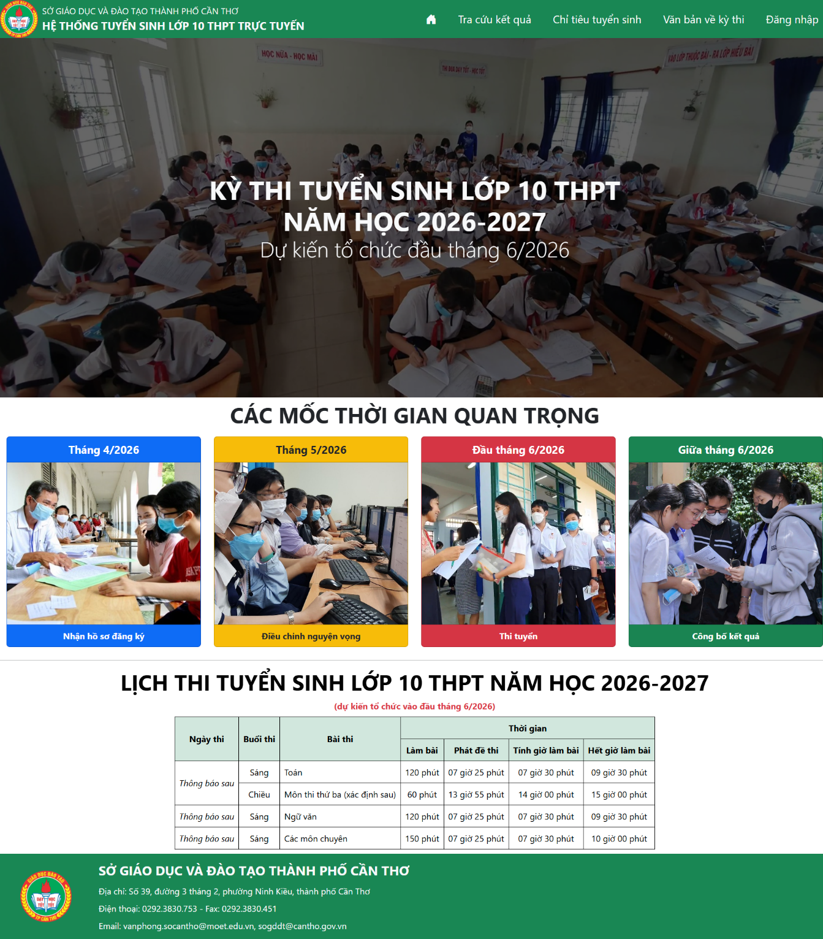

Figure 5.1. The homepage web interface

In the footer of the interface, beside the information of the Department of Education and Training of the city, there is also a map that represents the address of the office, as shown in Figure 5.2 below.

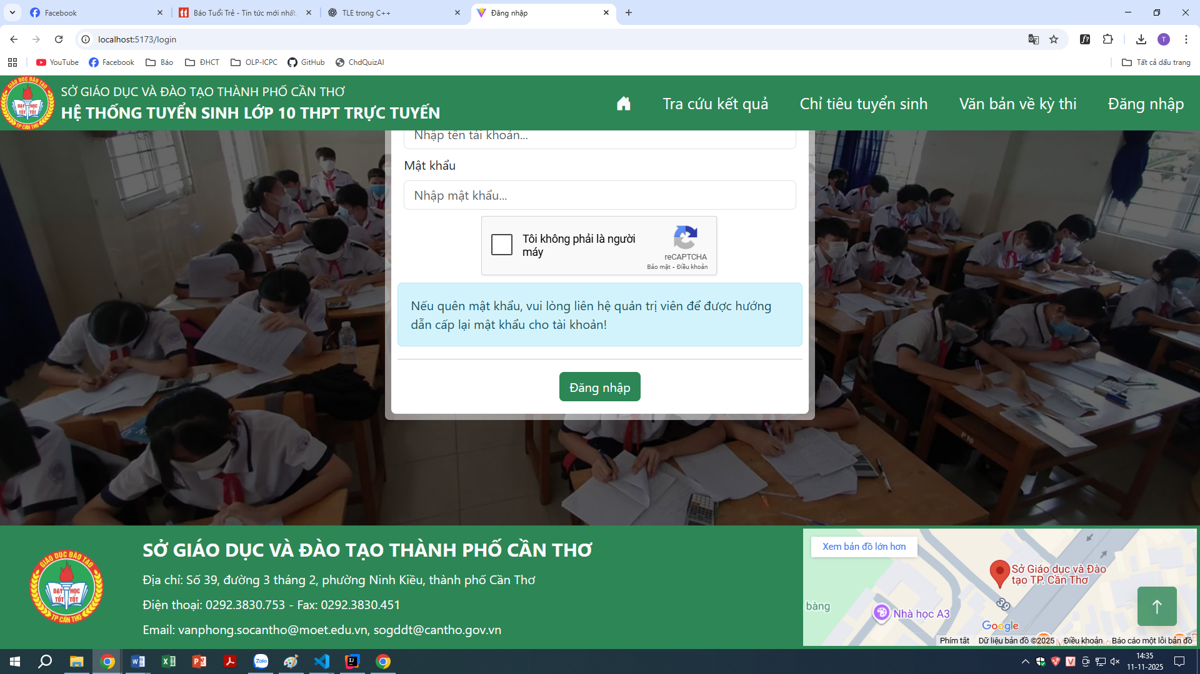

Figure 5.2. The footer of the web interface

When users click on the Search Admission Result button, the interface of this function is shown in Figure 5.3 below. To search the admission result, users need to choose the high school in the first dropdown and choose the search type in the second dropdown. There are 3 search types, which are searching by student ID, searching by students’ full name, and searching by candidate number. After that, users type the search content in the textbox. After choosing and typing, users need to click on the reCAPTCHA button to verify that “I’m not a robot” before clicking on the Search (*Tìm kiếm*) button to find the admission result.

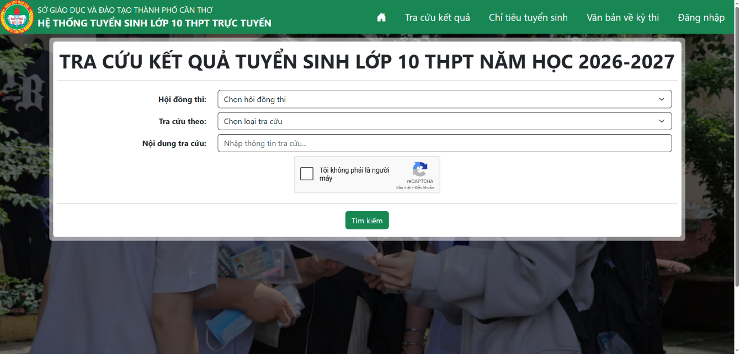

Figure 5.3. Search Admission Result interface

If there is only one student whose information matches the user’s search requirement, it will show the full result of this student, with the student’s full name, secondary school, scores of each subject, extra scores, and total score. It will also show whether the student has passed the examination and been admitted to any high school included in his/her choices, as shown in Figure 5.4 below.

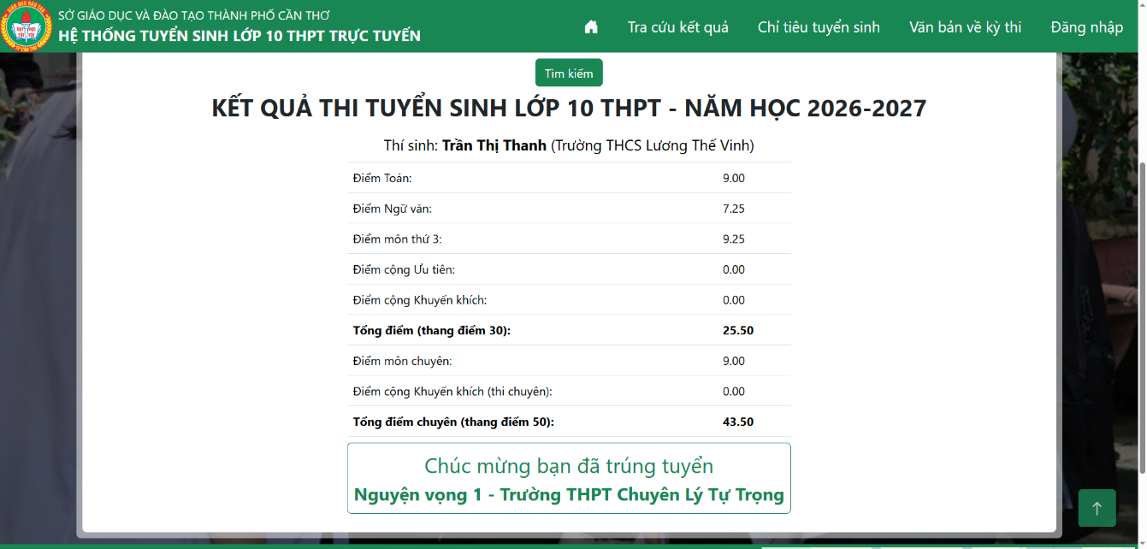

Figure 5.4. The Search Result interface with only one student

If there is more than one student whose information matches the user’s search requirement, it will show the list of students with the overview information of each student. Users then need to choose one of them to show the student’s detailed result they want to see, as shown in Figure 5.5 below.

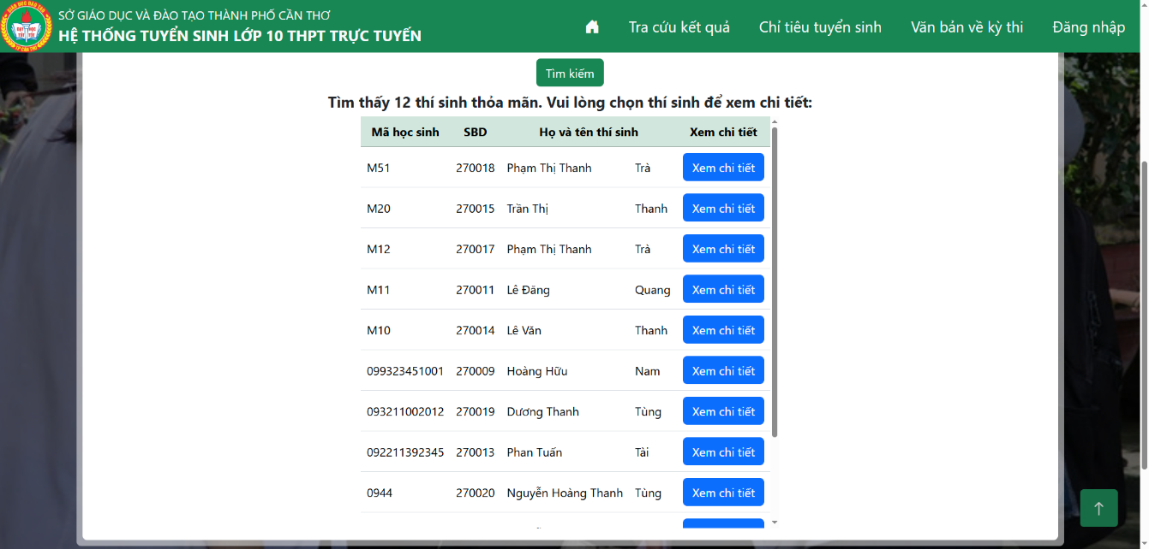

Figure 5.5. The Search Result page with more than one student

When users click on the Admission Numbers button, the interface of this function is shown in Figure 5.6 below. On this page, users will see the admission number of each high school in Can Tho City according to the official documents of the Department of Education and Training of Can Tho City. Each card contains the high school’s name, address, the number of students registered at this school, and the admission number of this school.

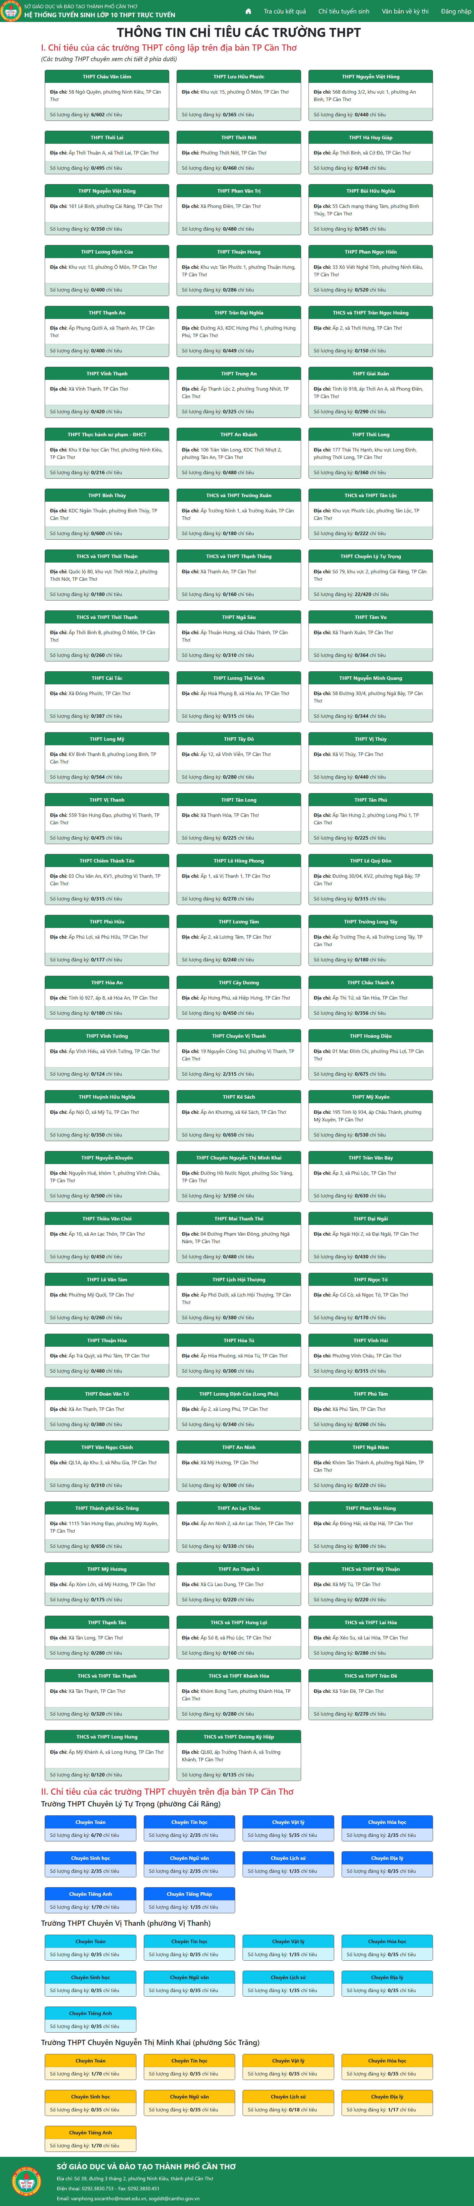

Figure 5.6. Admission Numbers interface

Also, with some high schools for gifted students, the admission number is divided by specialized subjects, as shown in Figure 5.7 below.



Figure 5.7. Admission Information of High School for the Gifted

When users click on the Admission Documents button, the interface of this function is shown in Figure 5.8 below. When users choose one of the documents shown, it will show a window to show the document details. Users can also open this document in a new tab by clicking on the Open document (*Mở văn bản*) button.

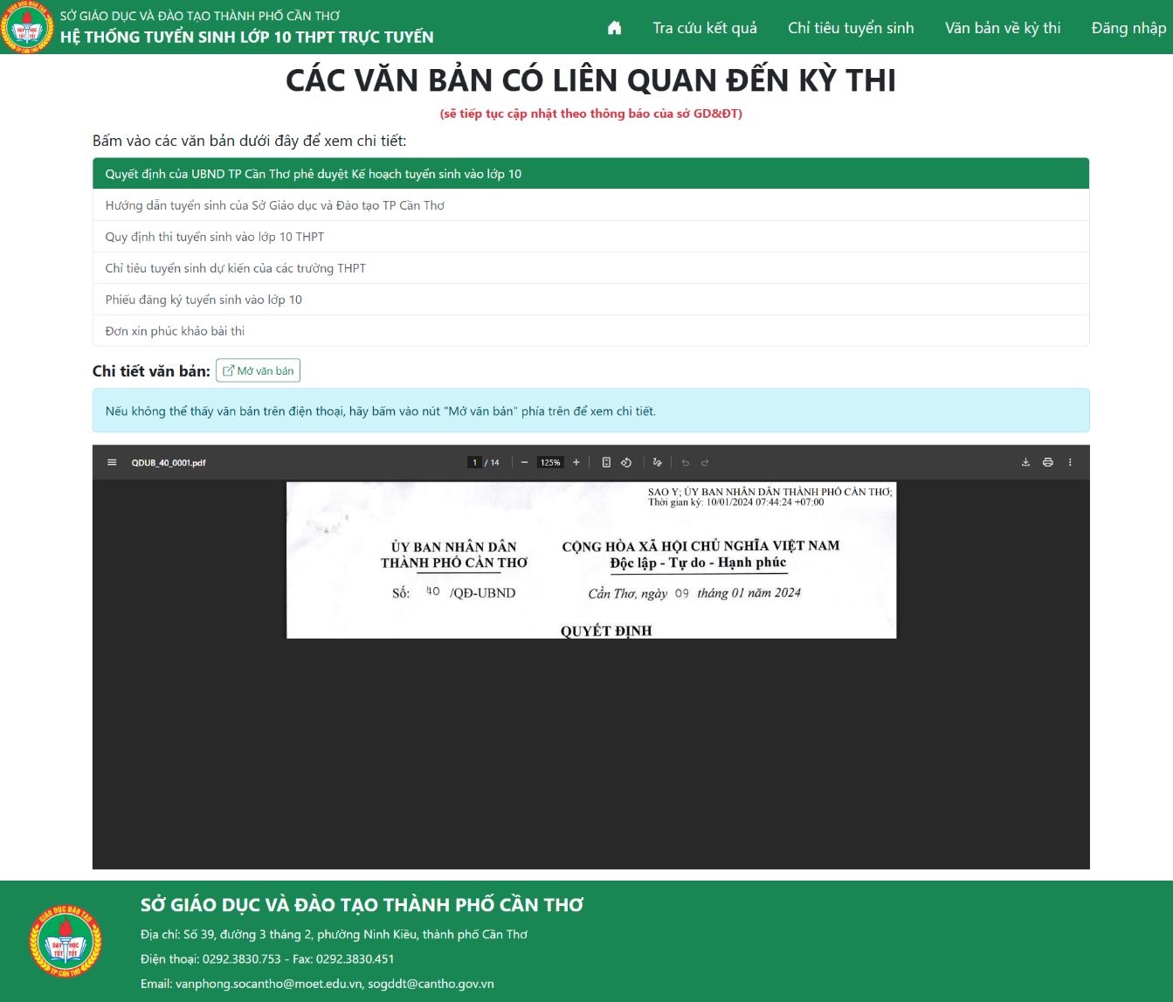

Figure 5.8. Admission Documents interface

When users click on the Login button, the interface of this function is shown in Figure 5.9 below. Users need to have an account given by teachers or administrators of the Department of Education and Training. Users need to log in by typing their username and password of their account, then click on the reCAPTCHA button to verify “I’m not a robot” before logging in by pressing the Login (*Đăng nhập*) button. If the username and password are matched, users will be redirected to the page according to their role; otherwise, it will show an error message, and users need to retype their username and password.

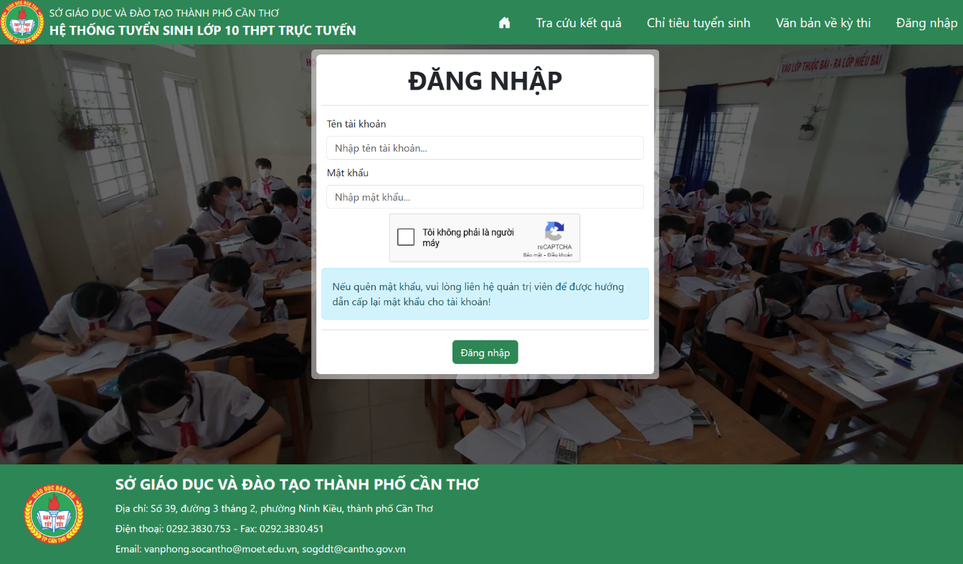

Figure 5.9. Login interface

### Functions for Administrators

The Administrator’s homepage after logging in is shown in Figure 5.10 below. Administrators have one main subsystem, which is Account Management (*Quản lý tài khoản*).

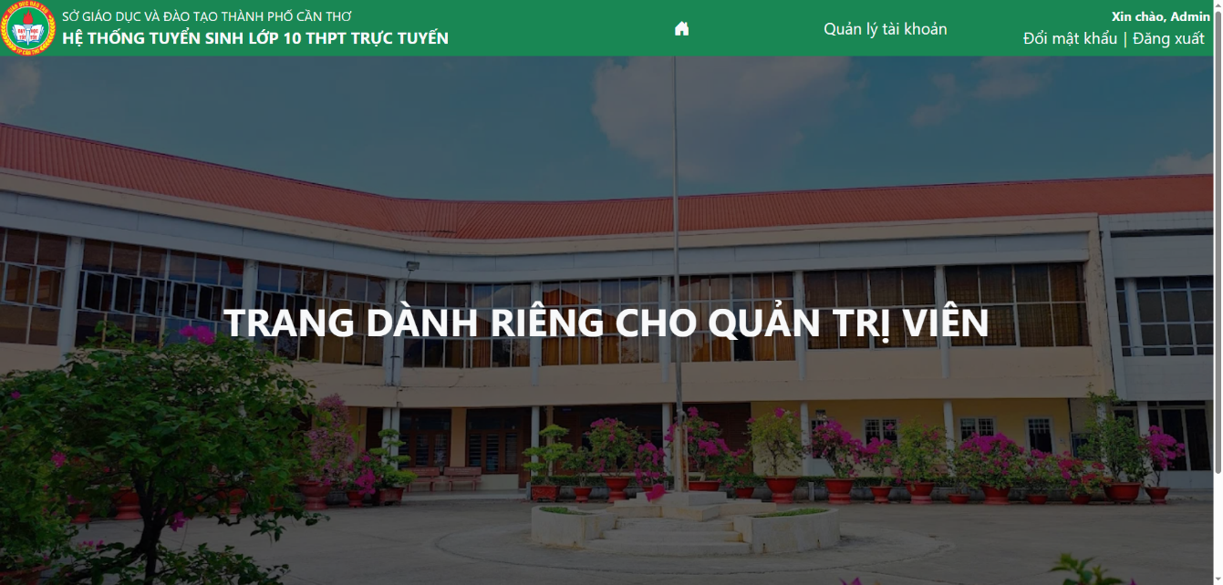

Figure 5.10. Administrator’s homepage

The homepage of the Account Management subsystem is shown in Figure 5.11 below. In this page, the main content includes a search box for users to find accounts that have a similar name or ID. There is also a table showing the list of accounts according to the user’s keyword. If the search box is empty, it will show all accounts existing in the system. If there are no accounts that match the keyword, it will show the message that no accounts exist. Users can also refresh the search box to show the full accounts list as the default.

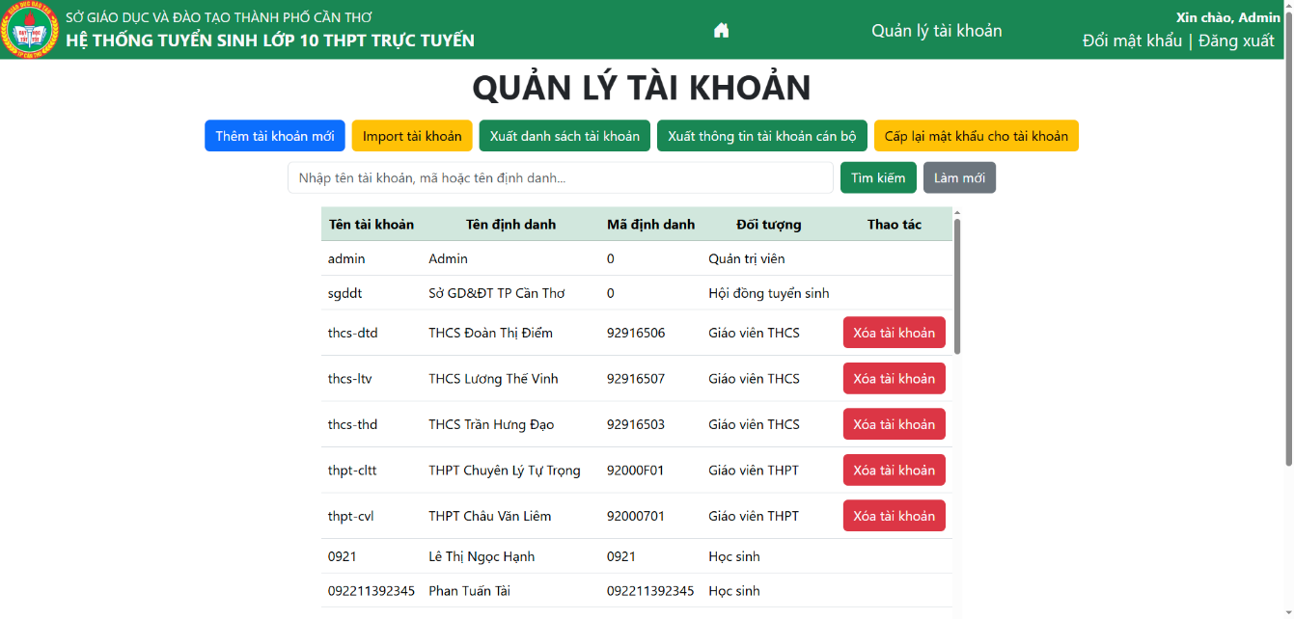

Figure 5.11. Account Management homepage

Administrators can also delete accounts by clicking on the Delete account (*Xóa tài khoản*) button. After clicking, it will show a confirmation dialog as Figure 5.12 below. If users want to delete this account, they can click on the Delete (Xóa) button to confirm. (Administrators can only delete accounts of Secondary School and High School Officials for safety reasons.)

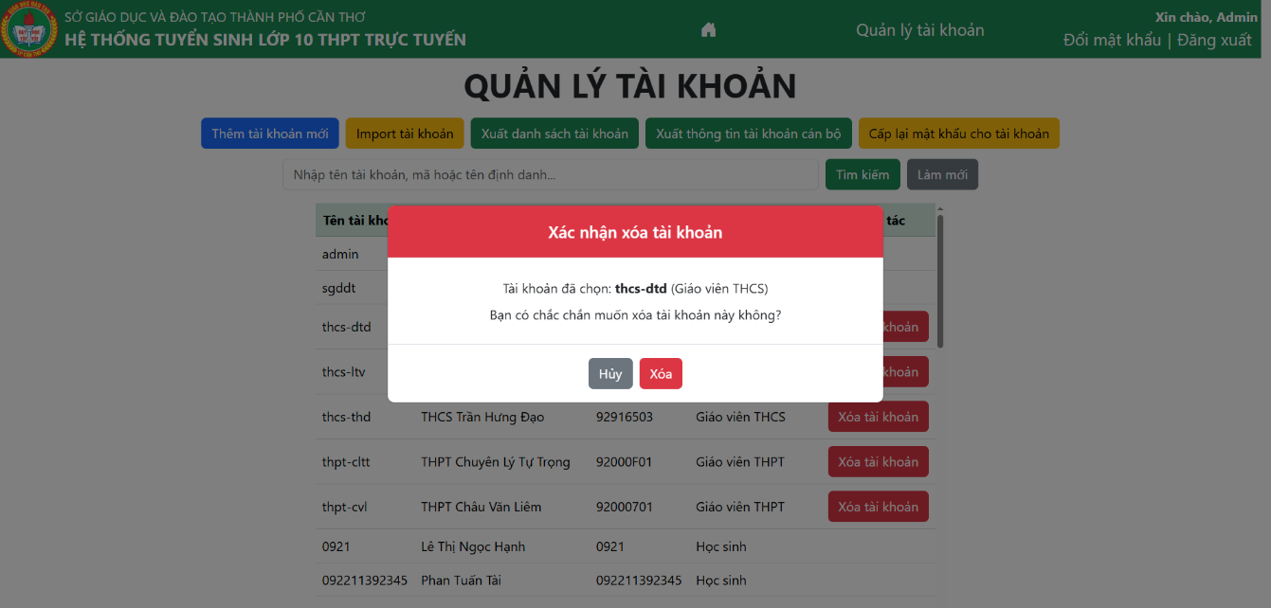

Figure 5.12. Confirmation dialog for deleting an account

Besides, administrators can also add new accounts in 2 ways: adding a new account manually, or using an Excel file to import multiple accounts at a time. If administrators want to add a new account manually, they can click on the Add new account (*Thêm tài khoản mới*) button to go to the Add Account page. The interface of this page is shown in Figure 5.13 below. To add a new account, users need to provide the username and the user type (including 2 types: Secondary School Officials and High School Officials). With each type, the system will then show a list of schools that satisfy the user type that users have chosen. After that, the user can click on Add account to confirm. If the account can be added, a default password will be provided for this user, and it will show a success message to administrators.

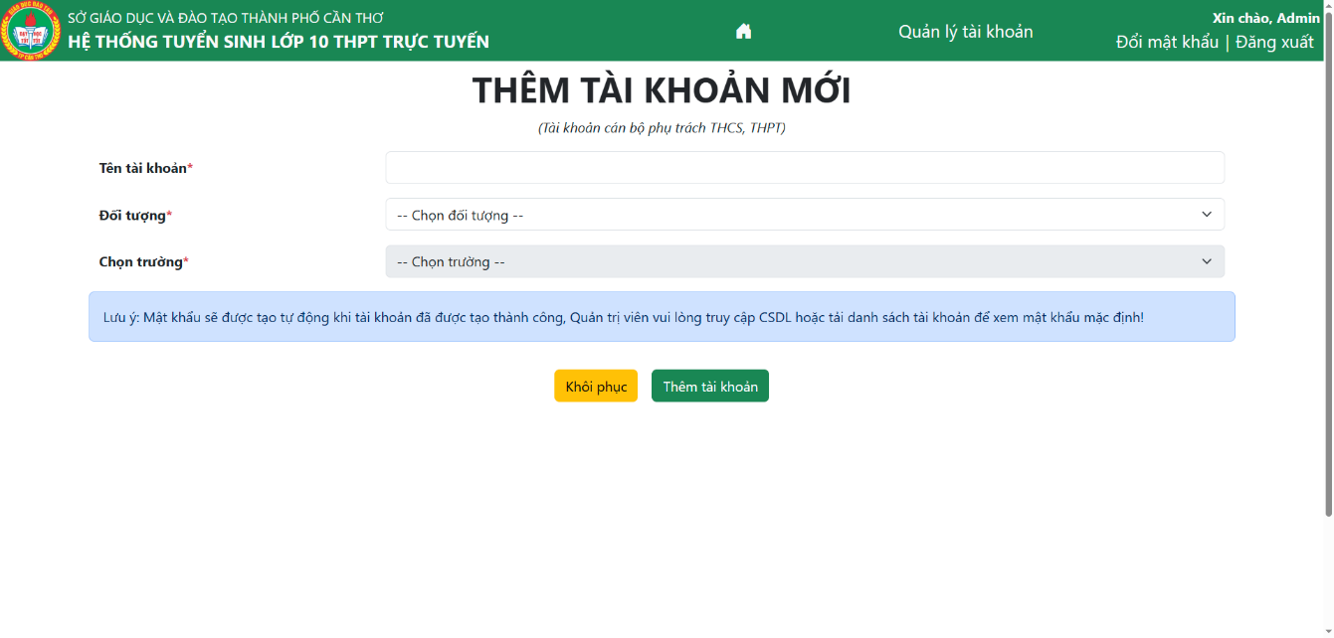

Figure 5.13. Add Account page

If users want to import accounts, after clicking on the Import accounts (Import tài khoản) button, a dialog will be shown as Figure 5.14 below. To import accounts, administrators need to install Excel templates first by clicking on the Install template here (*Tải file mẫu tại đây*) button. After that, they can type on that template to add new accounts with 3 pieces of information: Username, user type, ID, before importing into the dialog above and clicking “Import” (*Thực hiện import*). After that, it will show how many accounts have been imported successfully and how many errors are in the Excel file they have imported.

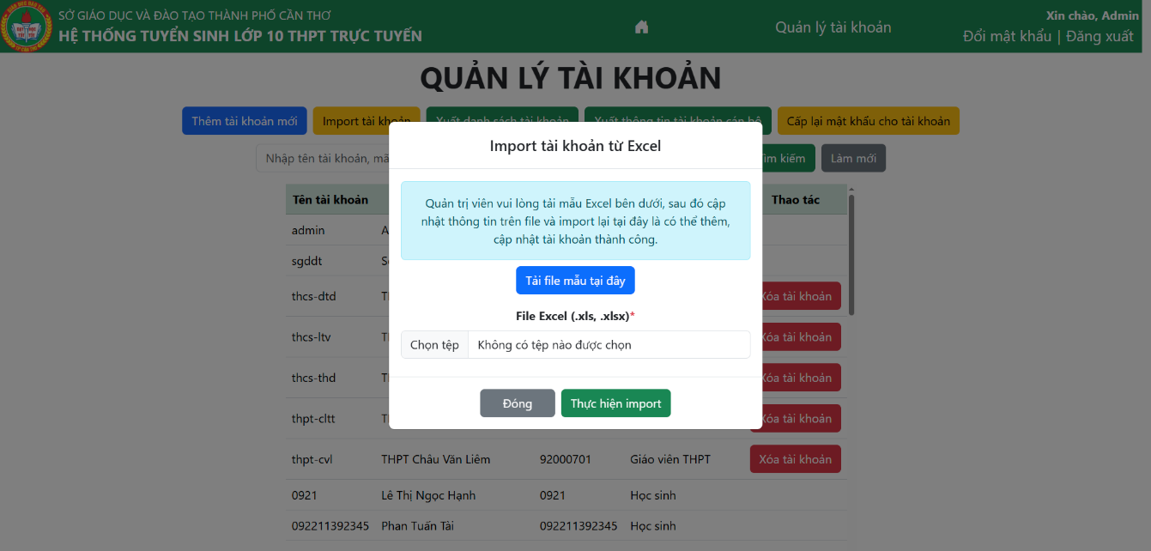

Figure 5.14. Dialog for importing accounts

To export account information, administrators can also use 2 functions, which are Export account list (*Xuất danh sách tài khoản*) and Export official’s accounts (*Xuất thông tin tài khoản cán bộ*). The Export account list function will export all accounts in the system with only simple information about those accounts, such as username, identification name, ID number, and role, while the Export officials’ accounts function will export all accounts with default passwords for officials to log in to the system. This is an important function because administrators need to transfer this file to all officials in Can Tho City and give them an account to connect to this system and perform other tasks related to admission.

Administrators can also reset the password for users by clicking on the Reset password (*Cấp lại mật khẩu cho tài khoản*) button. After clicking, it will show a dialog as Figure 5.15 below. They will need to type the username of the account that users want to reset the password and click the Reset password (*Cấp lại mật khẩu*) button to reset the password. When the process finishes, it will show the new password for administrators, and they will send this new password to users.

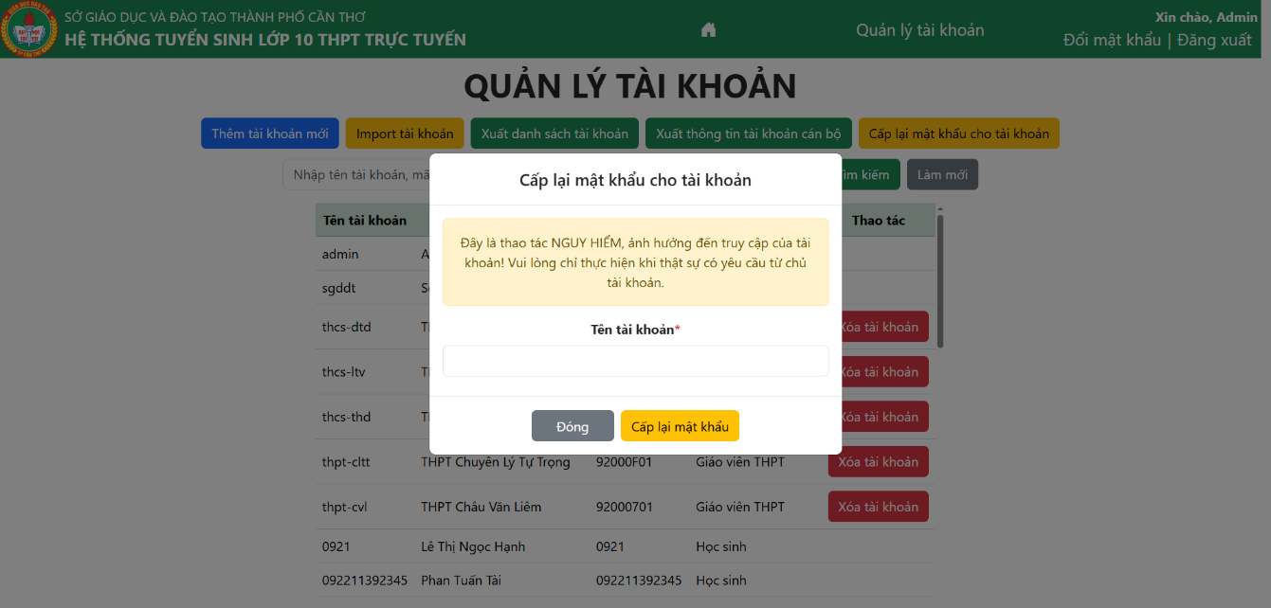

Figure 5.15. Reset password dialog

Administrators can also change their current password by clicking on the Change password (*Đổi mật khẩu*) button on the header of the page. The interface for this function is shown in Figure 5.16 below. Administrators need to type their current password, the new password and the confirmation of their new password before clicking on the Save button. After clicking the button, a message will be shown to notify users that their password has been changed successfully.

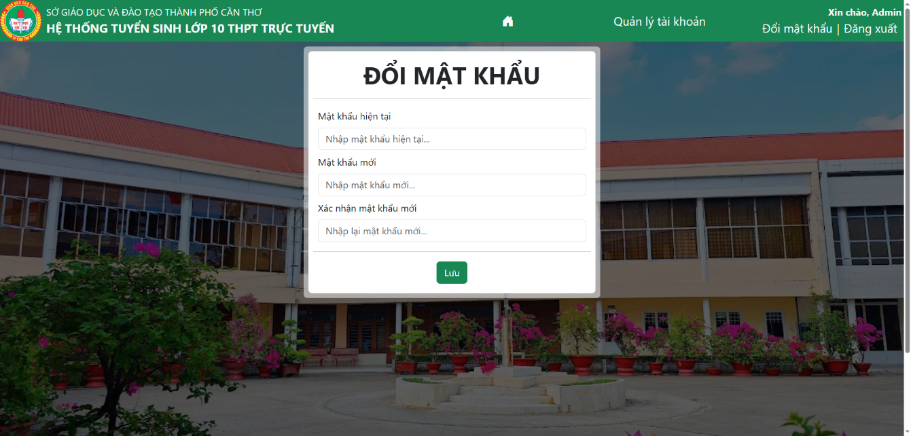

Figure 5.16. Change Password page

### Functions for Admissions Council Officials

The Admissions Council Official’s homepage after logging in to the system is shown in Figure 5.17 below. Admissions Council Officials have two main subsystems, which are Student Management (*Quản lý thí sinh*) and State Management (*Quản lý trạng thái*).

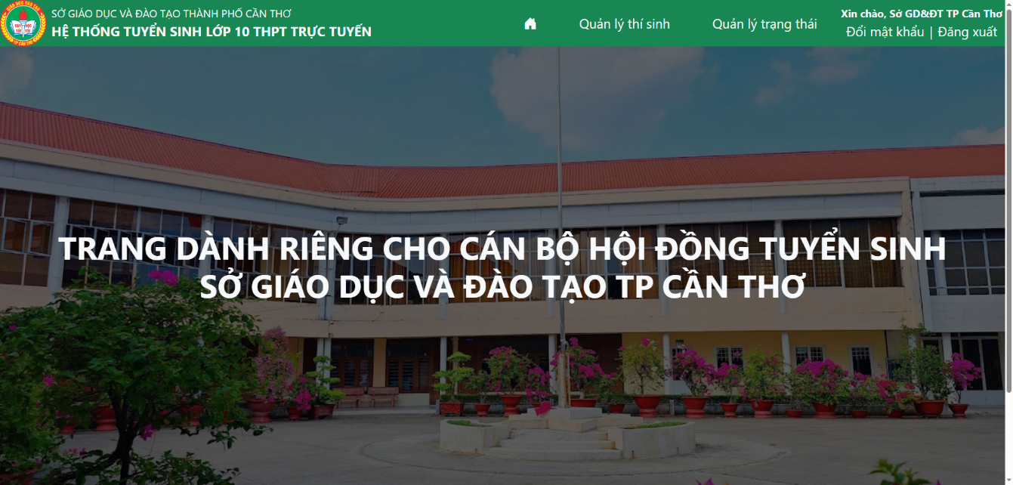

Figure 5.17. Admissions Council Official’s homepage

The homepage interface of the Student Management subsystem is shown in Figure 5.18 below. In this page, the main content includes a search box for users to find students by student ID, candidate number, or the student’s full name. There is also a table showing the list of students according to the user’s keyword. By default, it will show all students and their scores in the system. If there are no students whose information matches the keyword, it will show the message that no student exists. Officials can also refresh the search box to show the full candidate list as the default.

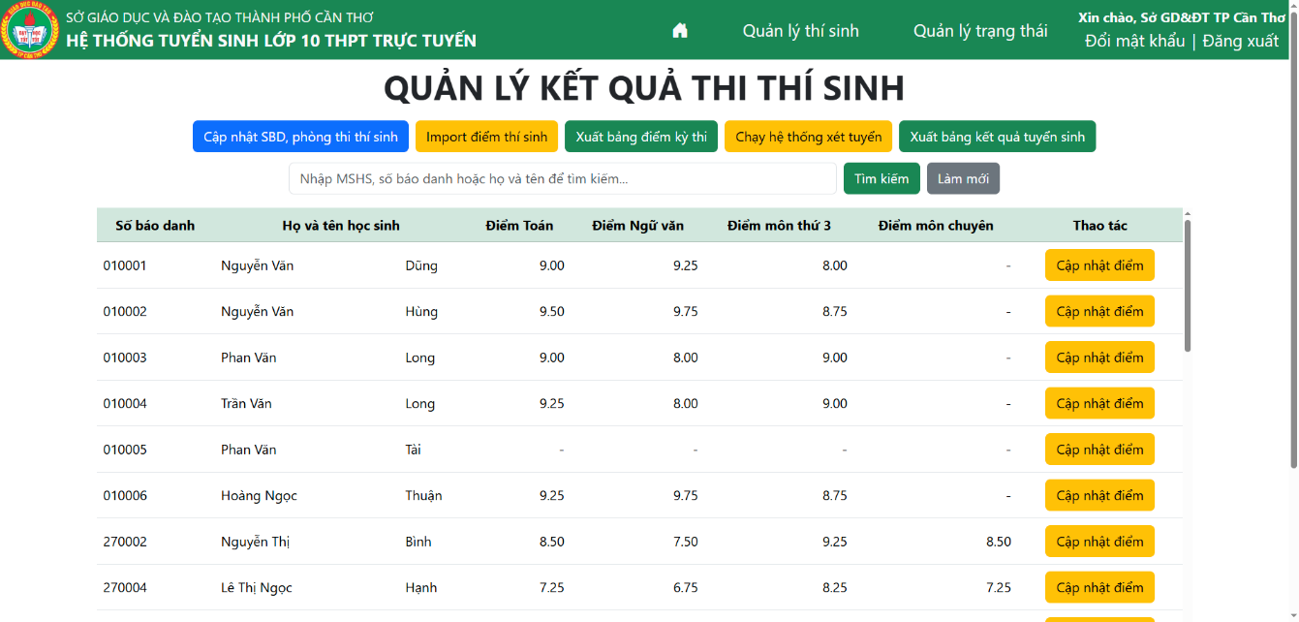

Figure 5.18. Student Management homepage

To update the student’s score, each student needs to have a candidate number. This can be done by clicking on Setting candidate number and exam room for students (*Cập nhật số báo danh, phòng thi thí sinh*). It will sort the student list by the high school students who have registered, then by their name to set the candidate number and exam room for all students registered in Can Tho City. After that, users can click on the Update score (*Cập nhật điểm*) button of the students they want to update. The interface of this function is shown in Figure 5.19 below.

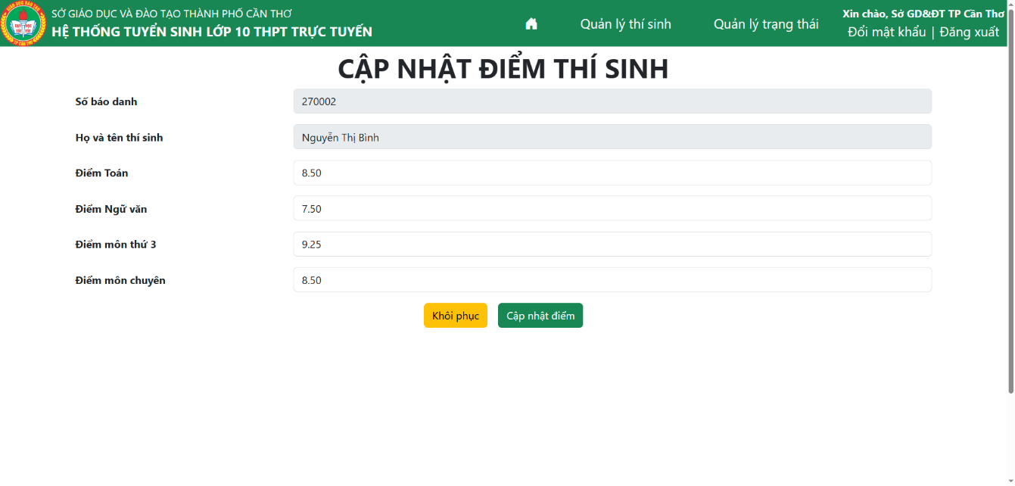

Figure 5.19. Update Student’s Score page

The interface will show the student’s information and his/her current score. Officials can update the score by changing any of their scores in each text box before clicking on the Update score (*Cập nhật điểm*) button to save. (Note that if students have not chosen any High school for the Gifted, the Specialized score (*Điểm môn chuyên*) will be disabled, so users cannot modify this score.)

Besides updating scores manually, users can also import scores from an Excel file. Users can export the current scoreboard by clicking on Export exam scoreboard (*Xuất bảng điểm kỳ thi*) to use as a template to update scores. After that, officials can update the file, then import by clicking on the Import scores (*Import điểm thí sinh*) button. A dialog will be shown as Figure 5.20 below. Users then choose the file they have updated and click on Import (*Thực hiện import*) to start the process. After finishing, it will show the result, including the number of successful students who have been updated and the number of errors while importing.

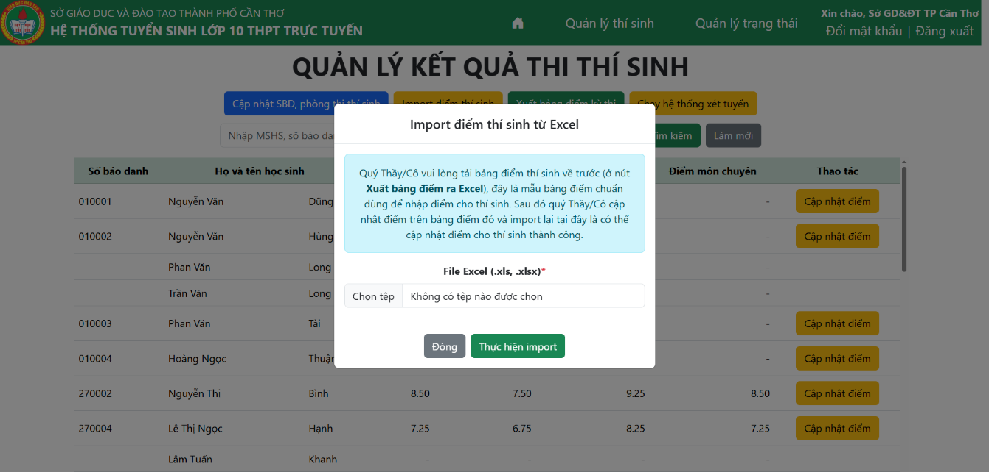

Figure 5.20. Import Student’s Score

Officials can also click on Run the admission system (*Chạy hệ thống xét tuyển*), which will run the admission process by looping through each student’s choices (including five choices) and then assign them to the suitable high school according to their scores, the choices order, and the admission number of each school. After finishing, it will show a message to notify that the admission process has been finished. After that, they can click on Export admission result (*Xuất bảng kết quả tuyển sinh*) to install the detailed result of all students in Can Tho City.

The State Management subsystem homepage is shown in Figure 5.21 below. The interface will show some important states of the admission process. Some of them will be expressed as a Boolean state, while others will be expressed as a Timestamp state.

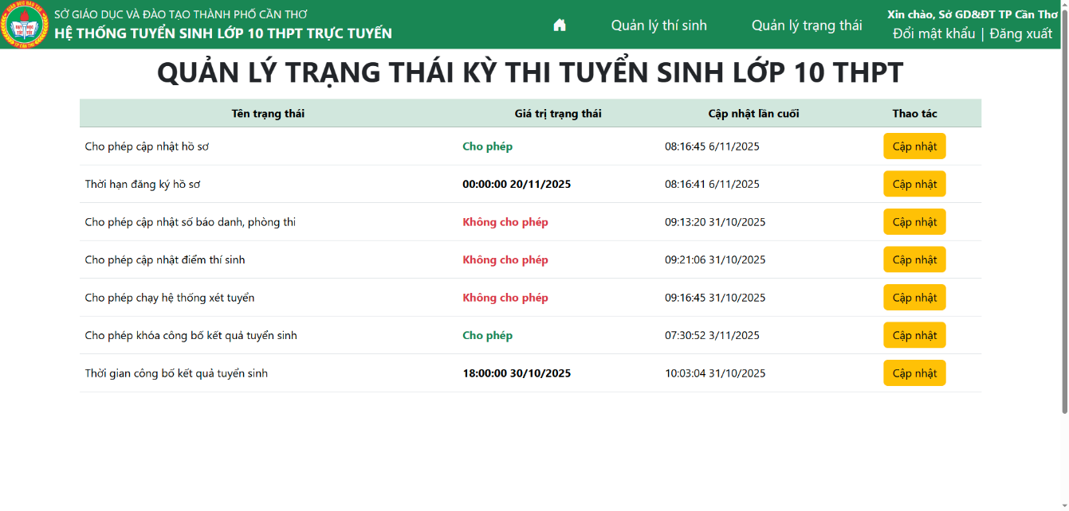

Figure 5.21. State Management homepage

If users want to update the state, they can click on the Update (*Cập nhật*) button of the state that officials want to update. A dialog will be shown as Figure 5.22 below, depending on the state type of data. With a Boolean state, users will choose from a dropdown value they want to assign now, while with a Timestamp state, users will type or choose the date and time for the state, before clicking the Update (*Cập nhật*) button to save. (Note that this state will be important for all user types, because some functions will be hidden or cannot be done if the state is not validated.)

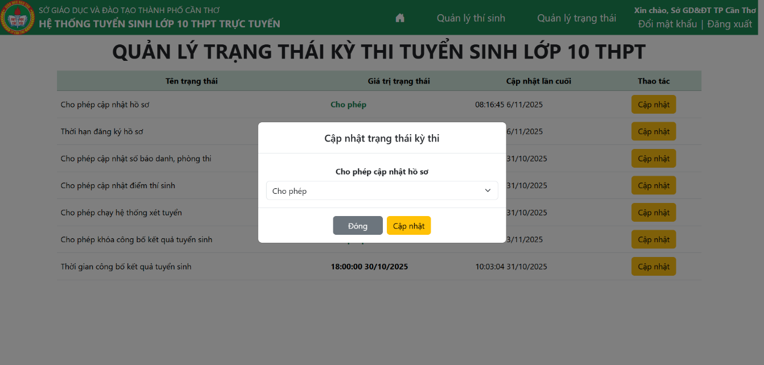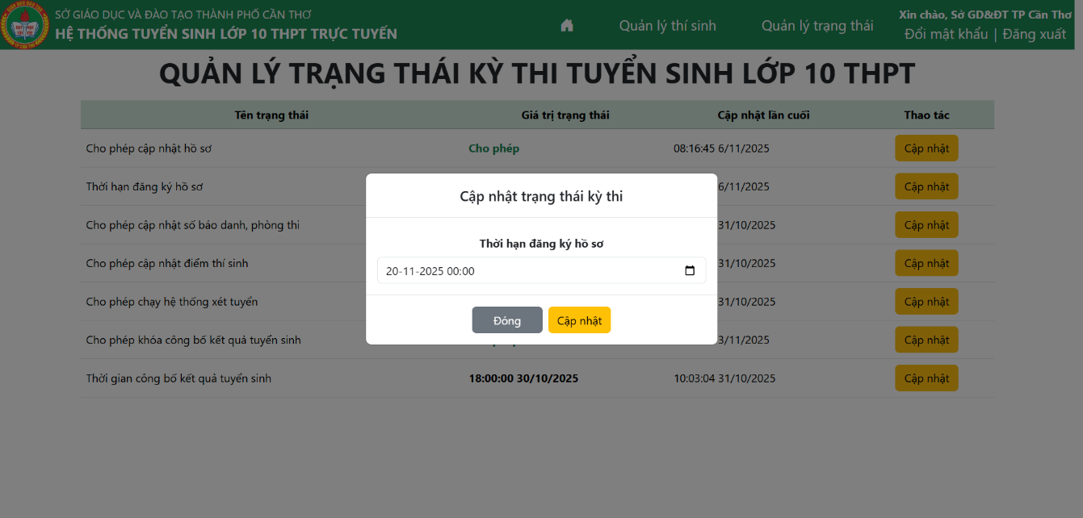

Figure 5.22. Update State dialogs (for Boolean and Timestamp states)

Officials can also change their current password by clicking on the Change password (*Đổi mật khẩu*) button on the header of the page. This function is similar to the function of Administrators, which has been presented in part 5.1.2 above.

### Functions for Secondary School Officials

The Secondary School Official’s homepage after logging in is shown in Figure 5.23 below. Secondary School Officials have one main subsystem, which is Student Management (*Quản lý học sinh*).

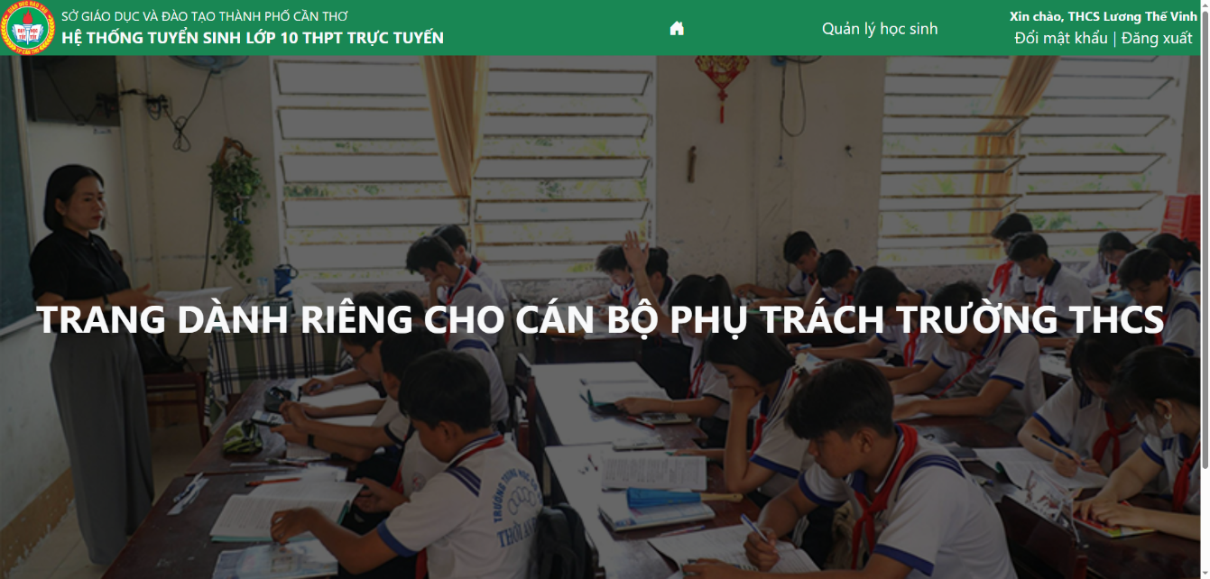

Figure 5.23. Secondary School Official’s homepage

The homepage of the Student Management subsystem is shown in Figure 5.24 below. In this page, the main content includes a search box for officials to find students who have a similar name or ID. There is also a table showing the list of students according to the user’s keyword. By default, it will show all students registered in the user’s secondary school. If there are no students that satisfy the keyword, it will show the message that no students exist. They can also refresh the search box to show the full list of students as the default. With each student, officials can choose the Detailed Information (*Xem chi tiết*) function to see the detailed profile of this student, the Update (*Cập nhật*) function to update the student profile, or the Delete student (*Xóa*) function to delete this student from the list.

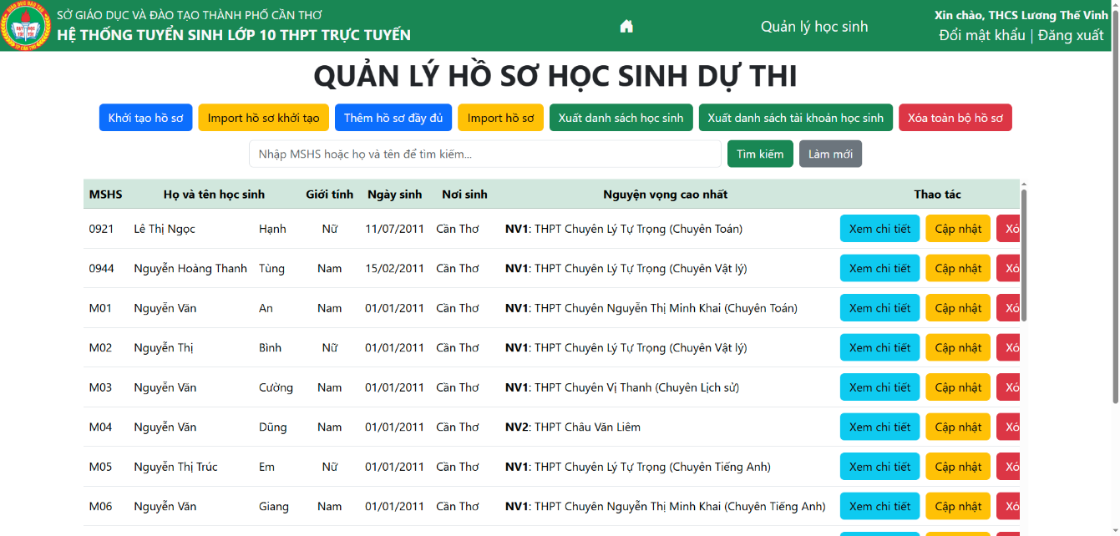

Figure 5.24. Student Management homepage

The Detailed Information page is shown in Figure 5.25 below. This page will show the detailed information of a student studying in the user’s secondary school. The structure of this page includes 3 parts, which are similar to the actual register form of the Department of Education and Training.

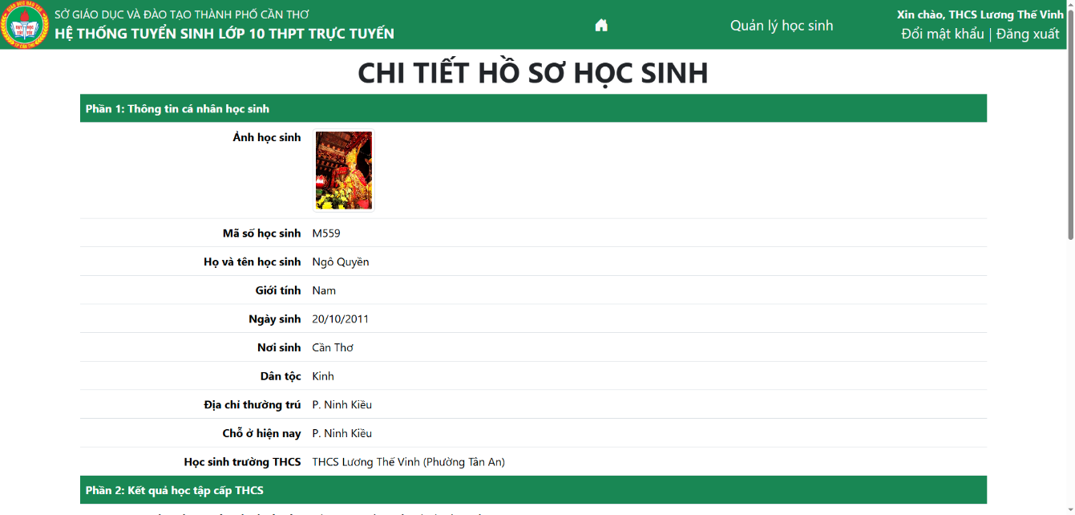

Figure 5.25. Detailed Information page

The Update page is shown in Figure 5.26 below. This page will show all detailed information about a student, and officials can also update the student’s information that they want to modify by clicking on textboxes and form fields. After modifying, officials click on the Update profile (*Cập nhật hồ sơ*) button to confirm.

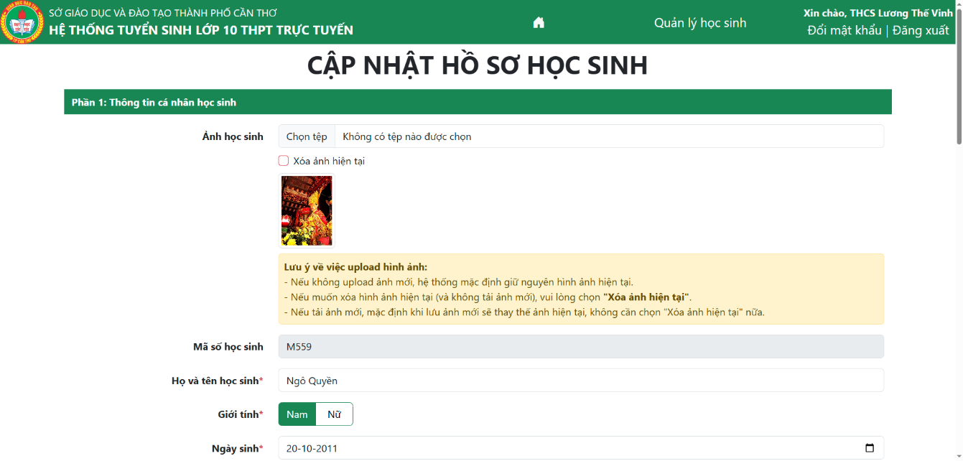

Figure 5.26. Update Students page

When officials click on the Delete students button, it will show a dialog as shown in Figure 5.27 below. If they want to delete this student, they can click on the Delete (*Xóa*) button to confirm; otherwise, they can click on the Undo (*Hủy*) button to close the dialog.

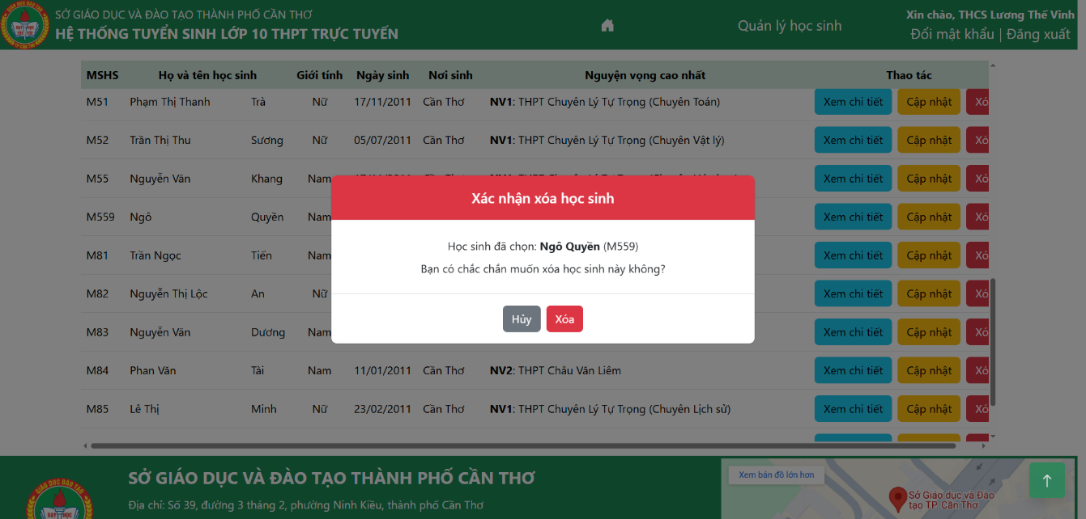

Figure 5.27. Confirmation dialog to delete a student

Besides the above functions used for each student, officials can also use some functions in the button row above the search box. If they want to add new students to the list, there are four ways to do that: Initiate student profile (*Khởi tạo hồ sơ*), Import initial student profile (*Import hồ sơ khởi tạo*), Add student profile (*Thêm hồ sơ đầy đủ*), and Import student profile (*Import hồ sơ*).

The Initiate Student Profile page is shown in Figure 5.28 below. Officials can add some initial information about the student (student ID, full name, gender, date of birth, birthplace, secondary school) and then click on the Submit button to confirm.

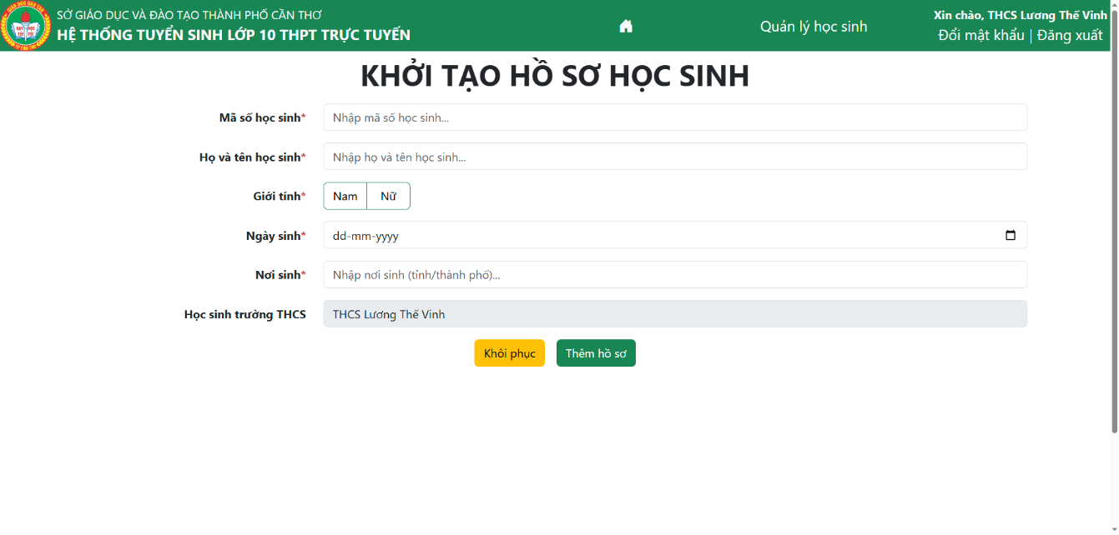

Figure 5.28. Initiate Student Profile page

The Add Student Profile page is shown in Figure 5.29 below. Users will type in all textboxes with (*) showing that this is a mandatory field and needs to be typed before submitting. After typing in all fields, users can click on the Add profile (*Thêm hồ sơ*) button to confirm and add a new student to the system.

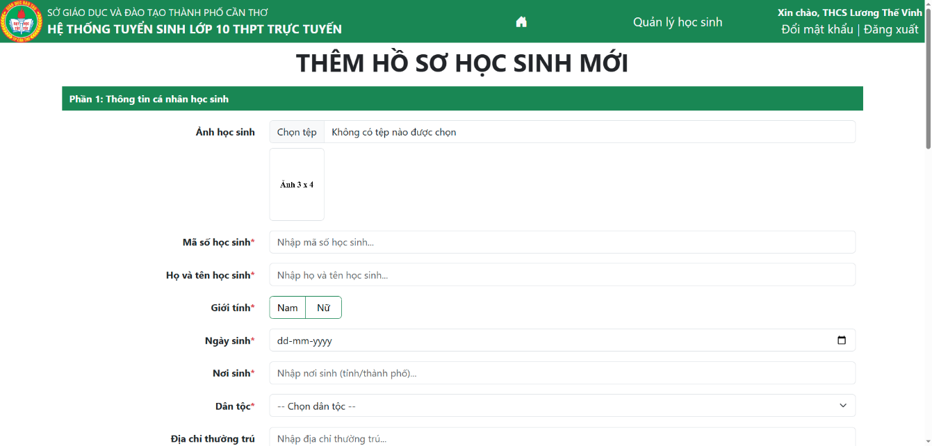

Figure 5.29. Add Student Profile page

Besides adding manually, users can also import a student profile by using two import buttons: Import Initial Student Profile (*Import hồ sơ khởi tạo*) and Import Student Profile (*Import hồ sơ*). The Import Initial Student Profile dialog is shown in Figure 5.30 below. With this function, officials need to install the template by clicking the Install template here (*Tải file mẫu tại đây*) button and add initial information of students before importing and uploading that file back to this dialog, then click on the Import (*Thực hiện import*) button to confirm. After importing, it will show the number of students’ profiles imported successfully and errors while importing.

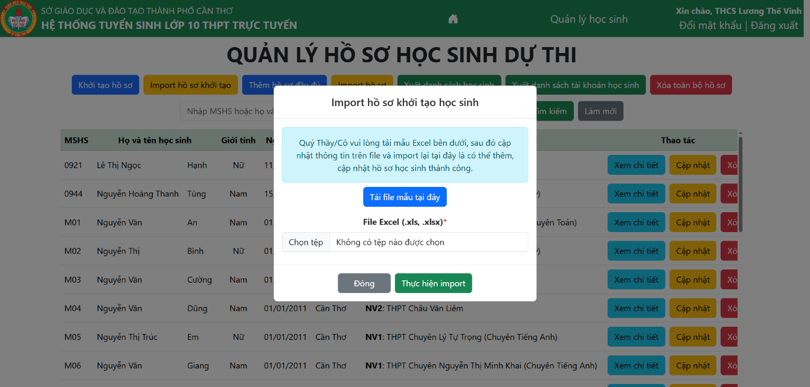

Figure 5.30. Import Initial Student Profile dialog

The Import Student Profile dialog is shown in Figure 5.31 below. With this function, officials need to install the template by clicking Install template here (*Tải file mẫu tại đây*) and then add information about students in an Excel file before importing and uploading that file back to this dialog. Besides that, officials should upload a ZIP file including students’ avatars and upload that also in this dialog (this is optional) and click on the Import (*Thực hiện import*) button to confirm. After importing, it will show the number of students’ profiles imported successfully and the errors while importing. This function can also be used for updating multiple students at a time because it will only need to update existing students in the list and add them if they do not exist in the list.

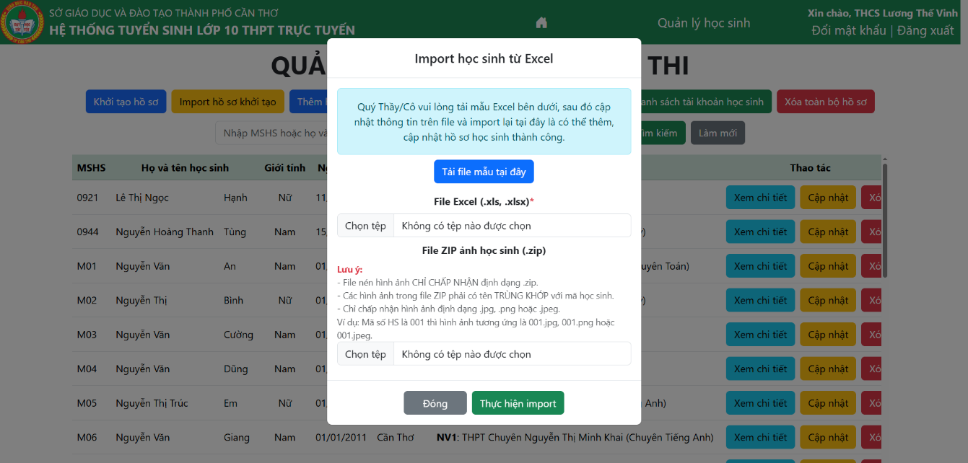

Figure 5.31. Import Student Profile dialog

Officials can also use two functions to export data, which are Export student list (*Xuất danh sách học sinh*) and Export student’s account (*Xuất danh sách tài khoản học sinh*). The difference between those functions is that while Export student list will export all detailed information of all students this secondary school is managing, Export student’s account will only export the student’s account list and the default password for each account. Officials can use this function to give accounts for students to connect to this system and modify information if they need to update.

Officials can also use the Delete all students (*Xóa toàn bộ hồ sơ*) function to delete all students in their secondary school. This function’s dialog after clicking on this button is shown in Figure 5.32 below. If they want to delete all, they can click on the Delete (*Xóa*) button to confirm, or click on Undo (*Hủy*) to close the dialog.

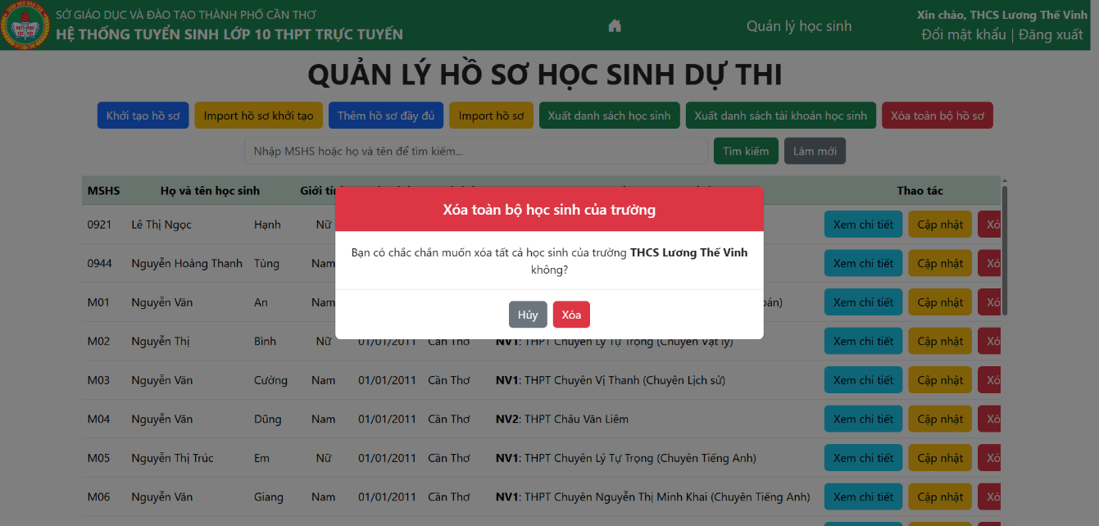

Figure 5.32. Delete All Students dialog

Officials can also change their current password by clicking on the Change password (*Đổi mật khẩu*) button on the header of the page. This function is similar to the function of Administrators, which has been presented in part 5.1.2 above.

### Functions for High School Officials

The High School Official’s homepage after logging in is shown in Figure 5.33 below. High School Officials have two main subsystems: Profile Management (*Quản lý hồ sơ*) and Candidate Management (*Quản lý thí sinh*). The Candidate Management subsystem is only available for high schools that admit students in both Can Tho City and outside Can Tho City; other high schools will not have this function.

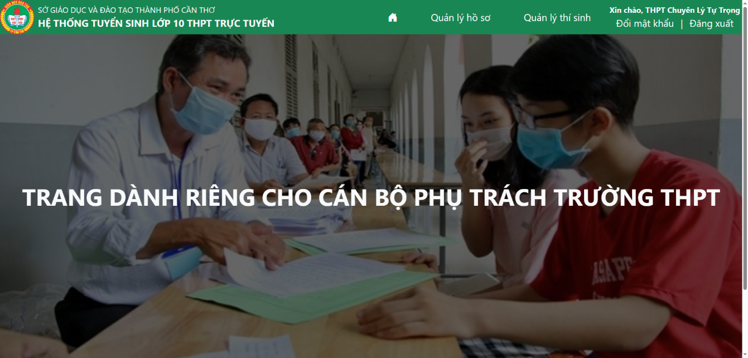

Figure 5.33. High School Official’s homepage

The Profile Management subsystem homepage is shown in Figure 5.34 below. The main content of this page includes a search box for users to find students (outside Can Tho City) with a similar name or ID. There is also a table showing the list of students according to the user’s keyword. If the search box is empty, it will show all students registered in the user’s secondary school. If there are no students that match the keyword, it will show a message that no students exist. Officials can also refresh the search box to show the full list of students as the default. With each student, officials can choose the See detailed information (*Xem chi tiết*) function to see the detailed profile of this student, the Update (*Cập nhật*) function to update the student’s profile, or the Delete student (*Xóa*) button to delete this student from the list. The difference is that the table will show a column named Secondary school (*Trường THCS*), which is the place to show the full secondary school name and the address of this school for retrieving information.

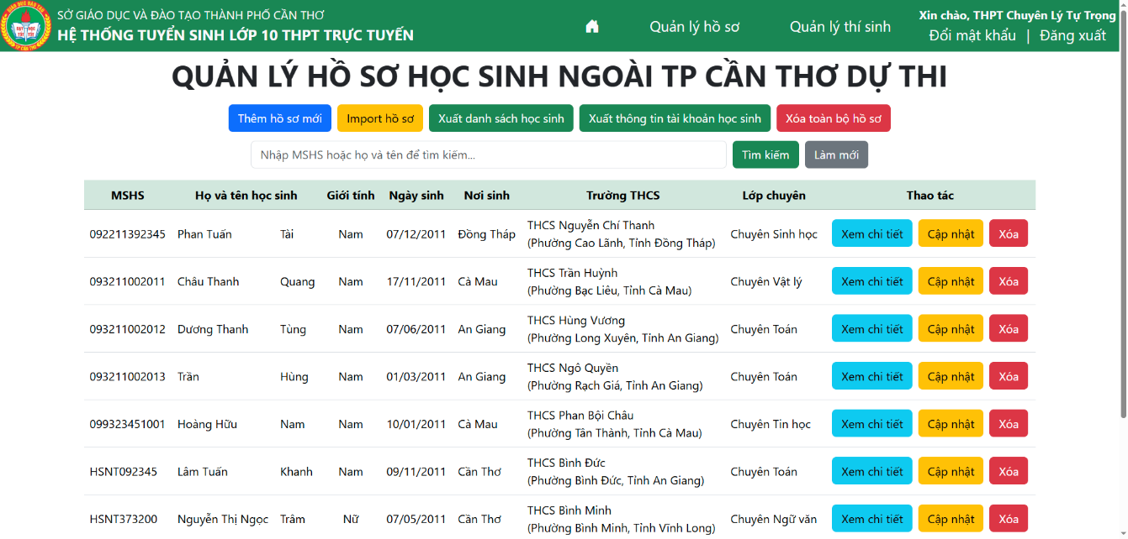

Figure 5.34. Profile Management homepage

The Detailed Information page is shown in Figure 5.35 below. This page will show the detailed information of a student studying in the user’s secondary school, with the structure of 3 parts, similar to the actual register form of the Department of Education and Training.

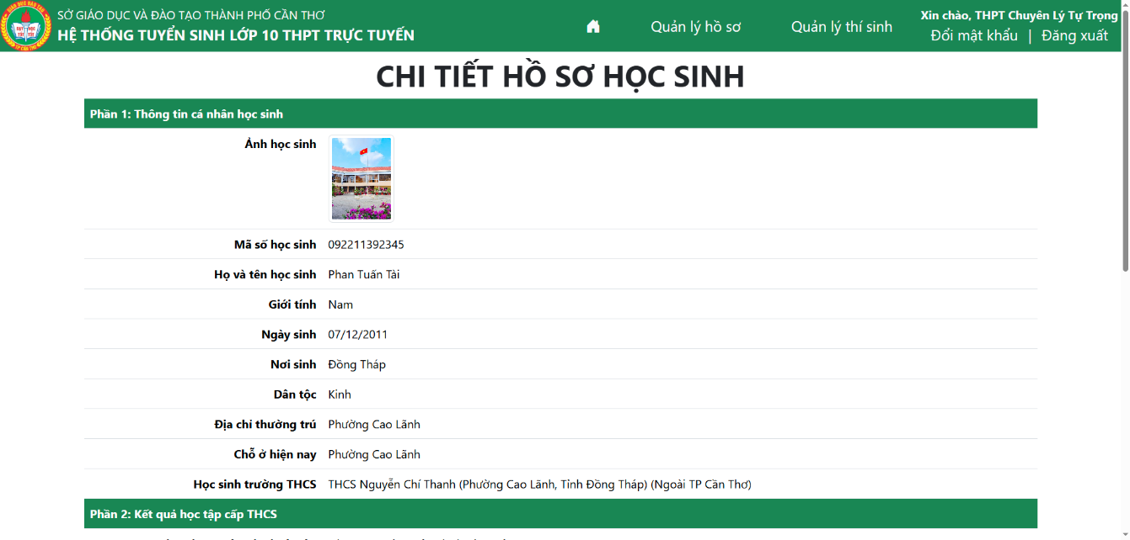

Figure 5.35. Detailed Information page

The Update Student page is shown in Figure 5.36 below. This page shows all detailed information of a student, and officials can also update information that they want to modify by clicking on textboxes and form fields. After modifying, officials click on the Update profile (*Cập nhật hồ sơ*) button to confirm.

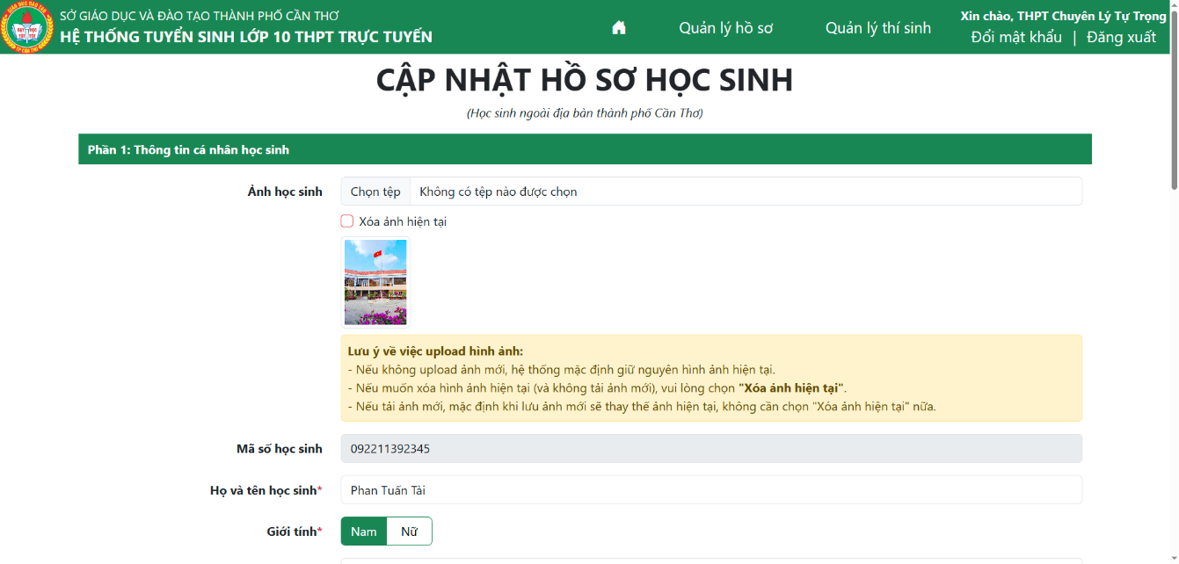

Figure 5.36. Update Student page

The confirmation dialog when officials click on the Delete students button is shown in Figure 5.37 below. If officials want to delete this student, they can click on the Delete (*Xóa*) button to confirm; otherwise, they can click on the Undo (*Hủy*) button to close the dialog.

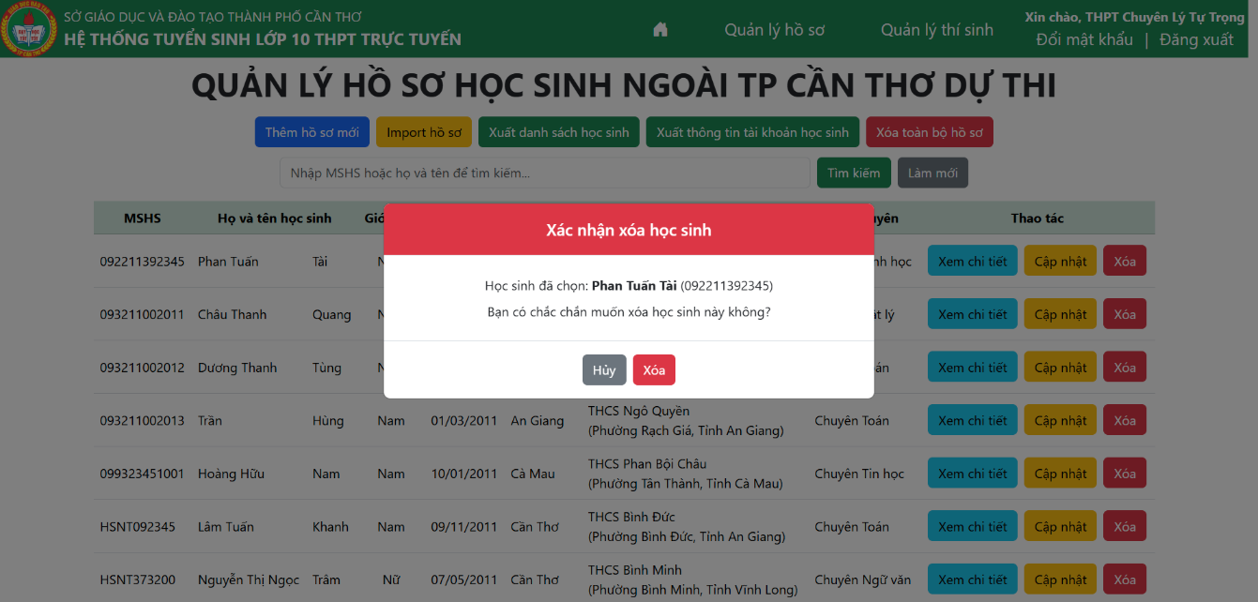

Figure 5.37. Confirmation dialog to delete a student

Besides some functions used for each student, High School Officials can also perform some functions in the button row above the search box. If they want to add new students to the list, they can add by using 2 functions: Add new profile (*Thêm hồ sơ mới*) or Import profile (*Import hồ sơ*). With the Add new profile function, the interface is shown in Figure 5.38 below. Officials will type in all textboxes with (*) to show that this is a mandatory field and needs to be typed before submitting. After typing in all fields, users can click on the Add profile (*Thêm hồ sơ*) button to confirm and add a new student to the system.

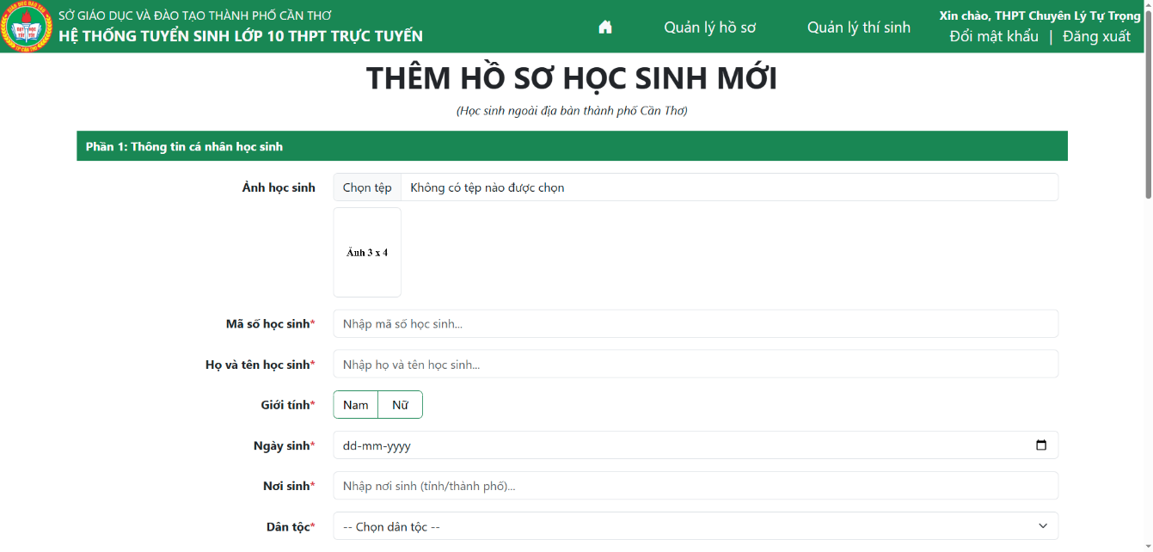

Figure 5.38. Add Student Profile page

Besides adding manually, users can also import a student’s profile by using Import profile (*Import hồ sơ*). The dialog interface of Import profile is shown in Figure 5.39 below. With the Import profile function, officials need to install the template by clicking Install template here (*Tải file mẫu tại đây*) and then add information of students in an Excel file before importing and uploading that file back to this dialog. Besides that, officials should upload a ZIP file including students’ avatars and upload that also in this dialog (this is optional) and click on the Import (*Thực hiện import*) button to confirm. After importing, it will show the number of students’ profiles imported successfully and errors while importing. This function can also be used for updating multiple students at a time because it will only need to update existing students in the list and add them if they do not exist in the list.

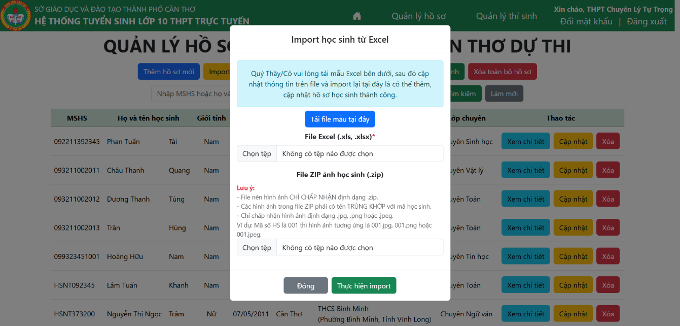

Figure 5.39. Import Student Profile dialog

High School Officials can also use 2 functions to export data, which are Export student list (*Xuất danh sách học sinh*) and Export student’s account (*Xuất thông tin tài khoản học sinh*). The difference between those functions is that while Export student list will export all detailed information of all students this secondary school is managing, Export student’s account will only export the student’s account list and the default password for each account. Officials can use this function to give accounts for students to connect to this system and modify information if they need to update.

The confirmation dialog when officials click on the Delete all students (*Xóa toàn bộ hồ sơ*) button is shown in Figure 5.40 below. If they want to delete all students, they can choose the Delete (*Xóa*) button, or they can click on the Undo (*Hủy*) to close the dialog.

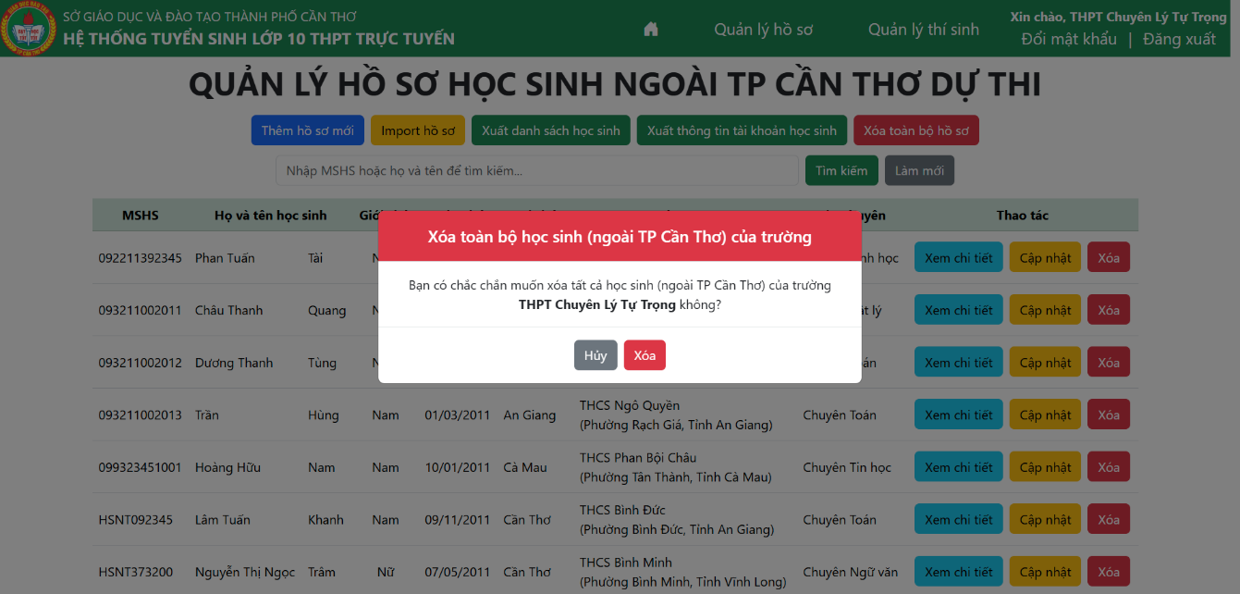

Figure 5.40. Confirmation dialog for deleting all students

The homepage of the Candidate Management subsystem is shown in Figure 5.41 below. On this page, officials can see the full list of students who will participate in the examination at the current high school. The table includes student ID, candidate number, exam room, and other personal information of students. To help officials find students more conveniently, a search box will help them find students by Student ID or their full name. If the search box is empty, it will show all students participating in this school. Otherwise, it will filter according to the user’s keyword. Also, it has a refresh (*Làm mới*) button, which will delete the keyword in the search box and go back to the full list of students.

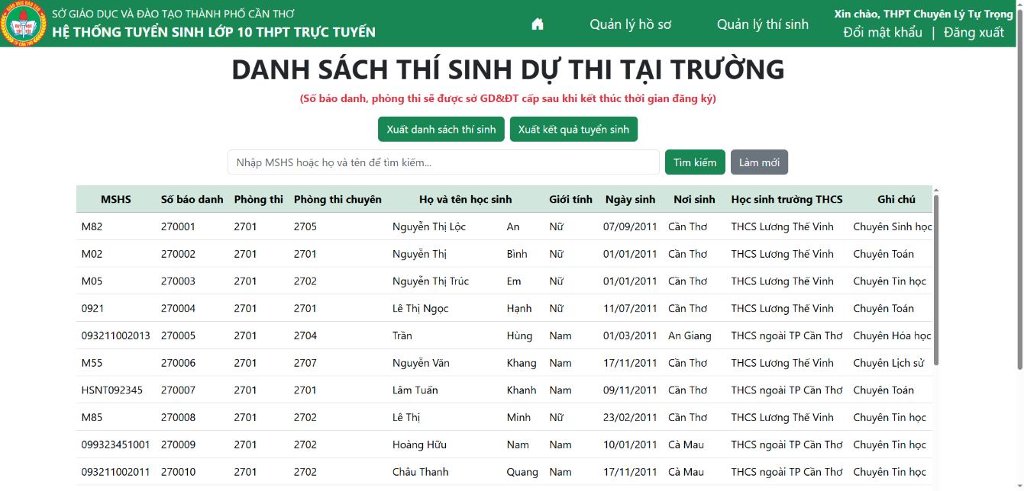

Figure 5.41. Candidate Management page

Officials can also export the student list by clicking on the Export candidate list (*Xuất danh sách thí sinh*) button to export the student list into an Excel file. This file will include the full list of students and the list of each exam room, which is simple for officials and teachers of high schools to print and determine the number of rooms they need to allocate for the exam. Also, they can click on Export admission result (*Xuất kết quả tuyển sinh*) to install the detailed result of all students participating in the admission exam in their high school.

Officials can also change their current password by clicking on the Change password (*Đổi mật khẩu*) button on the header of the page. This function is similar to the function of Administrators, which has been presented in part 5.1.2 above.

### Functions for Students

The Student’s homepage after logging in is shown in Figure 5.42 below. Students have two main subsystems: Student Information (*Thông tin học sinh*) and Result (*Kết quả*).

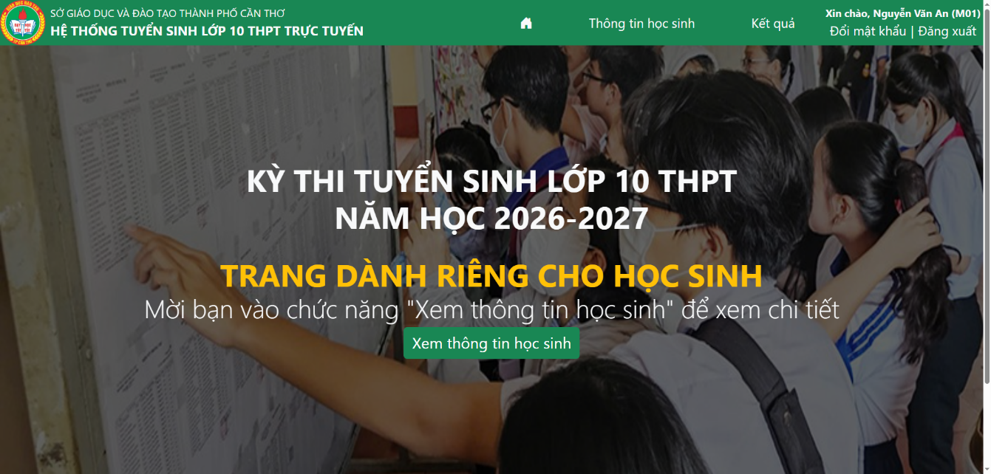

Figure 5.42. Student’s homepage

The homepage of the Student Information is shown in Figure 5.43 below. In this page, the detailed information of this student will be shown in 3 parts, similar to the Admission Form of the Department of Education and Training.

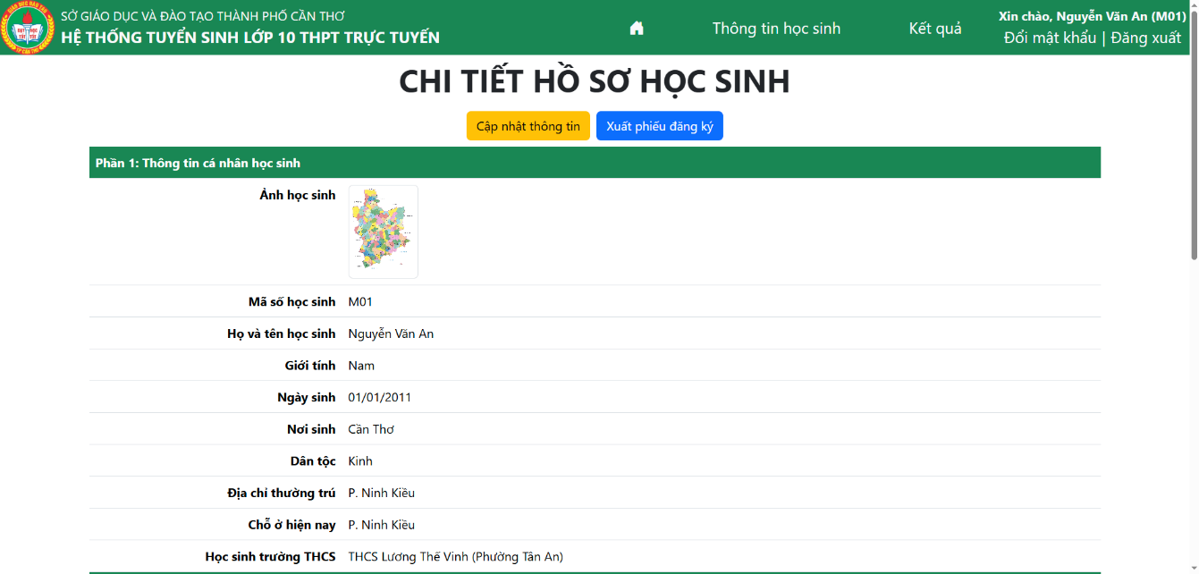

Figure 5.43. Student Information homepage

Students can also modify information by clicking on the Update information (*Cập nhật thông tin*) button to go to the Update information page, with the interface as Figure 5.44 below. On this page, it will show all detailed information about a student, and they can update the information that they want to modify. After modifying, they can click on the Update profile (*Cập nhật hồ sơ*) button to confirm.

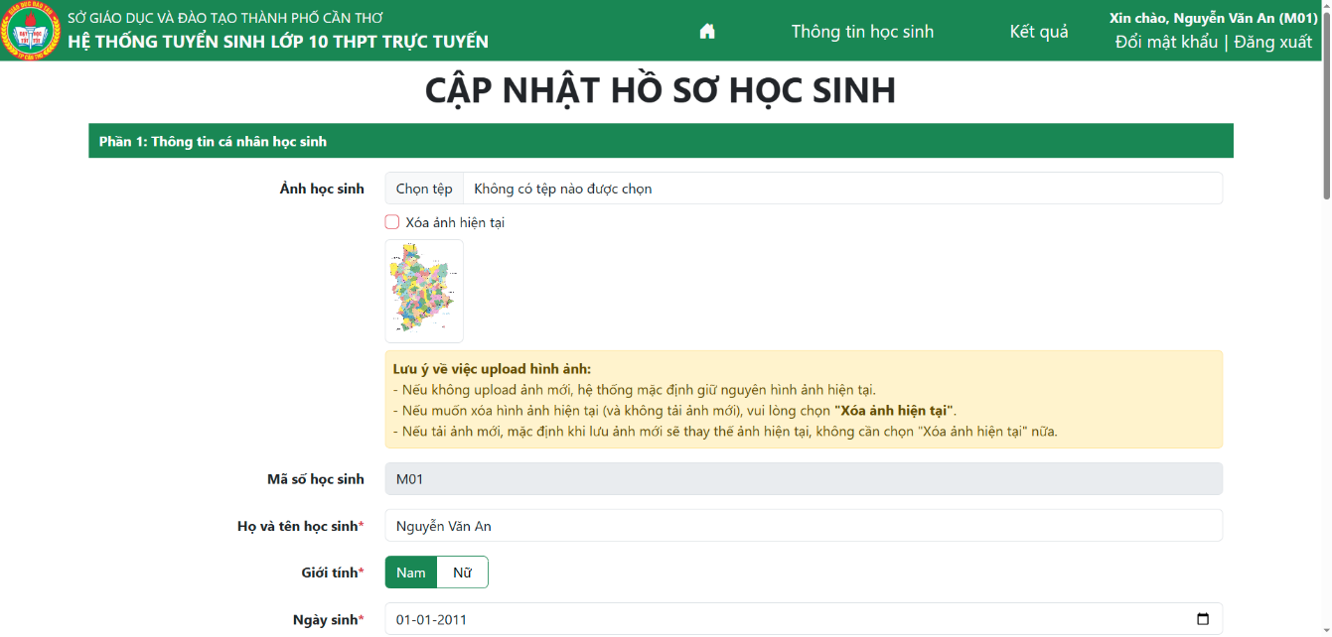

Figure 5.44. Update Information page

Also, students can use the Export Admission Form (*Xuất phiếu đăng ký*) function to export the admission information into a Word file, as shown in Figure 5.45 below. Students can use this Word file to print and give it to the Officials.

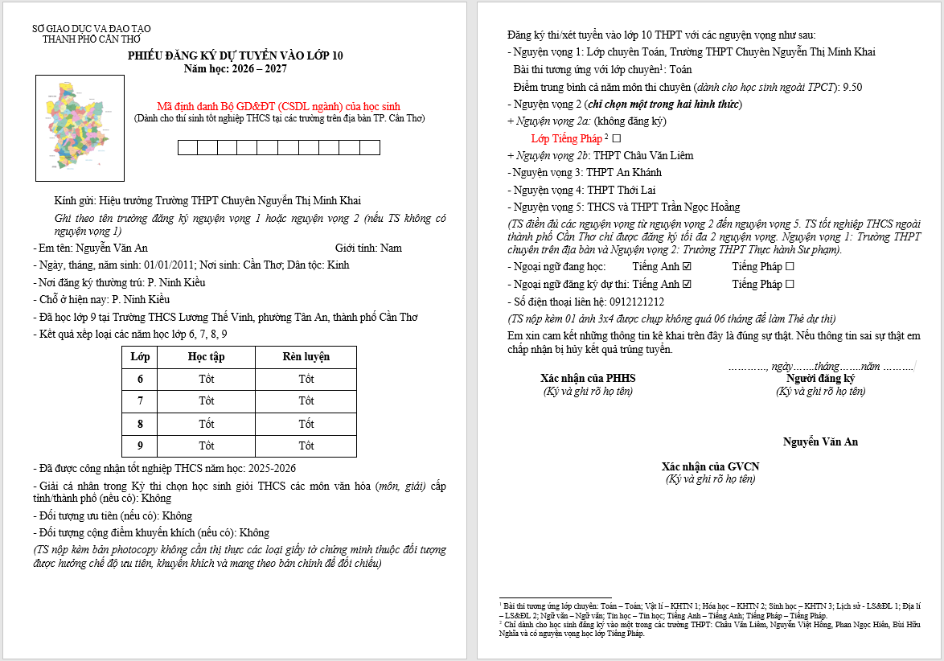

Figure 5.45. The Admission Form after exporting

The Result homepage is shown in Figure 5.46 and Figure 5.47 below (if the Department of Education and Training has allowed showing the admission results). The result includes student information (name, secondary school), the scores of all subjects, the extra score, and the total score. Also, it will show whether students have been admitted to any school in their choices in the last column.

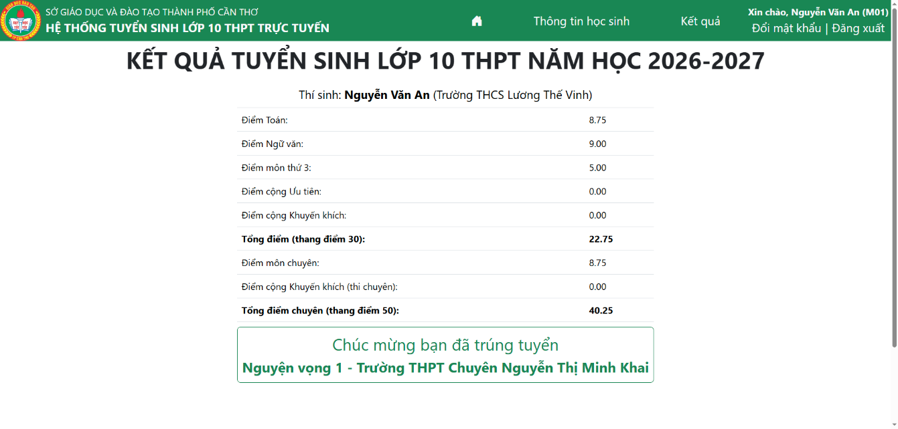

Figure 5.46. Admission Result page (with successful message)

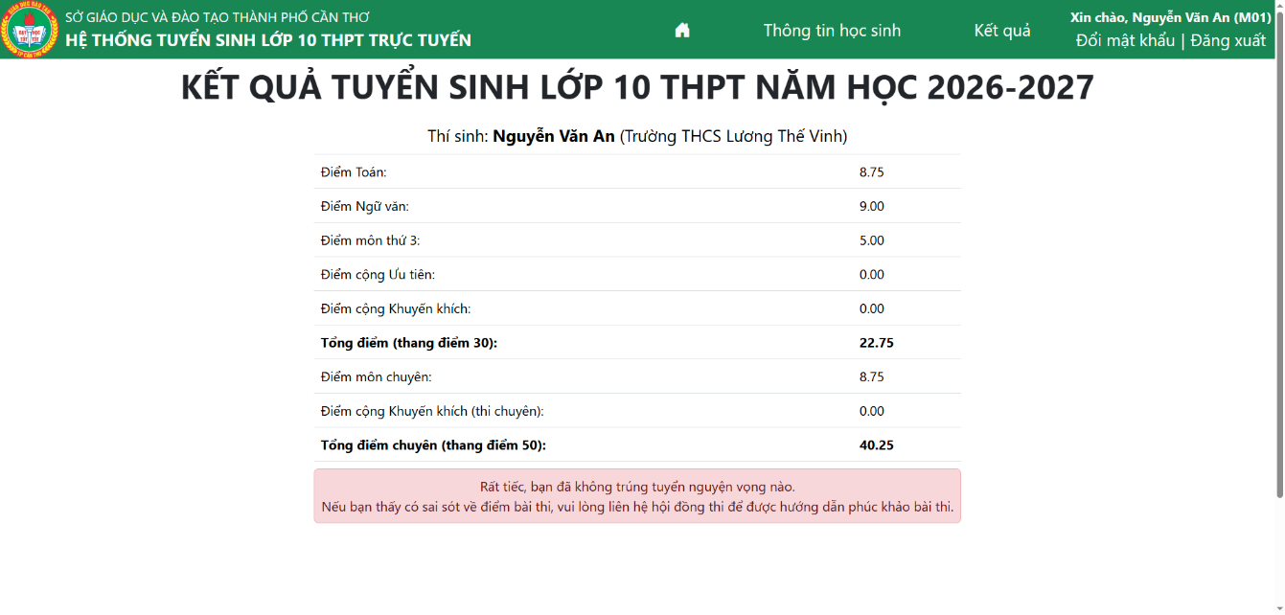

Figure 5.47. Admission Result page (with failure message)

Students can also change their current password by clicking on the Change password (*Đổi mật khẩu*) button on the header of the page. This function is similar to the function of Administrators, which has been presented in part 5.1.2 above.

## Mobile application

### Functions for Guest users

When users open the mobile application, a welcome page will show as Figure 5.48a below. After that, if users have not logged in to any roles, it will redirect users to the homepage of the application, as shown in Figure 5.48b below. The interface also includes a background image illustrating the website and the exam time notification. At the bottom of the background image is information about important milestones in the registration process and the expected exam schedule. At the bottom of the interface, there is a navigation bar including five buttons, which are five main pages and functions for guest users: Home (*Trang chủ*), Search admission result (*Tra cứu*), Admission numbers (*Chỉ tiêu*), Admission documents (*Văn bản*), and Login (*Đăng nhập*).

 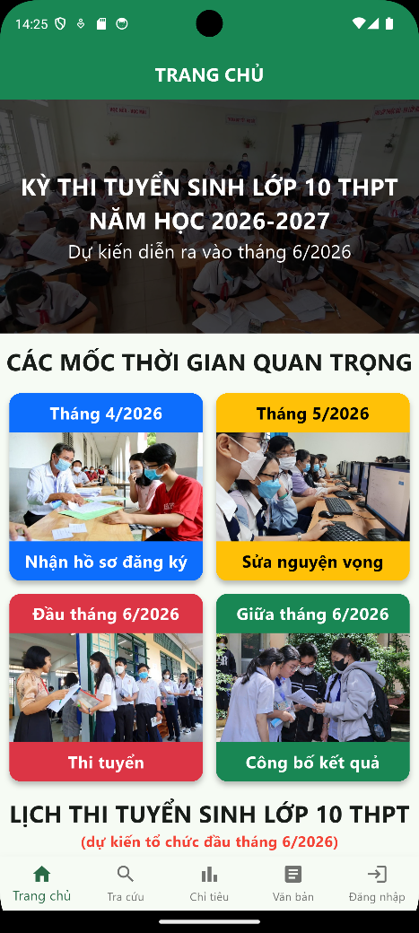

(a) (b)

Figure 5.48. Welcome page and homepage of the mobile application

The Search Admission Result page is shown in Figure 5.49 below. To search the admission result, users need to choose the high school in the first dropdown and choose the search type in the second dropdown. There are three search types: Search by Student ID, Search by Student Full name, and Search by Candidate number. After that, users type the search content in the textbox. After choosing and typing, users need to click on the reCAPTCHA button (*Xác thực reCAPTCHA*) to verify that “I’m not a robot”, before clicking on the Search (*Tra cứu kết quả*) button to find.

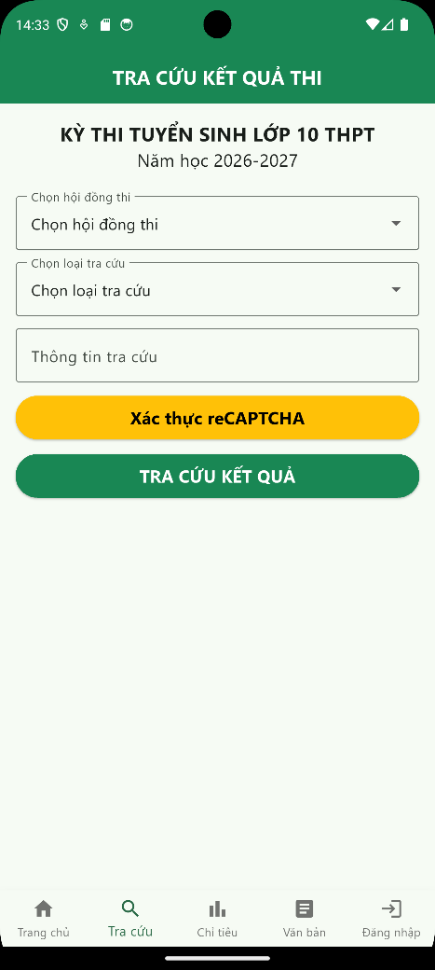

Figure 5.49. Search Admission Result interface of the mobile application

If there is only one student who matches the user’s search requirement, it will show the full result of this student, with the student’s full name, secondary school, score of each subject, extra scores, and total score. It will also show whether the student has passed the examination and been admitted to any high school included in his/her choices, as shown in Figure 5.50a below. If there is more than one student who matches the user’s search requirement, it will show the list of students with the overview information of each student. Users then need to choose one of them to show the detailed result of the student they want to see, as shown in Figure 5.50b below.

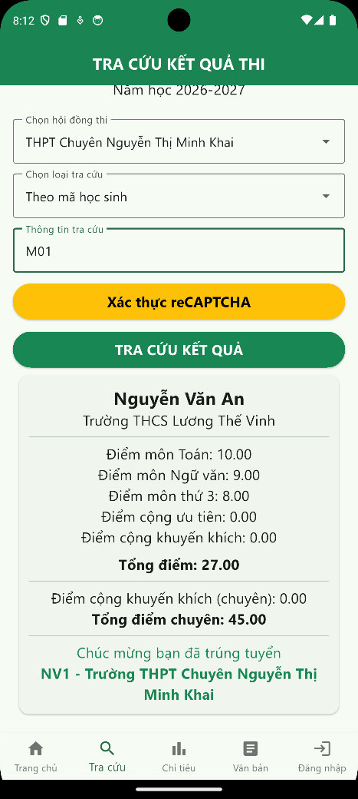 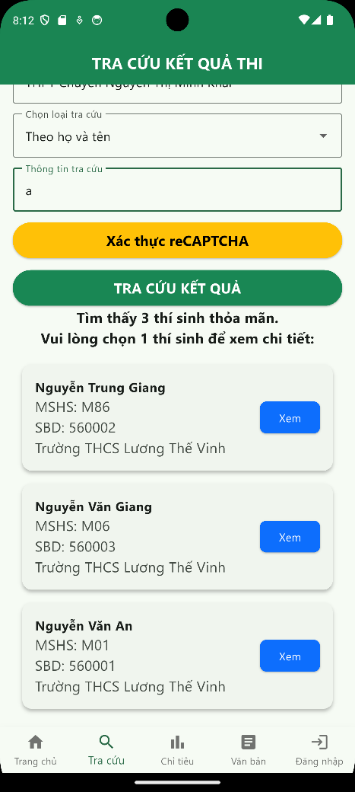

(a) (b)

Figure 5.50. The result interface after typing information

When users click on the Admission Numbers button, the interface is shown in Figure 5.51a below. On this page, users will see the admission number of each high school in Can Tho City according to the official documents of the Department of Education and Training of Can Tho City. Each card contains the high school’s name, address, the number of students registered to this school, and the admission number of this school. Also, with some High Schools for the Gifted, the admission number is divided by specialized subjects, as shown in Figure 5.51b below.

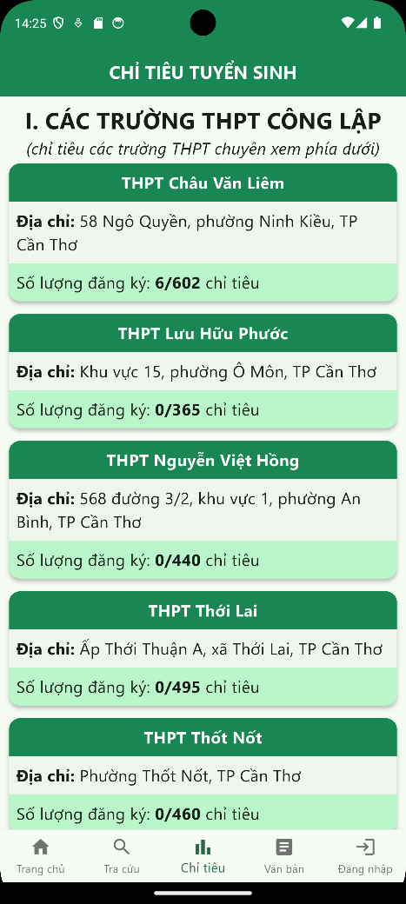 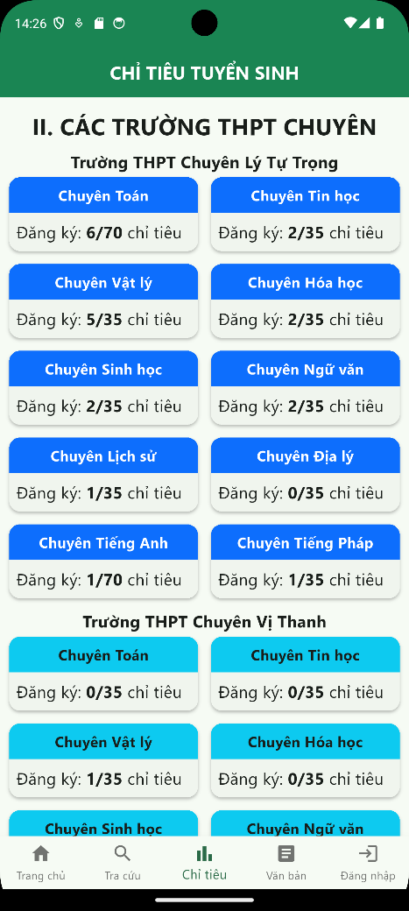

(a) (b)

Figure 5.51. Admission Numbers interface of the mobile application

When users click on the Admission Documents button, the interface is shown in Figure 5.52 below. When users choose one of the documents shown, it will show a window to show the details of this document. Users can also open this document in another app by clicking on the Open document in another app (*Mở bằng ứng dụng khác*) button.

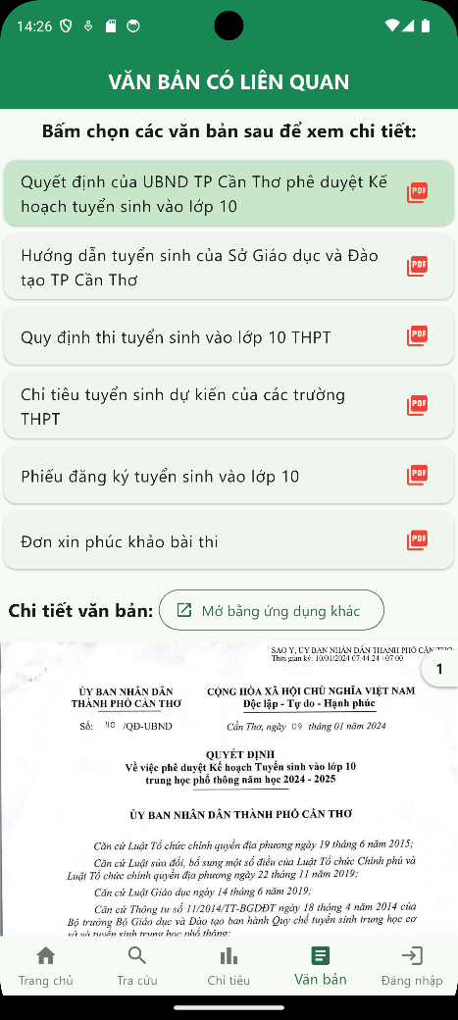

Figure 5.52. Admission Documents interface of the mobile application

When users click on the Login button, the interface is shown in Figure 5.53 below. In this interface, users need to have an account given by teachers or administrators of the Department of Education and Training. Users need to log in by typing their username and password for their account, then click on the reCAPTCHA button (*Xác thực reCAPTCHA*) to verify “I’m not a robot” before logging in by pressing the “Login” (*Đăng nhập*) button. If the username and password match, users will be redirected to the page according to their role; otherwise, it will show an error message, and users need to retype their username and password.

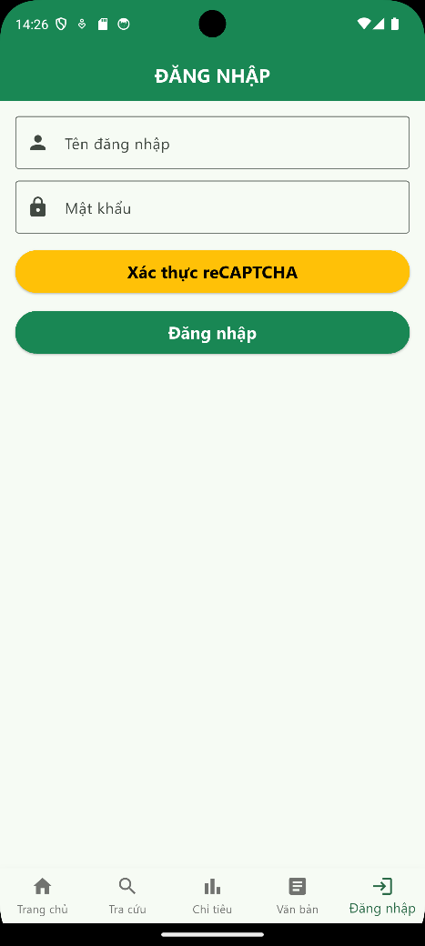

Figure 5.53. Login interface of the mobile application

### Functions for Administrators

The Administrator’s homepage is shown in Figure 5.54 below. In the mobile application, administrators have 2 main functions: Account Management (*Quản lý tài khoản*) and Change Password (*Đổi mật khẩu*).

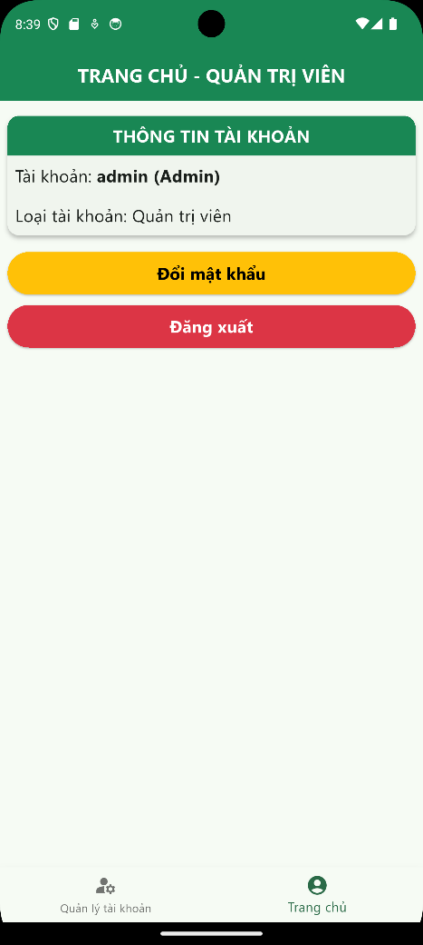

Figure 5.54. Administrator Homepage

The Account Management page is shown in Figure 5.55 below. In the mobile application, Admins can see the list of accounts existing in the system. Admins can also search for accounts by keyword by typing in the search box near the top of the page. For safety reasons, admins cannot modify or add new accounts using the mobile application; all sensitive activities will be done in the web application.

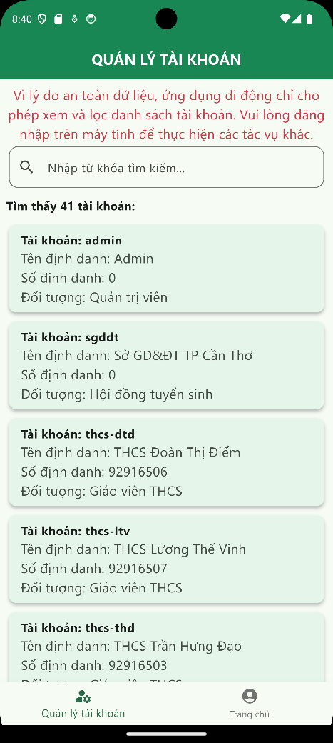

Figure 5.55. Account Management page

The Change Password page is shown in Figure 5.56 below. To change the password, users need to type their current password, the new password, and the confirmation of the new password. After that, users need to click on Change password (*Đổi mật khẩu*) to complete the process. If the process has been finished successfully, it will show a message to notify users and redirect to the homepage of current users.

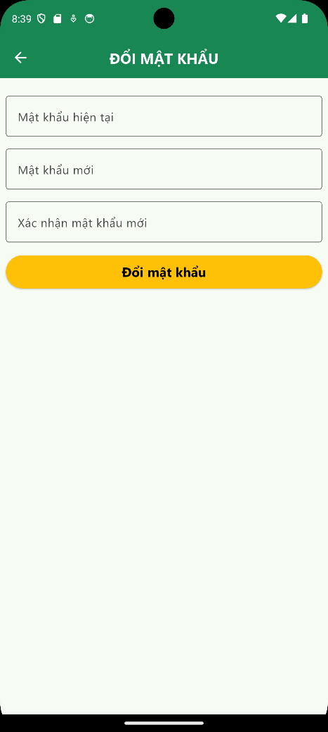

Figure 5.56. Change Password page

### Functions for Admissions Council Officials

The Admissions Council Official’s homepage after logging in is shown in Figure 5.57 below. In the mobile application, Admissions Council Officials have 3 main functions: Candidate Management (*Quản lý thí sinh*), State Management (*Quản lý trạng thái*) and Change Password (*Đổi mật khẩu*).

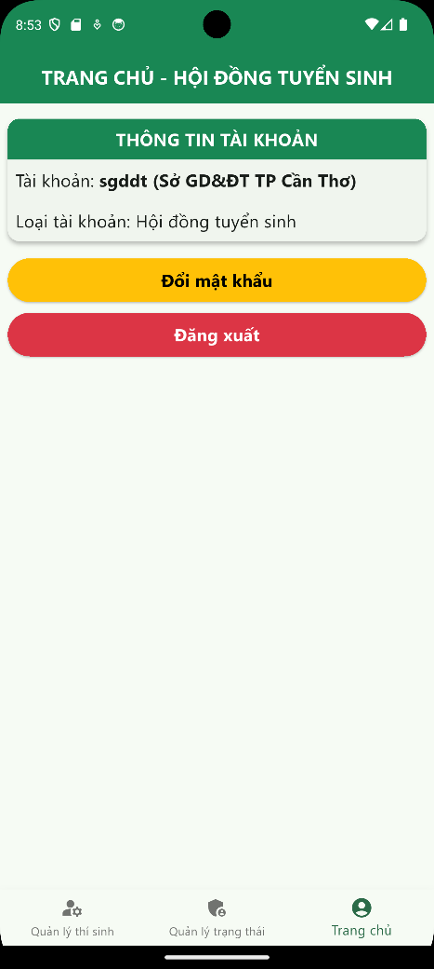

Figure 5.57. Admissions Council Official’s homepage

The Candidate Management page is shown in Figure 5.58a below. In the mobile application, officials can see the list of candidates in the examination and their scores. Officials can also update scores of each student by clicking the Update score (*Cập nhật điểm*) button at the bottom of each student’s card. The interface of the Update Score function is shown in Figure 5.58b below. Officials can modify scores of a student by modifying in the textboxes before clicking on Update score (*Cập nhật điểm*) to complete the process.

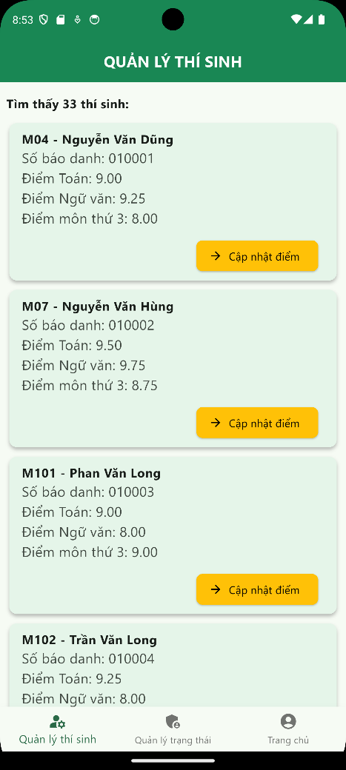 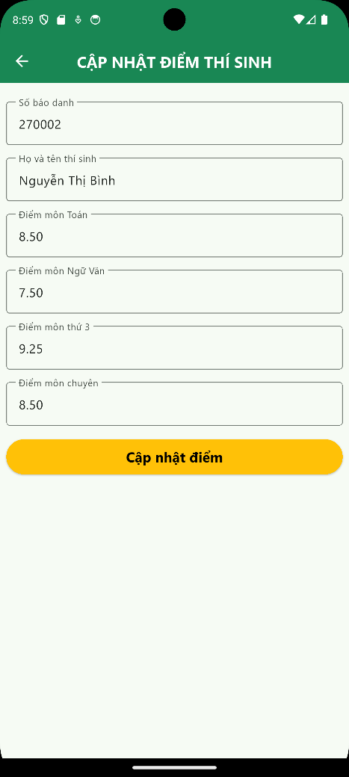

(a) (b)

Figure 5.58. Candidate Management and Update Score page

The State Management page is shown in Figure 5.59 below. In the mobile application, officials can see the full list of admission states, including the current value of the state and the last time the state was updated. Officials can also update a state by clicking on the “Update state” (*Cập nhật trạng thái*) button at the bottom of each state’s card.

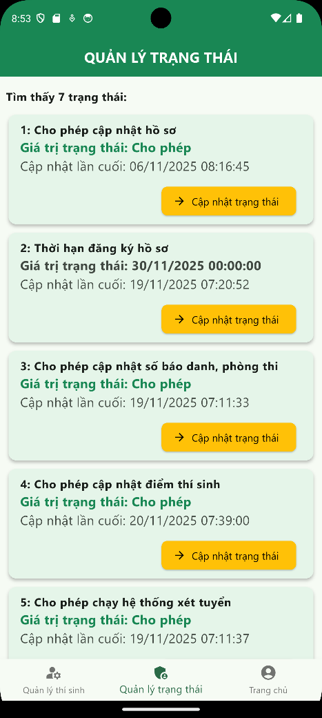

Figure 5.59. State Management page

The dialog to update state is shown in Figure 5.60a (with Boolean state) and Figure 5.60b (with Timestamp state) below. With a Boolean state, users can choose one of two states provided in the dropdown, then select Save to update the state. With a Timestamp state, users need to click on the box containing the current timestamp state, then choose the date and time in order, as shown in Figure 5.61a and Figure 5.61b below, before clicking on the Save button after finishing choosing the new timestamp.

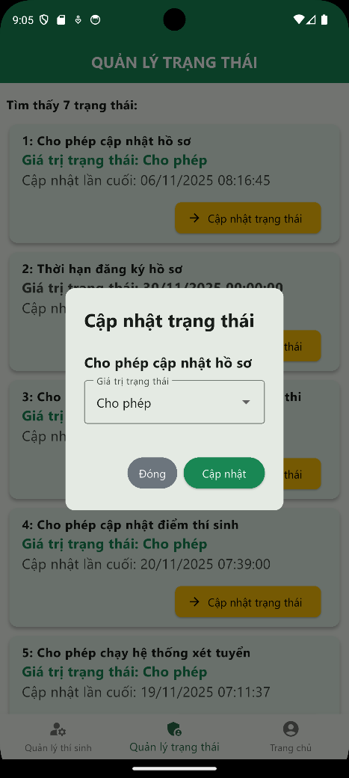 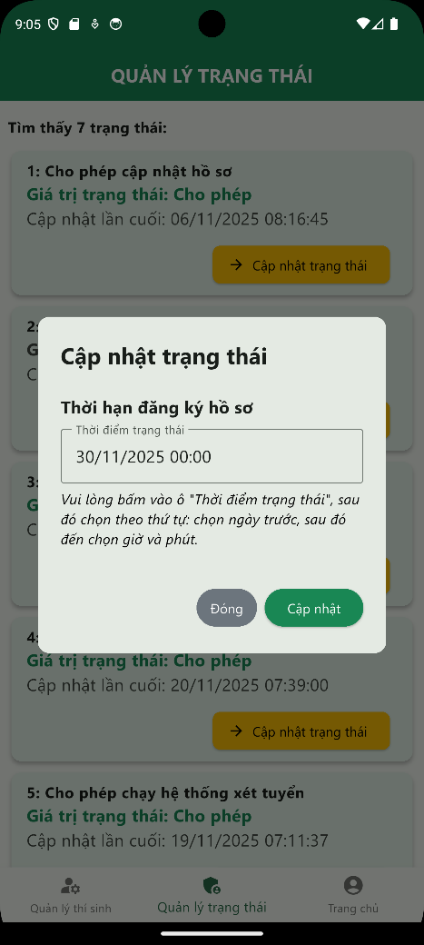

(a) (b)

Figure 5.60. Update State dialog

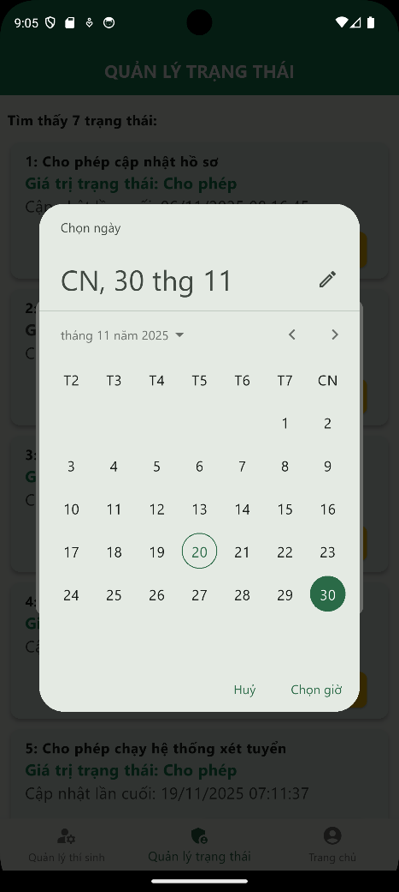 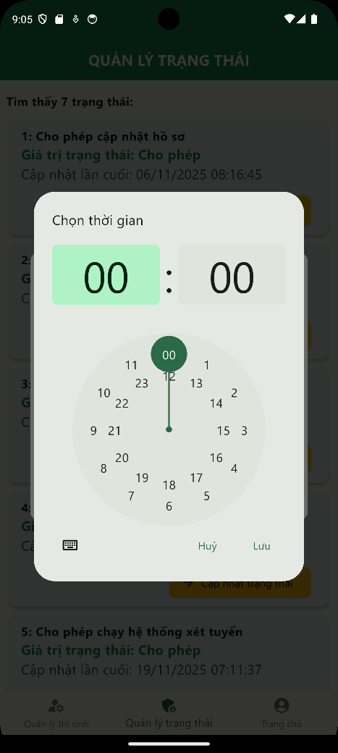

(a) (b)

Figure 5.61. Timestamp modifying (date and time)

Officials can also change their password by clicking on the Change Password button on their homepage. This function is similar to the function of Administrators, which has been presented in part 5.2.2 above.

### Functions for Secondary School Officials

The Secondary School Official’s homepage after logging in is shown in Figure 5.62 below. In the mobile application, Secondary School Officials have 2 main functions, which are Student Management (*Quản lý học sinh*) and Change Password (*Đổi mật khẩu*).

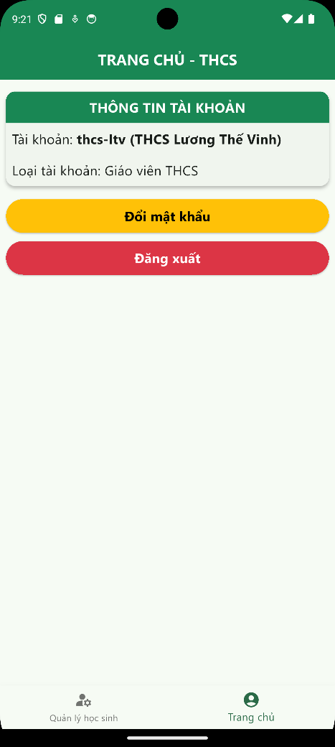

Figure 5.62. Secondary School Official’s homepage

The Student Management page is shown in Figure 5.63a below. In the mobile application, officials can see the full list of students in their secondary school, with the overview profile of each student. Officials can also see detailed information about each student by clicking on the Detailed Information (*Xem chi tiết*) button to see their detailed information, as shown in Figure 5.63b below. The detailed information is divided into 3 main parts, similar to the Admission Form structure given by the Department of Education and Training. Officials can also search for students by keyword by typing in the search box. For safety reasons, if officials want to modify or add new students, they need to use the web application instead.

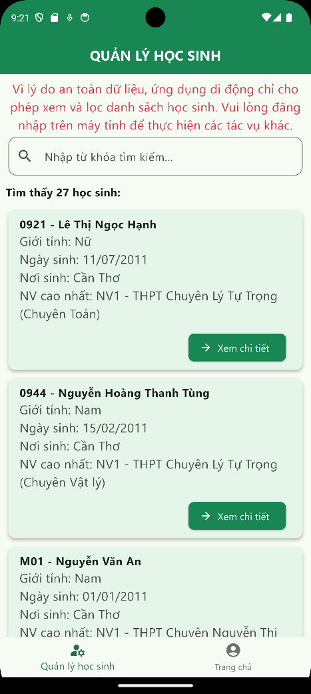 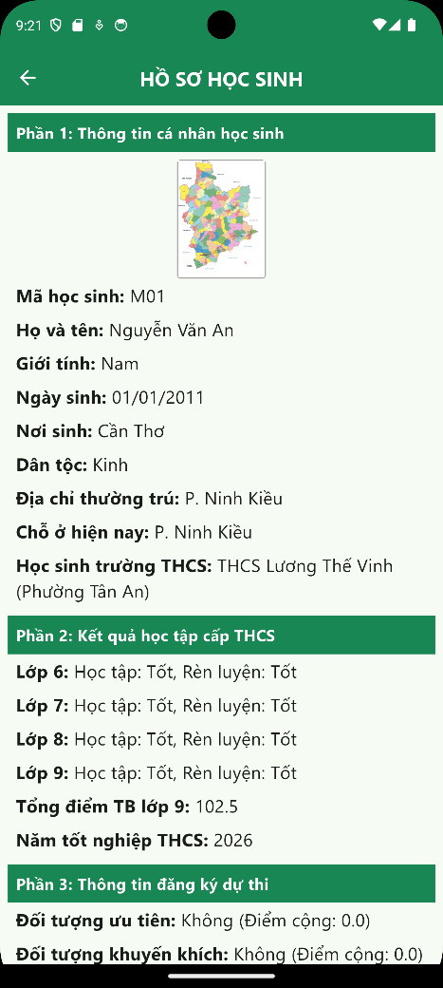

(a) (b)

Figure 5.63. Student Management and Student Detailed Information page

Officials can also change their password by clicking on the Change Password button on their homepage. This function is similar to the function of Administrators, which has been presented in part 5.2.2 above.

### Functions for High School Officials

The High School Official’s homepage after logging in is shown in Figure 5.64 below. In the mobile application, High School Officials have 3 main functions: Student Management (*Quản lý học sinh*), Candidate Management (*Quản lý thí sinh*) and Change Password (*Đổi mật khẩu*).

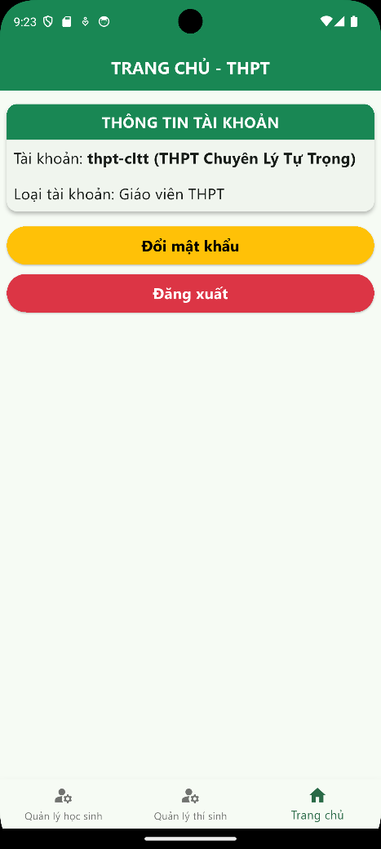

Figure 5.64. High School Official’s homepage

The Student Management page is shown in Figure 5.65a below. On this page, officials can see the list of students (outside Can Tho City) registering in their high school, including the overview and some important information about each student. Officials can also search for students by keyword using the search box near the top of the page. Also, if they want to see more information about a student, they can click on Detailed information (*Xem chi tiết*). The interface of this function is shown in Figure 5.65b below. For safety reasons, if officials want to modify or add new students, they should use the web application instead.

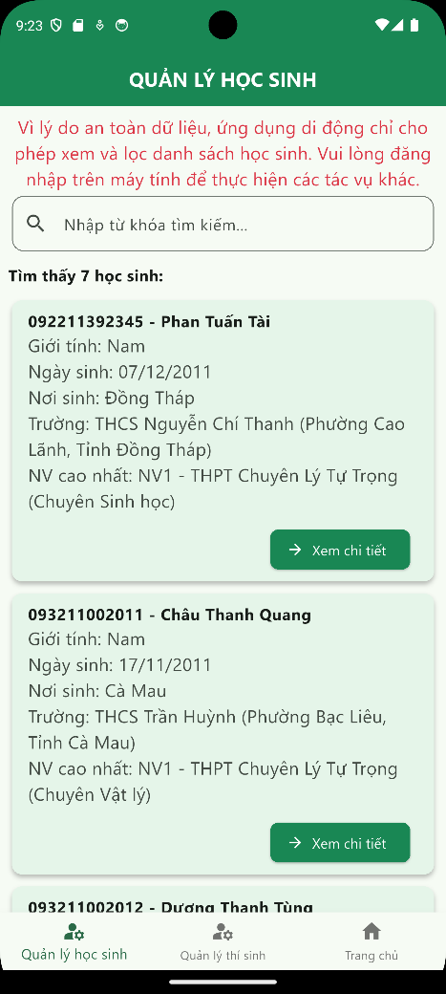 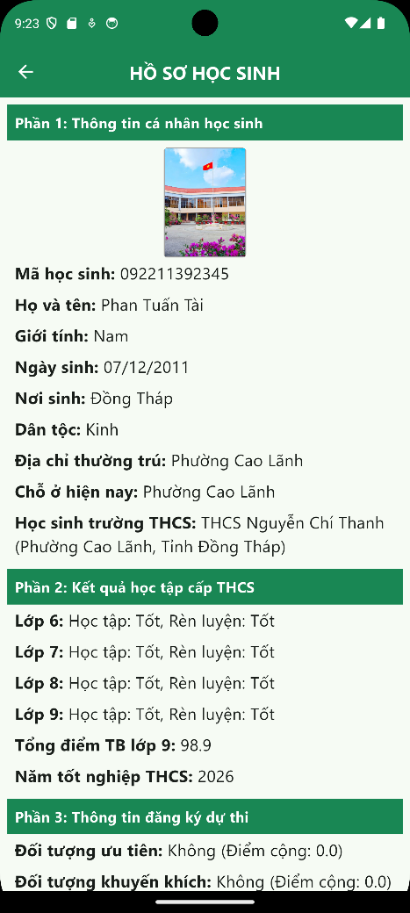

(a) (b)

Figure 5.65. Student Management and Detailed Information page

The Candidate Management page is shown in Figure 5.66 below. On this page, officials will see the list of candidates participating in the admission exam in their high school (students who choose the highest choice, which is their high school), including candidate number, student ID, full name, exam room, and some personal information. All information related to the exam will be updated by the Department of Education and Training, so officials will not modify anything on this page. Officials can also search for candidates by keyword using the search box.

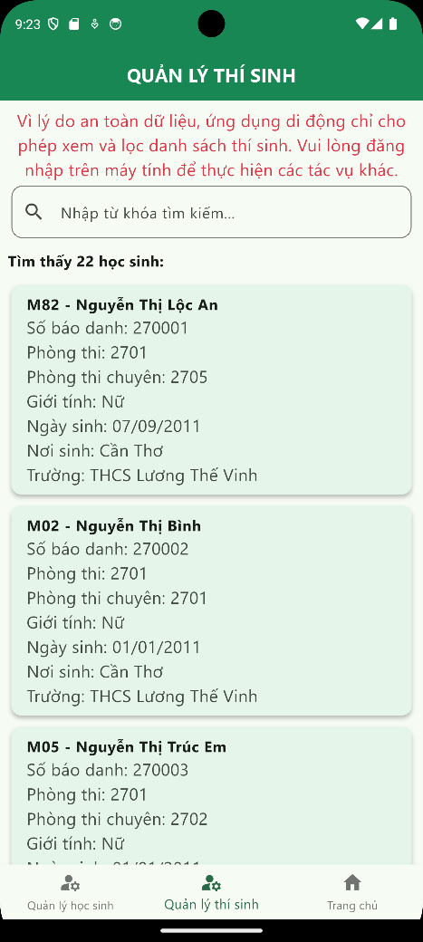

Figure 5.66. Candidate Management page

Officials can also change their password by clicking on the Change Password button on their homepage. This function is similar to the function of Administrators, which has been presented in part 5.2.2 above.

### Functions for Students

The Student’s homepage after logging in is shown in Figure 5.67 below. In the mobile application, students have 2 main functions: Student Information (*Thông tin học sinh*) and Change Password (*Đổi mật khẩu*).

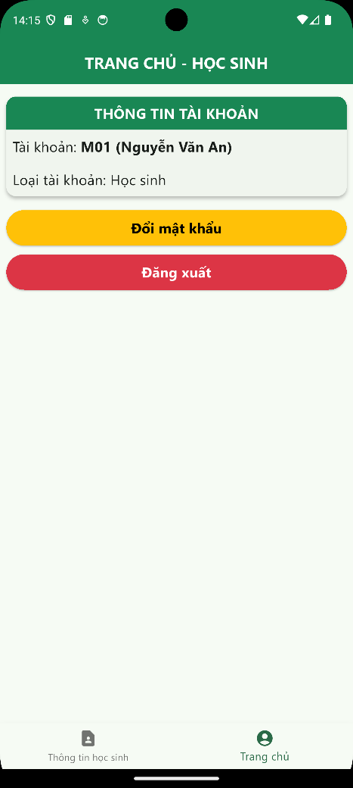

Figure 5.67. Student’s homepage

To go to the Student Information page, users click on the first button on the footer. The interface of this function is shown in Figure 5.68 below. In this page, the detailed admission information of this student will be shown and divided into 3 parts, similar to the Admission Form structure of the Department of Education and Training. For safety reasons, if students want to update their information or print the Admission Form, they need to go to the web application instead of the mobile application.

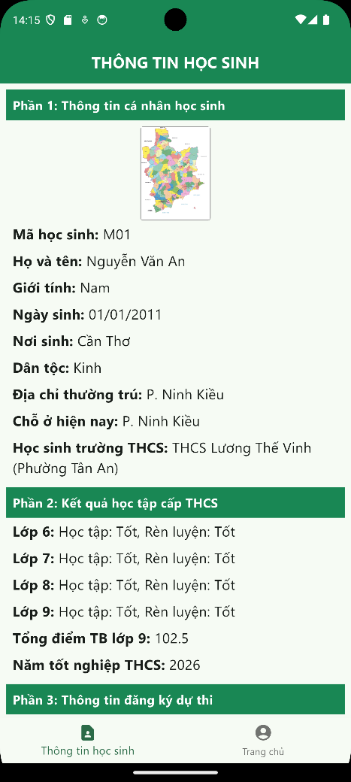

Figure 5.68. Student Information page

Students can also change their password by clicking on the Change Password button on their homepage. This function is similar to the function of Administrators, which has been presented in part 5.2.2 above.

# CONCLUSION

## Conclusion

In this thesis, I have finished developing a grade 10 admission system for Can Tho City, with four main subsystems: Subsystem for managing admission records; Subsystem for managing candidate exam information; Subsystem for managing scores and announcing admission results; Subsystem for managing and controlling exam status and 6 main user groups, including Guest users, Administrators, Admissions Council Officials (in the Department of Education and Training), Secondary School Officials, High School Officials and Students. All functions have been tested carefully to avoid errors during production.

One of the most important contributions of the thesis topic is that this application can replace the old admission system of three cities and provinces: Can Tho City, Hau Giang Province, and Soc Trang Province, to become the common system for the new Can Tho City, with the data and information merged from those cities and provinces. Also, this application has been advised, evaluated, and commented on by some officials working in some secondary schools, high schools in Can Tho City, and in the Department of Education and Training, so it will suit the needs of the majority of the main users of the system.

## Future work

Besides the result and contributions above, this application also has some points that need to be updated to fulfill the requirements and meet the needs of different user groups, such as:

- Creating and exporting more documents relating to the admission exam, especially the admission benchmarks for each High School and each specialized class in High Schools for the gifted.

- Creating interactive and easy-to-use dashboards for statistical purposes for officials in the Department of Education and Training and officials in Secondary Schools and High Schools.

- Improving the user interface and experience to suit a wider range of users with varying levels of technological proficiency.

- Designing an AI chatbot to help users interact and ask questions about the information related to the admission process in Can Tho City.

To improve this application, one of the most important factors is the valuable advice and comments from officials of the Department of Education and Training. These will ensure that this application is usable and it will bring benefits to all user groups in real life.

# REFERENCES

|  |  |
| --- | --- |
| [1] | Can Tho Department of Education and Training, "Admission Website of Can Tho City," [Online]. Available: http://tuyensinh.cantho.gov.vn/. [Accessed 24 November 2025]. |
| [2] | Standing Committee of the National Assembly of Vietnam, *Resolution No. 1668/NQ-UBTVQH15 on the arrangement of commune-level administrative units of Can Tho City in 2025,* 2025. |
| [3] | A. S. Tanenbaum and D. Wetherall, Computer Networks, 5th ed., Pearson, 2011. |
| [4] | "Client-Server overview," Mozilla Foundation, [Online]. Available: https://developer.mozilla.org/en-US/docs/Learn_web_development/Extensions/Server-side/First_steps/Client-Server_overview. [Accessed 24 November 2025]. |
| [5] | E. Gamma, R. Helm, R. Johnson, and J. Vlissides, Design Patterns: Elements of Reusable Object-Oriented Software, Addison-Wesley, 1994. |
| [6] | J. Reenskaug, Models–Views–Controllers, Xerox PARC Technical Report, 1979. |
| [7] | P. DuBois, MySQL, 5th ed., Addison-Wesley, 2013. |
| [8] | Oracle Corporation, "MySQL 8.0 Reference Manual - Including MySQL NDB Cluster 8.0," 21 November 2025. [Online]. Available: https://downloads.mysql.com/docs/refman-8.0-en.pdf. [Accessed 24 November 2025]. |
| [9] | H. Schildt, Java: The Complete Reference, 12th ed., McGraw-Hill, 2021. |
| [10] | "Spring Framework," Broadcom Inc., [Online]. Available: https://spring.io/projects/spring-framework. [Accessed 24 November 2025]. |
| [11] | A. Banks and E. Porcello, Learning React, 2nd ed., O’Reilly Media, 2017. |
| [12] | Meta Open Source, "Quick Start," Meta Platforms, [Online]. Available: https://react.dev/learn. [Accessed 24 November 2025]. |
| [13] | Google, "Dart language specification," Google, [Online]. Available: https://dart.dev/resources/language/spec. [Accessed 24 November 2025]. |
| [14] | Google, "Flutter documentation," Google, [Online]. Available: https://docs.flutter.dev/. [Accessed 24 November 2025]. |